Day in the Life of the Hudson River 10/12/17 Data
(Salt Front ~ RM 65)
RIVER MILE 61.2
Beacon Landing Park, City of Beacon, Dutchess County
Will Gunther, Nancy Fabrizio, Nancy Rypkema - Valley Central Middle School,
7th & 8th graders (95 students and 12 adults)
Latitude 41.507975, Longitude -73.986708

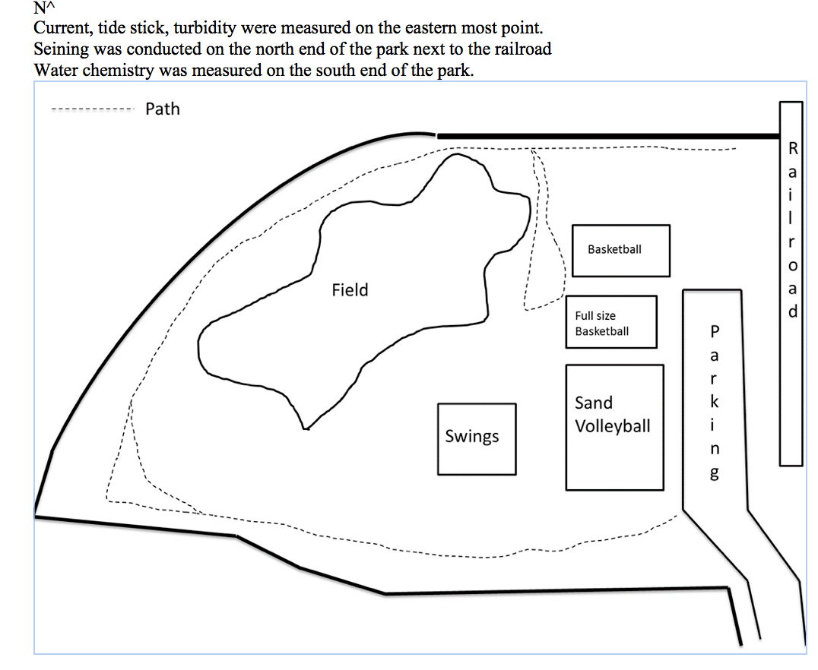
Location: Beacon Landing Waterfront Park, Beacon, Dutchess County NY
Area: The park at the end of Red Flynn Drive (past long dock park) near the Beacon train station – center at the park with stations all around it and fish in the cove at the end of the park - grassy lawns, forested around edges, parking lot to the side. Children’s play area, large riprap
Surrounding Land Use: Urban/residential 100% (Parkland)
Shoreline: A bridge, train station, covered in vegetation trees, concrete debris, dock
Sampling Site: beach, covered in vegetation, banks altered, rip rap
Plants in the water: no plants in the water
Water depth: <1 m
Bottom Surface: muddy
ITEM | Time |  | Reading 1 | Reading |  | Comments
Physical
Air Temperature | 9:50 AM  10:09 AM  10:41 AM  11:00 AM  11:20 AM  11:42 AM  12:09 PM  12:42 PM |  | 14.2°C  15  15.4  16.4  17.8  17  18.2  17 | 58°F  58.6  59.7  61.4  64  62.9  64  63.3
Wind Speed | Beaufort |  | #2 | 5 kts
Cloud Cover | Partly Cloudy |  | 26-50%
Weather today | No rain
Weather recently | Rain on Monday, Warmer Tuesday and Wed. mid 70s,
Water Surface | Choppy
Water Temperature | Time | Degrees °C |  |  |  |  | Average
 | 9:46 AM  10:15 AM  10:40 AM  12:16 PM | 10°C  12  12  14 |  |  | X3  X3  12,13,12  X3 |  | 10°C average  12  12.7  14
Turbidity- long sight tube | 12:00 PM | 43 cm  45  35 |  |  |  |  | 41 cm average
Chemical | Time | DO |  |  | Temp |  | % saturation
DO  (drop kit) | 9:46 AM | 9 ppm |  |  | 10°C |  | 80%
pH –  litmus paper | 11:51 AM | 6  7  7 |  |  |  |  | 6.7 average
Salinity –QTs- HR | Time | Chloride reading Cl- |  |  |  |  | Total Salinity conversion
 | 12:30 PM | 546 ppm  598 ppm  654 ppm |  |  |  |  | 986 ppm TS  1080 ppm  1181 ppm
Fish Catch  seine 8X4feet | Number Caught | Species |  |  | Length
4X6 ft. pull | 10 | Shiner |  |  | 7.5 cm
 | 3 | Striped Bass |  |  | 12.7 cm
 | 2 | Sunfish |  |  | 8.0 cm
 | 1 | Bluefish |  |  | 20.5 cm
DIV | 4 | TOTAL |  |  | 16
Macroinvert | NONE
Sed. Core | NR
Tides | Time | Tide Stick |  |  | Flood/Ebb Still |  | Rate of change – cm/min
 | 10:01 AM  10:12 AM  10:38 AM  10:54 AM  11:23 AM  11:45 AM  12:09 PM | 30 cm  30 cm  28 cm  25 cm  25 cm  23 cm  20 cm |  |  | Falling  Unchanged  Falling  Falling  Unchanged  Falling  Falling |  | NA  0  0.125  0.125  0  0.08  0.125
Currents | Time | Cm/30 secs |  |  | Cm/sec |  | knots | Ebb Flood
 | 10:55 AM  11:45 AM  12:35 PM | 152  216  162 |  |  | 2.5  3.6  2.7 |  | 0.05  0.07  0.05
There is a 15’ rock outcropping. We attempted to measure the current in the main channel of the Hudson beyond the outcrop.

