Day in the Life of the Hudson River 10/12/17 Data
(Salt front ~ RM 65)
RIVER MILE 75.5
Waryas Park, Poughkeepsie, Dutchess County
Sharon Ellis, Walkill HS, 25 students, 9th gr Living Environment, 3 adults
N 41°7056’ – W -73°9403’
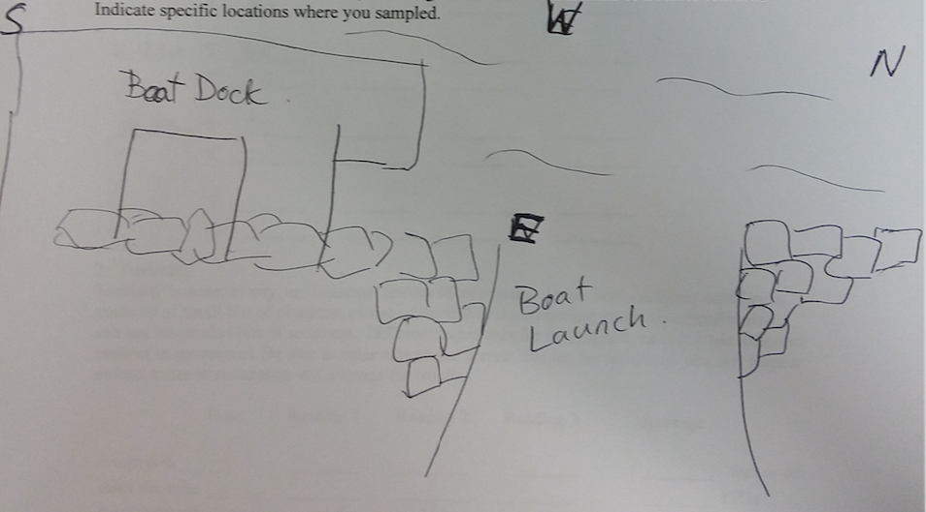

Location: Waryas Park, Poughkeepsie, New York.
Area: public park, pier, grassy, parking lot. Park used for fishing, small boat launch, another pier for small boat launching
Surrounding Land Use: 75 % industrial/commercial; 25% park area with grass and waterfront docks
Sampling Site: shoreline is 100% riprap along the water with vegetation, banks altered, pier, alongside and behind, brick pieces
Plants in area: none
River Bottom – rocky/muddy
Water depth: 3-4ft

ITEM | Time |  | Reading 1 | Reading 2 | Comments
Physical
Air Temperature | NR
Wind Speed |  |  | Beaufort 1-2 | N
Cloud Cover | Partly cloudy
Water | calm
Observations
Water Temp. | 11:03 AM  11:13 AM  12:20 PM | 20ºC  20ºC  20ºC |  | 70ºF  68  70
Turbidity – long site tube | 12:16 PM | 45cm  46  44 |  | Average: 45 cm
Chemical
DO - Drop test kits | 10:54 | 20ºC |  | 5 ppm | 55% sat
pH – indicator solution | 10:35 AM | 7.2  7.2  7.2 |  | Average: 7.2
Salinity - Low Range quantab | 11:03 AM | 2.0 Quantab Units |  | 49ppm Cl⁻ | 89 ppm TS
Fish Catch – 20 foot net – 8.5 foot pull | Number Caught | Species |  | Largest
10-12:30 PM | 11  1  28  2  2 | YOY herring  Spottail Shiner  Bay Anchovy  Banded Killifish  American Shad |  |  | DIV 5  TOTAL 44  12 pulls of the net
Tides | NR
Currents | NR | 100 cm/28sec |  | 3.57 cm/sec | 0.069kts  South Ebb
Core | NR
Shipping – rec. | NR

