Day in the Life of the Hudson River 10/12/17
(Saltfront ~ RM 65)
RIVER MILE 84.5
Mills-Norrie Point Environmental Center, Staatsburgh, NY, Dutchess County
Jim Herrington, Norrie Point Environmental Center
34 High School 12th graders, 4 adults
Shannon Considine, Mark Angevine, Poughkeepsie High School
40 High School students 11th and 12th graders
41.8319 N – 73.9425W
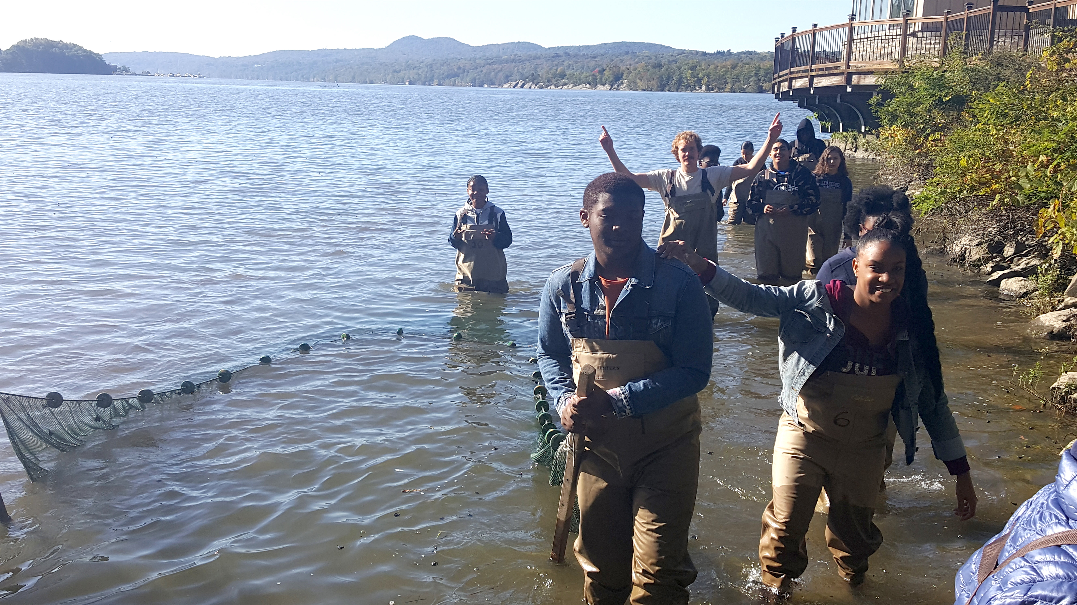
Location: Sampling done Norrie Cove and the SW corner of Norrie Point Env. Center Patio. East side of Hudson far from the main channel in a protected cove
Area: Substantial paved areas nearby, large environmental center building adjacent to the water. Shallow cove, facing south onto the HR, bordered by RR embankment, parking lot & the environmental center.
Surrounding Land Use: 90% Forested; 10% Parking lot, road and building
Sampling Site: Front banks altered, Rip Rap. Cove is very muddy with some riprap and west side is rocky
Shoreline: beach area, shore with bulkhead, shoreline rip rap, banks altered for EEC building, riprap along RR tracks, collected wood and debris in shallow cove, piping entering river area
Plants in area: All water chestnut had died back leaving only detritus; some water milfoil (several big patches 10X10 ft.; Some water celery in rocky river side but none in cove.
River Bottom –50% muddy and 50% rocky
Water Depth – 2 ft.

ITEM | Time | Reading 1 |  |  | Reading 2 | Comments
Physical | Time
Air Temperature | NR | °C |  |  | °F
Wind Speed | NR
Cloud Cover
Weather today
Weather recently | NR
Water Surface | NR
Water Temperature | AM |  | 20°C | 68°F
Turbidity | TIME |  | Cm
 | NR
Chemical
DO - (Hach drop count) | NR
pH – | Time |  | Reading #1 | Reading #2 |  | Average
 | NR
Salinity | Time |  | Chl-units | Chloride |  | Total Salinity
Quantabs | *Recorded as 1.6 ppm |  |  |  |  | *Refractometer
FISH Catch –
~50 ft. net
Alewife | 1 |  |  | DIV 10
American Shad | 1 |  |  | TOTALS 96
Herring (unidentified) | 50
Goldfish | 1
Golden Shiner | 1
Red breasted Sunfish | 1
Pumpkinseed | 15
Bluegill | 21
Largemouth Bass | 1
Tessellated Darter | 4
MACRO INVERT |  |  |  | DIV 1
Blue Crab | 1 |  |  | TOTALS 1
Tides | NR
Currents

