Day in the Life of the Hudson River 10/12/17 Data
RIVER MILE 87
(Salt Front ~ RM 65)
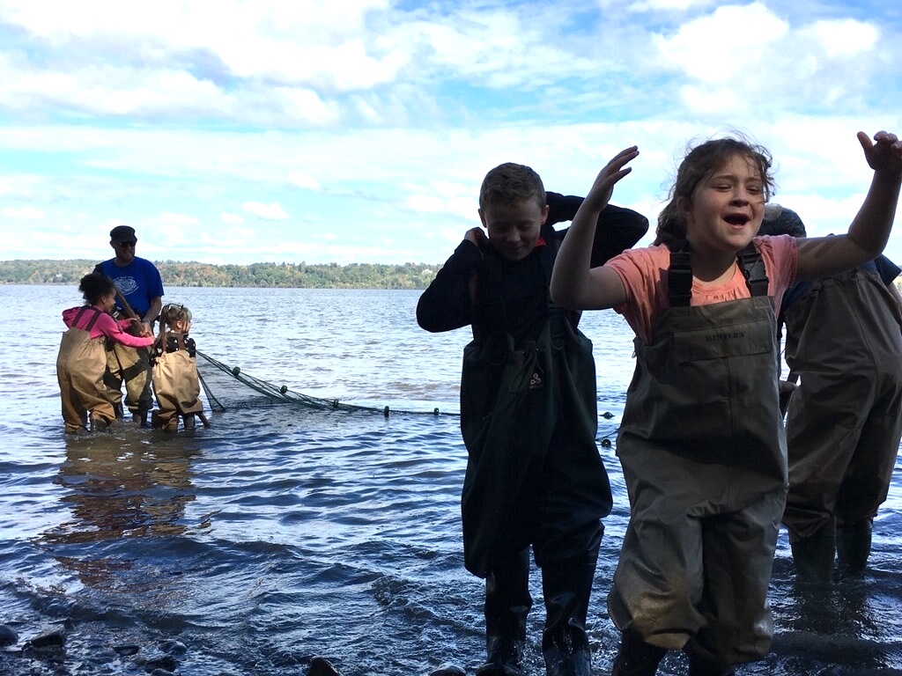
Eli Schloss & Esopus Meadows Environmental Center, Ulster Park, Ulster County
Donna Nageli, Robert Graves Elementary School – 4th grade – 45 students, 5 adults
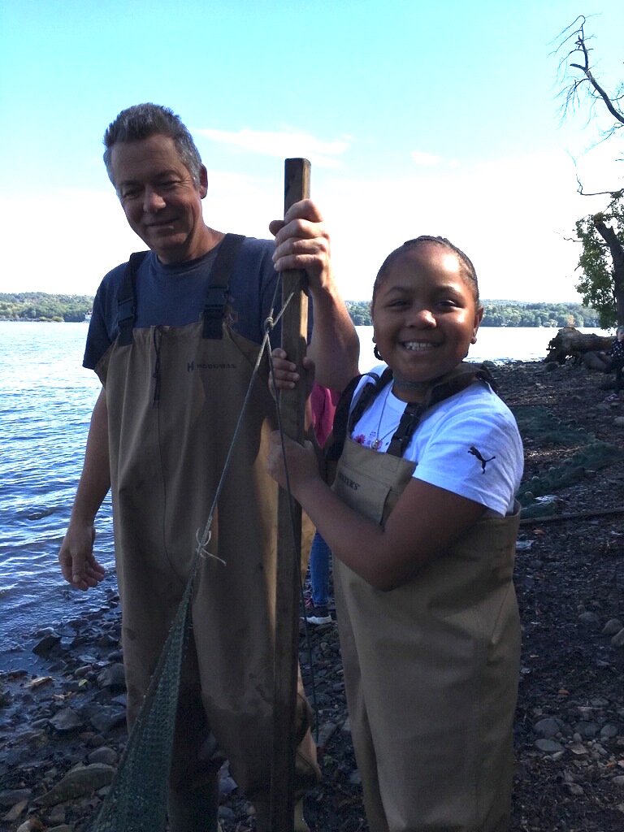 | 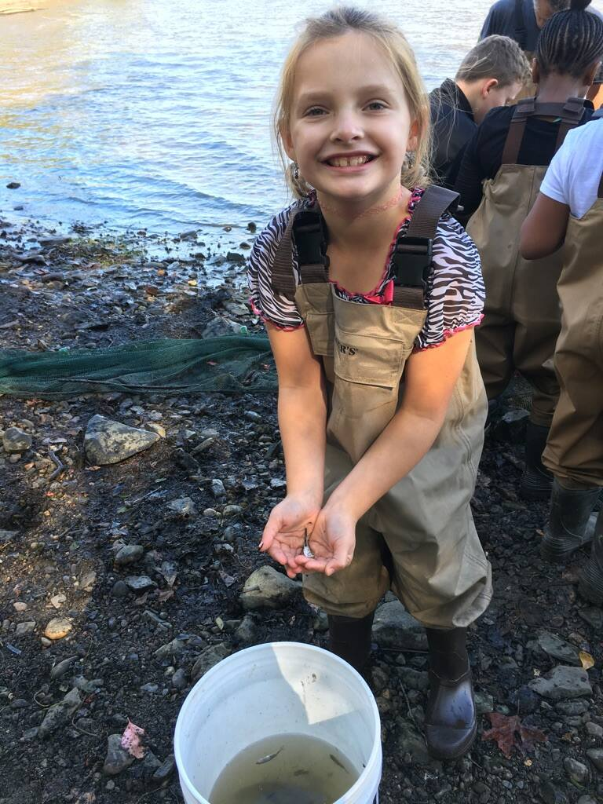
Location: Beach Lighthouse Park, Esopus Meadows Preserve Town of Esopus. Ulster County
Area: A path along the beach with rising forested hills
Surrounding Land Use: Forested 85%, Beach 10%, 5% other
Sampling Site: Rocky shallow, sloping beach area covered with vegetation
Water depth: 2 ft.
River Bottom –rocky & muddy
Plants in area:
ITEM | Time |  | Reading 1 | Reading 2 | Comments
Physical
Air Temperature | 10:28 AM |  | 16°C  61 °F
 | 10:38 AM |  | 16°C  61 °F
 | 12:16 PM |  | 16°C  62 °F
Wind Speed | 10:08 AM |  | Beaufort #1 |  | NE
Cloud Cover | 10:08 AM |  | Partly cloudy
Weather today | No rain
Weather recently | Very warm (mid 80s) and dry
Water Temperature | 10:20AM | 18°C  °F
Water | Calm
Turbidity -  Long Turbidity tube | 10:20 AM | 47 cm  45  45 |  | Average 46 cm
Chemical
DO  (drop count kit) | 11:57 AM | 7 mg/L |  | 18°C | >70%
pH  Indicator sol. | 10:20 AM | 7.5 X 3 |  | 7.5 average
Salinity | NR
Fish Catch  25 ft.X 4 ft. X ¼ inch mesh | Number Caught | Species |  | Seine  ~30 ft. pulls
 | 6 | Banded Killi |  |  | Fish Div. 10
 | 1 | Catfish |  |  | Fish Total 264
 | >200 | Herring
 | 13 | White Perch
 | 15 | Shiner
 | 4 | Bullhead
 | 9 | Spottail Shiner
 | 1 | Black Crappie
 | 6 | Sunfish
 | 9 | Striped Bass
Macrinvertebrates | 1 | Blue Crab M |  | Macro Div. 1 | Total 1
Tides | 10:08 AM | Falling
 | 10:38 AM | Falling
 | 11:13 AM | Falling
 | 12:16 PM | Falling
Currents | 10:08 AM | Ebb
 | 10:38 AM | Ebb
 | 11:13 AM | Ebb
 | 12:16 PM | Ebb
Traffic – commercial | 13:25 PM | Moran/ red |  | Light | Southbound

