Day in the Life of the Hudson River 10/12/17 Data
(Salt Front ~RM 65)
RIVER MILE 92
Kingston Point Park, Kingston, Ulster County
Julie Noble, KC Keegan-Twonbly, Forsyth Nature Center (Site Hosts)
Robert Graves School, 95 students, 3rd grade, 9 adults
GPS Latitude 41°55.48 N Longitude 73°57.55 W
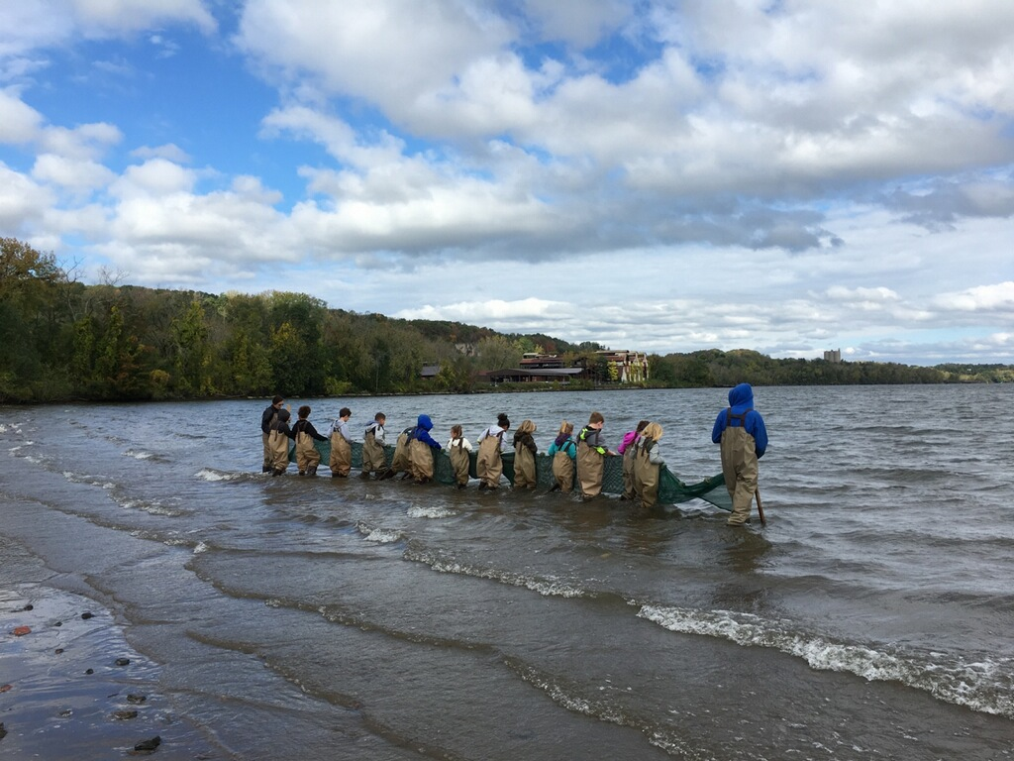 | 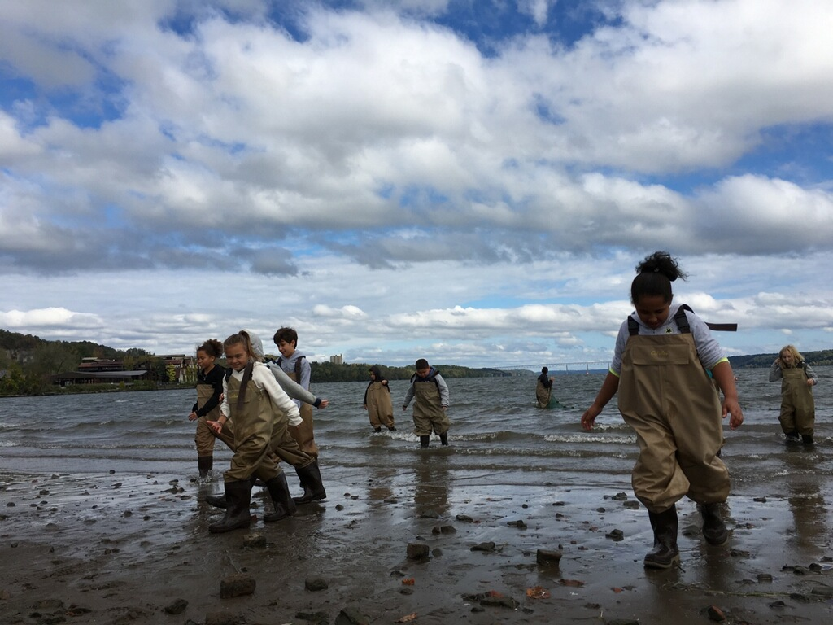
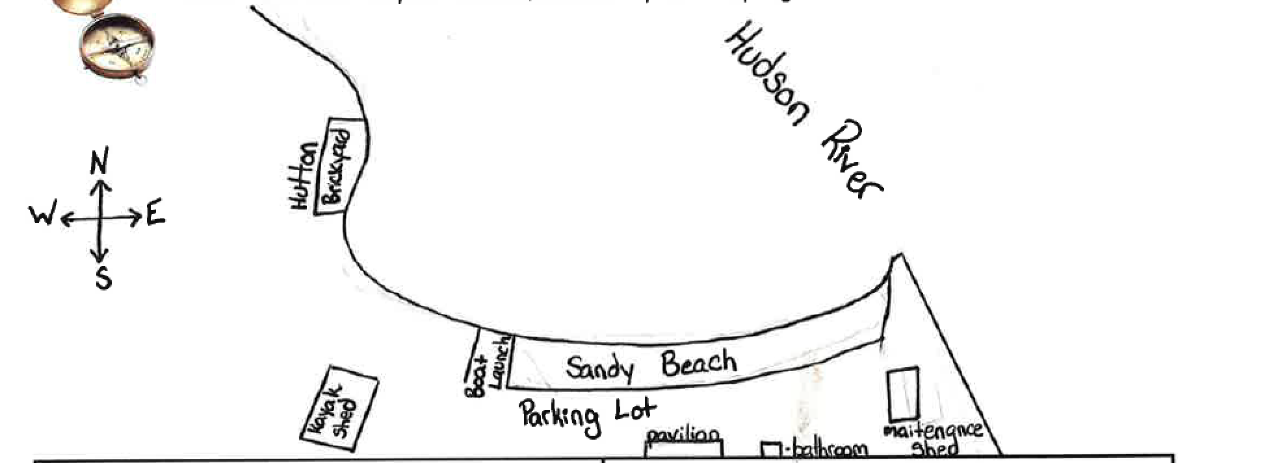
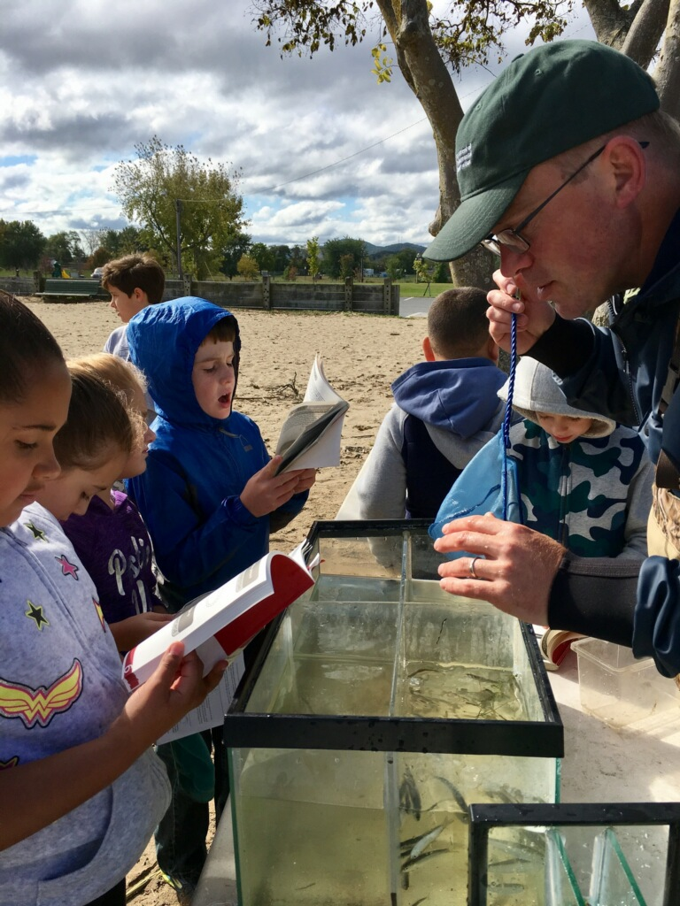
Location: Swimming Beach Kingston Point, City of Kingston, forested, beach and parking lot
Area:, Used for picnics, boating, fishing, swimming, jogging, kayaking
Surrounding Land Use: 5% forested; 85% beach; 10% Industrial/Commercial
Sampling Site: Beach area - shoreline is sandy with some bricks, banks are altered, collected wood debris in the area, rip rap to north along brickyard shoreline. Sandy shoreline 75 feet from shoreline to parking lot, 200 feet wide with boat launch, large amount of brick debris from prior industry
Plants in area: All found on shore - duckweed, spatterdock, water chestnut, water celery, milfoil, walnuts, acorns, hickory nuts,
Water depth: 0.4 depth
River Bottom : sandy
Water Surface: Choppy

ITEM | Time |  |  | Reading 1 |  | Reading 2 | Comments
Physical
Air Temperature | 10:30 AM  11:15 AM  12:40 PM |  |  | 56°F  58  56 |  | °C
Wind Speed | 11:17 AM |  |  | #4 Beaufort |  | N
Cloud Cover | 12:50 PM |  |  | Partly cloudy 26-50% cover
Weather today | Clouds and wind
Weather recently | Rain two days prior
Turbidity – long site tube | 45 cm
Water Temperature | Time  10:45 AM | Temperature  20 °C |  |  |  | Temperature | Average
Chemical
DO  Test tabs | NR |  |  |  |  | C
pH – test strips | 11:15 AM | 6.5
Salinity - Quantab | 1:15 PM | 1.005 - 1.4 quantab units |  |  |  | 32 ppm Cl- | 58 ppm Total Salinity
Fish Catch  30’seine X 4 ft. with bag – 20 ft haul | Number Caught- 15 | Species - 2 |  |  |  | Largest Size
10:15 AM to 12:15 PM | 38 | Spottail Shiner |  |  |  | 5 cm
 | 18 | Striped Bass |  |  |  | 8 cm
 | 154 | Herring |  |  |  | 10 cm
 | 5 | Banded Killifish |  |  |  | 5 cm
DIVERSITY | 4 | TOTAL CATCH |  |  |  | 215
Tides
Currents | 10:30 AM  11:00 AM  12:30 AM | ebb  Ebb  ebb
Core Sample | Description | Rare |  |  |  | Common | Abundant
In 2 ft. water | 15 cm | Coal |  |  |  | Brick | Sand
Traffic – Recreational | 12:40 PM |  |  |  |  | White | North
Other Items | 10:30 AM Ring Billed Gulls (35)  12:30 3 swans
Zebra mussel shells
1/3 of beach had broken brick parts
½ had water chestnut seeds
few broken shells

