Day in the Life of the Hudson River 10/12/17 Data
(Salt Front ~RM65)
RIVER MILE 97
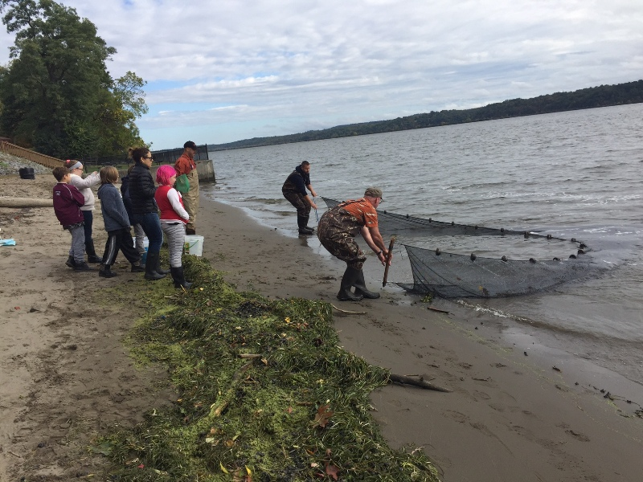
Sojourner Truth/Ulster Landing State Park, Town of Ulster, Ulster Co.
Latitude 42°N, Longitude 73°56’W
Stephen Hart, Mill Road Elementary School 4th graders – 44 students, 12 adults
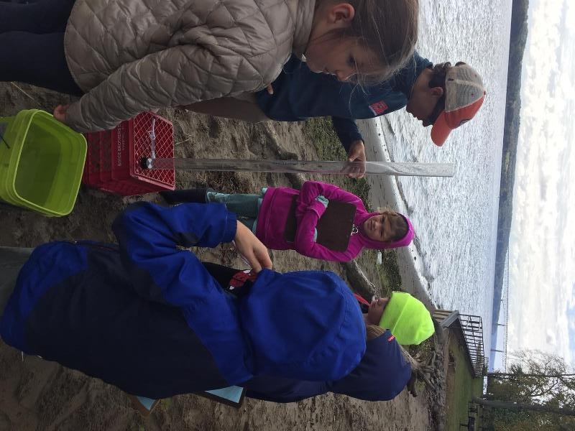 | 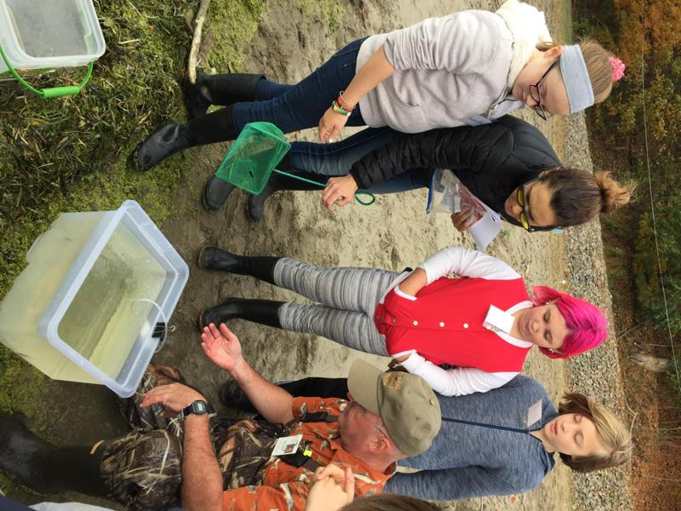 | 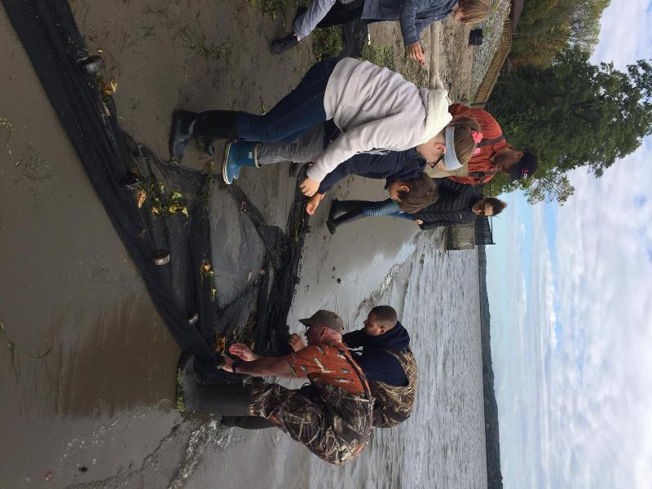

Location: Swimming beach, Sojourner Truth/Ulster Landing Park, Town of Ulster, Ulster County
Area: fishing, swimming beach, has a building with restrooms
Surrounding Land Use: Beach 5%; Forested area 90%; parkland with grass and picnic area 5%
Sampling Site: beach, altered bank with concrete bulkhead, wood debris driftwood, slag and brick in the area, drainage from bulkhead north of site immediately
River Bottom: sandy at the edge then very muddy
Site Sample Times 9:30AM-12:30 PM
ITEM | Time |  | Reading 1 | Reading 2 | Comments
Physical
Air Temperature | AM |  | 15.5°C  60 °F
Wind Speed | NR
Cloud Cover | NR
Weather today
Weather recently | Warm and dry
Water Temperature | AM | 18°C  65°F
Turbidity | AM | 70 cm
Fish Catch - seine | Species - | Number |  | Length of largest | Diversity & Totals
3 seines | Striped Bass | 10 |  | 8 cm | Diversity - 5
 | Spottail Shiner | 7 |  | 8 cm | Total - 59
 | Herring | 30 |  | 13 cm
 | Banded Killifish | 12 |  | 5 cm
Tides | Dropped 21 inches/53.3 cms in 3 hrs.

