Day in the Life of the Hudson River 10/12/17 Data
Salt Front RM 83)
RIVER MILE 9
Pier 125
N 40, W-73
Diane Lennon, Columbia Secondary School, 35 students 12th grade college environmental class, 1 adults
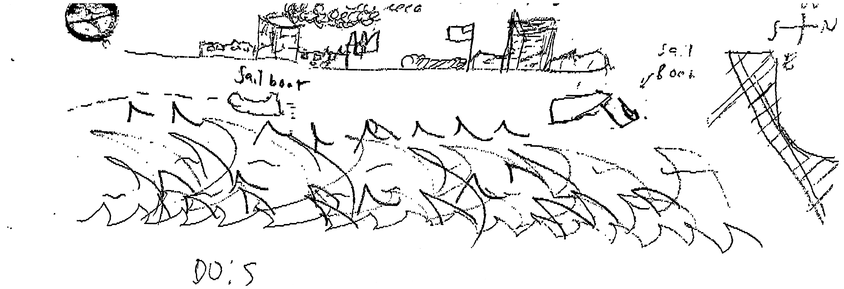
Location: Pier 125, is a pier used for boating and fishing
Area: Pier – made of concrete.
Surrounding Land Use: 100% Urban/Residential
Sampling Site: on a pier, see gulls
Plants in area: no plants in the water area
Water: Calm; mud, sand, weeds, and rocks at bottom

ITEM | Time |  | Readings
Physical
Air Temperature | 1:55  2:00  2:02 |  | 67.8ºF  68.1  67.9 | 19.9ºC  20  19.9
Wind Speed |  |  | 7mph | NW
Cloud Cover | 1:50 PM |  | Overcast | >75%
Weather today | Light showers
Weather recently | Rain
Water Temperature  (measured at 1.1m) | 1:43  1:45  1:50 | 17ºC, 15ºC  20,19  22,20 |  | Average: 16ºC  19.5  21

Turbidity  (Secchi disk, cm) | 1:30 | 115.24 cm  110.16  120.32 | The water is slightly turbid. It takes about 100cm to not be able to see the secchi disk. We tested in different areas so that we could see how light penetration can affect the turbidity and get more accurate results. However, we found that even in more sunlight, the turbidity did not create an outlier.
Chemical | Time | ppm | Temp | % Sat
DO | 1:24  1:48 | 6.6  5 | 15ºC  15 | 65% -  50%
pH  color match kit | 1:25 | 7, 7.5, 7 | Average: 7.2
Salinity – hydrometer | 1:36  1:42  1:48 | TS (ppt)  20, 19, 20  20, 20, 20  20, 20, 20
Nitrates  (nitrate tablets) | 2:05 | 0 ppm
Phosphates | 1:30 | 0.5, 0.5, 0.5
Alkalinity  (Direct reading titrator) | 1:35 | 1000, 1000, 1000 (ppm)
Tides - water depth
Currents | Time  1:45  1:52 | cm/30 sec | Cm/sec  43.33  26.02 | Ebb/Flood/still  Still  Still  Still
Shipping – Commercial | 1:52 | Black | Stationary, south of GWB | Loaded
Shipping Recreational | 1:30 | White sailboat | Both directions
Observations | We are on a pier, there are gulls.

