Snapshot Day 10/12/17
(Salt front ~RM 65)
RIVER MILE 13
Bloomers Beach @ Engelwood Boat Basin
Natalie Macke – Pascack Hills High School AP Environmental Science Students
13 students, 11-12th graders
N40.881383 -W73.943899
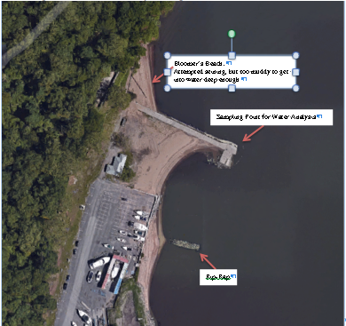
Location: Bloomers Beach – north end
Area: sandy beach, banks altered, pier with rip rap sections, wood bulkhead, forested area behind, with parking lot in front. Collected wood/debris in area, piping approx. 30” located at sampling site, 2 concrete bulkhead and stone breakwaters as well as on shoreline,
Surrounding Land Use: 25% forested; 25% beach; 50% Industrial/commercial
Shoreline: Loamy sand – sandy and muddy
Bottom: Muddy
Plants in area: none in the water

ITEM | Time |  | Reading 1 | Reading 2 | Comments
Physical
Air Temperature | 9:32 AM  9:57 AM |  | 11.7°C  11.1 | 55°F  52
Wind Speed | 9:36 AM |  | Beaufort #5 | 5.7 m/s | SW
Cloud Cover | 9:40 mostly overcast
Weather today | A little rain in the morning
Weather recently | Dry and warm until yesterday, then some rain
Water | Choppy
Water Temperature | 9:33 AM  10:07 AM  10:12 AM | 22°C  22°C  20°C |  | °F  °F  °F
Turbidity – long site tube | 9:35 AM | 5.5 cm  6.1 cm  5.1 cm |  | 5.567 cm
Description | Yes the water was very turbid. It was very murky. There was barely any water before we could see the bottom.
Chemical |  |  |  | Water | Saturation
DO –drop count | 9:33 AM  10:07 AM  10:12 AM | 8.4 mg/L  7.65 mg/L  7.12 mg/L |  | 22°C  22°C  20°C | 95%  75%  85%
pH – litmus paper | NR
Salinity (refractometer) | 9:33 AM | 20 ppt
Fish Catch | Count | Fish |  | Size of largest | Macros
Tides | NR
Currents  9:46 AM | 1097/30secs | 37cm/sec |  | 0.72 kts | South/ebb
Core –  9:33 AM | Length:  3 inches | Other:  No Scent  No oil |  | Common:  Sand  Pebbles | abundant:  Clay,  Mud,  Gravel
Location of core N40.881338 -W73.944172
Commercial Boat Traffic | 9:36 AM | Ferry – Red |  | SW | Loaded
Recreational Traffic | 9:36 AM | Sailboat – white |  | SW | Light
Other Observations | Seagull  Dog | Artificial shoreline & Pier/dock area could affect data

