Day in the Life of the Hudson River 10/12/17 Data
(Saltfront ~ RM 65)
RIVER MILE: ER 13.7
Frances Lewis Park, Queens, NY
Mirela Shpuza-Shurdha
International HS for Health Sciences
30 students– 10th grade, Living Environment 10 adults total
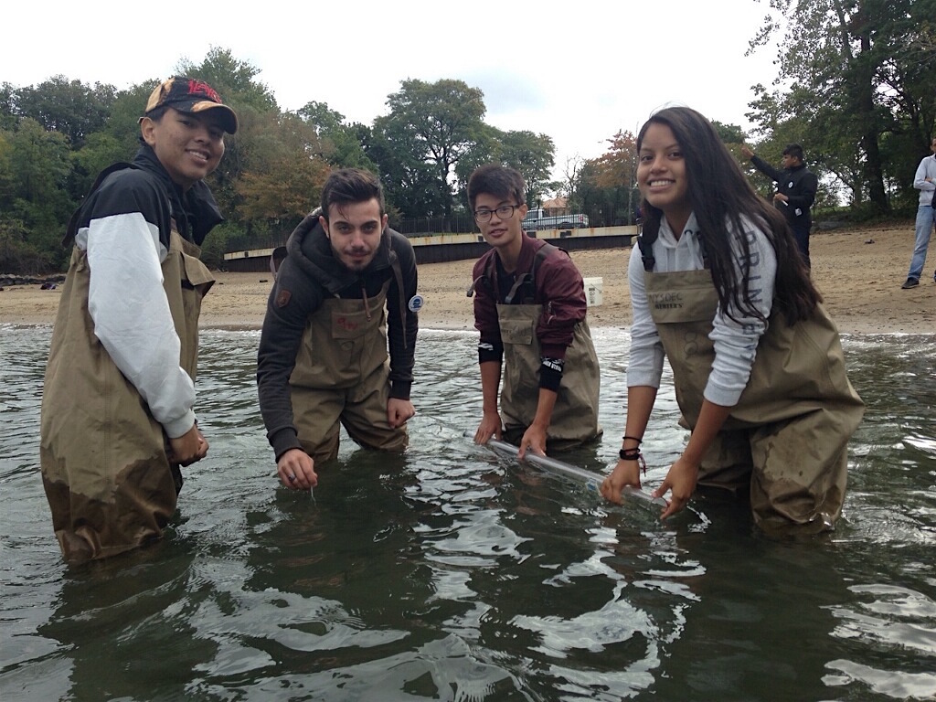 | 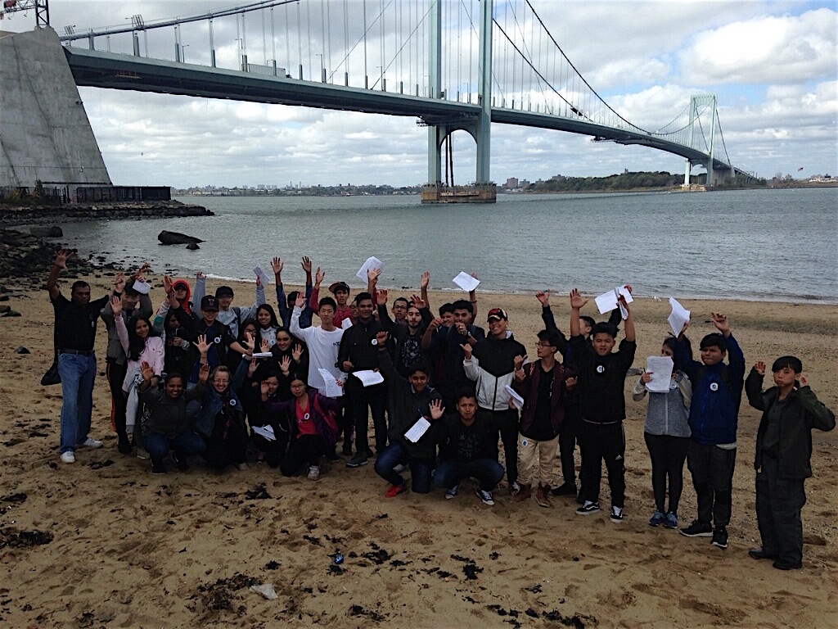 | 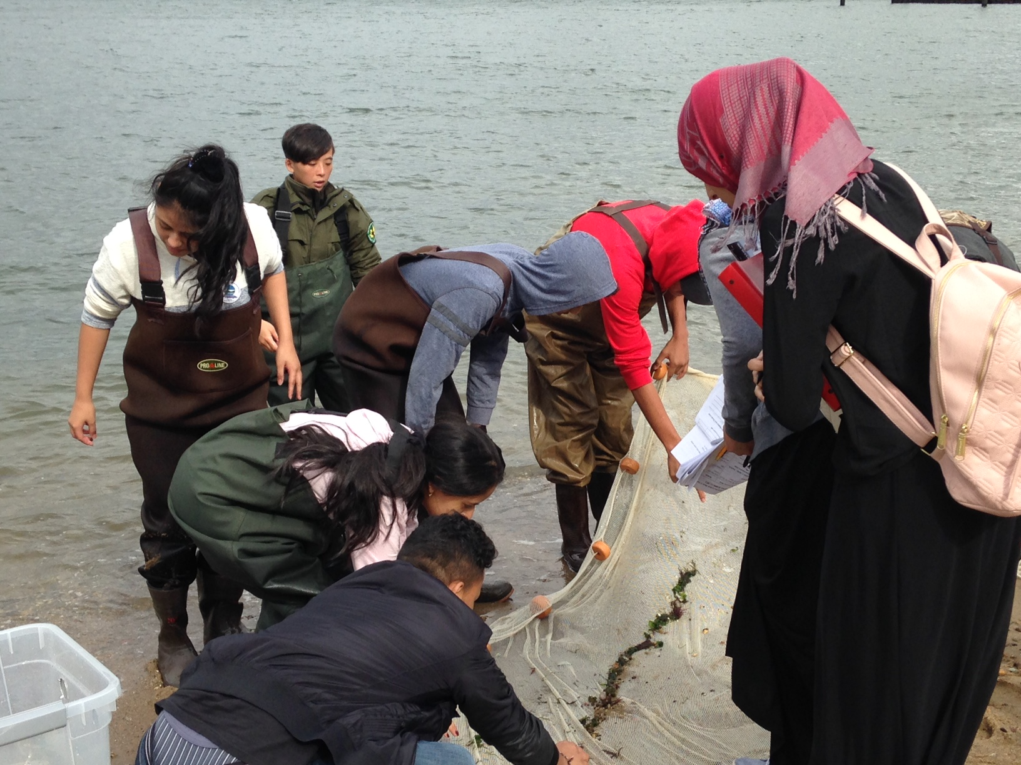

Mirela and her students reflect the incredible international diversity of their school. Her 30 students, all recent arrivals to the United States, were from Honduras, Dominican Republic, Guatemala, Haiti, Columbia, Ecuador, Yemen, Iran, Bhutan, Bangladesh, India, Nepal, Laos, China and the Philippines. Their faculty were from Guyana, Dominican Republic, and Albania.
40.79N, 73.82W
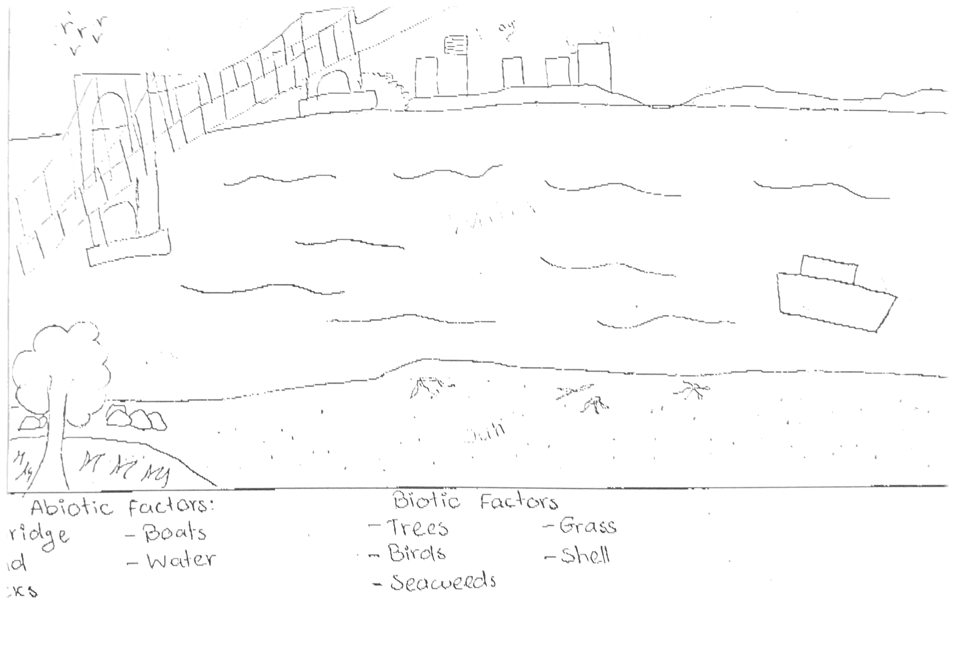

Location: Frances Lewis Park in Queens
Area: Forested and grassy near site, pier
Surrounding Land Use: Forested and beach
Sampling Site: Park area
Shoreline: Sandy, rocky, beach
Plants in area: none
Water: Choppy
River Bottom description: muddy

 | Time | Reading 1 | Reading 2 | Comments
Physical
Air Temperature | 10:50  11:20  12:10 | 16ºC  16ºC  16ºC
Wind Speed | 10:50  11:20  12:10 | 13-18mph  8-12mph  13-18mph
Cloud Cover | Mostly Cloudy
Weather today | Cloudy, windy, cold
Weather past 3 | Breezy, sunny, cool
Water Temperature | 10:50  11:20  12:10 | 16ºC  20ºC  18ºC | 60.08ºF
Turbidity –  long site tube | 10:50  11:20  12:10 | 60cm  47cm  60cm
Chemical | Time | Water Temp | ppm | Method
pH – indicator solution | 10:34  10:41  10:55  11:15  11:15  12:14  12:25 | 15ºC  16  15  10.5  10  20  16 | 6  8  6  5.5  8  6  8 | Hydrion paper  Wide range pH kit  Hyrdion  Hydrion  Wide range  Hydrion  Wide range
Salinity - | 10:34  10:41  11:15  11:15  12:14  12:25 | 15ºC  16  10.5  10  20  16 | 30ppt  30  38  30  30  30 | hydrometer
DO - | 10:34  11:15  12:14 | 15ºC  10.5  20 | 3.7mg/L  7.6mg/L  8.2mg/L | Method: LaMotte kit
Fish Catch – 10 ft. net | Number | Species | description
Fish - 11:05 AM  DIV - 1  TOTAL - 15 | 15-20 | Atlantic Silverside | silver, shiny, slimy, long body, small
Macro | 1 | Shrimp | Small, transparent, it can jump, hard to see
DIV - 2  TOTAL - 3 | 2 | Shell (hermit) crabs | Small, pointy shell, hide and live in the shell
 | DIV 3 | TOTAL | 202
Currents | Time | Cm/30 secs | Cm/sec | Direction
 | 11:20 am | 635 cm/30 sec | 21.2 cm/sec | Westward
Boat Traffic | 10:20 | -White boat  -1 Red, white, black, Speedboat  -3 white speedboats  -1 white speed boat  -Large black boat | Not moving  Fast moving  Not moving  -North bound | Light  Light  Light  Loaded
Other | Lots of birds flying around and ducks.

