Snapshot Day 10/12/17 Data
Mohawk River Valley
SCHOHARIE CREEK SITE RIVER MILE
Middleburgh, NY
Mollie Burgett, Middleburgh High School & 14 students 11/12th grade
42.599109 Lat and -74.331429 Long
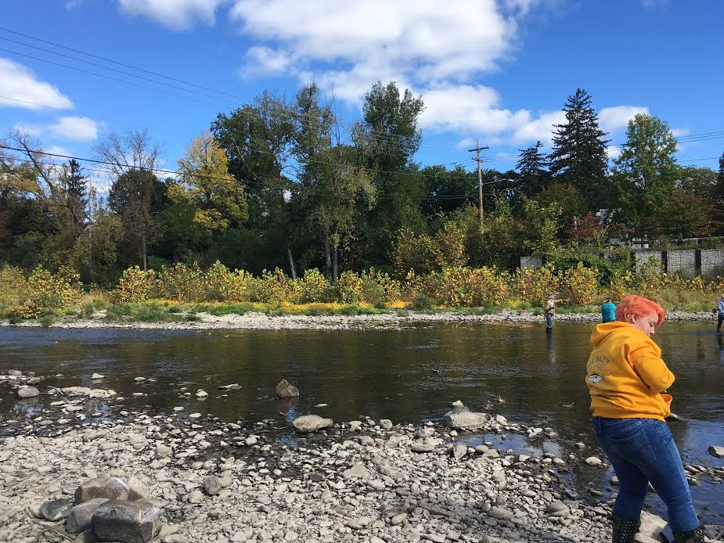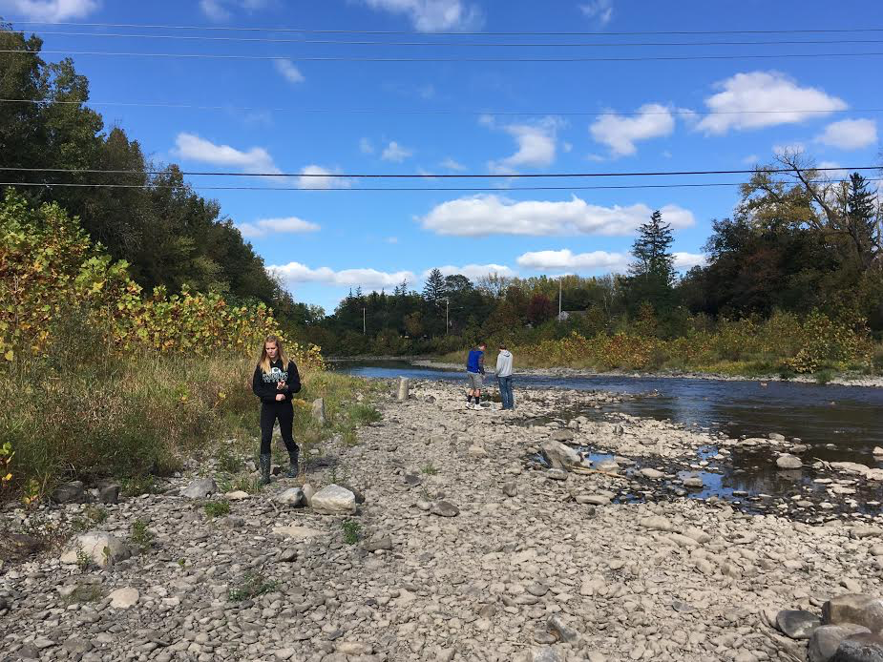

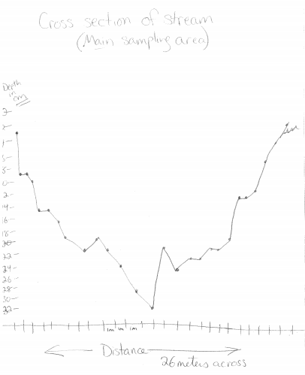
Location: On the Schoharie Creek, creek access point is north of Timothy Murphy Park Middleburgh, Schoharie County
Sample location runs right along river street (one of the main streets in the village) and is
full of cobbles, some grasses and short shrubs under 4 feet tall. The trees along the bank on one side make a break between the road and the creek and the other side divide the creek from farm fields.
Surrounding Land Use: 20% urban/residential, 20% forested, 30% beach, 10% Industrial/Commercial, 20% Agriculture
Shoreline: Rocky beach area, covered with vegetation, Strom drain outflow south of sampling, 200ft.
River Bottom: Rocky
Water Depth: 0-4ft
Water Conditions: Calm
Plants in water: no

ITEM | Time | Reading 1 | Reading 2 | Comments
Physical
Air Temperature | 12:50 PM  1:55 PM | 20ºC  20
Wind Speed |  | Beaufort 1.75 | South
Weather today | Started partly cloudy. It got sunny/no clouds as the day progressed, around 2:00 PM
Weather recently | Rain yesterday, partly cloudy 2+3 days ago. Mid 60’s
Water Temperature | 1:15 PM  1:38 PM  2:00 PM  2:15 PM | 15ºC  15  15  15
Turbidity - Secchi disk |  | 47 cm
Chemical
DO – drop count | Time | Temp | ppm DO | % saturation
 | 2:15 | 15ºC | 14.6ppm | 145%
Note: I would not use our numbers since our kits are so old
pH – test strips | 1:15  2:10 PM | 6, 7  7.6 | Avg:6.8
Nitrates | 2:00  2:15 | 0 ppm NO₃⁻  2
Current | Cm/sec | Area
 | 29.3  0.36  30.77 | Main part of stream  Riffle  Main part of stream
Fish | Number | Name | Length of longest
An attempt at Seining was made (once, 20ft net, 100ft pull) but it only resulted in crayfish. Two DEC staff however ran 2 electroshock runs (one that lasted 20-30 minutes + another that lasted 5 minutes) which is where the fish results came from. | 1  2  2  1  2  2  1  2  1 | Rock Bass  Rainbow Darter  Green Sided Darter  Long Nose Dace  Small Mouth Bass  Hog nose  Spottail Shiner  Central Stone Roller  Fall Fish | 17cm  7  9  11  19  18  4  14  5
Fish Totals | DIV 9 | TOTAL 14
Macroinvertebrates | Number | Species
 | 3  6  68  13  8 | Hellgramite  Caddisfly Larvae  Mayfly Larvae  Stonefly Larvae  Fishfly Larvae
 | DIV 5 | TOTAL 98

