Day in the Life of the Hudson River 10/16/18 Data
CONCRETE PLANT PARK, BRONX, RIVER MILE: 4.5 (Bronx River)
Salt Front: ~RM 24
Bronx Center for Science & Mathematics- Patrick Callahan
28 students 11th-12th grade AP Environmental Science, 2 adults
Bronx River Alliance- Katie Lamboy & Michelle Luibke
Latitude 40.826677 N & Longitude – 73.884901 W
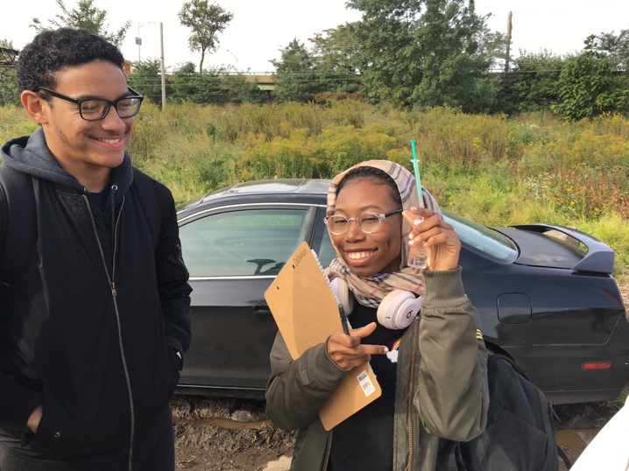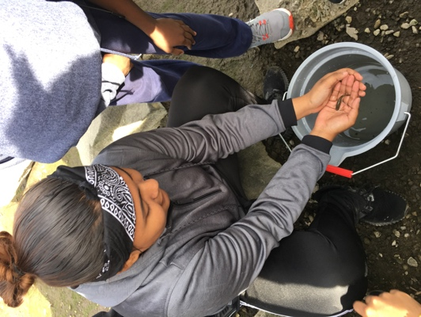
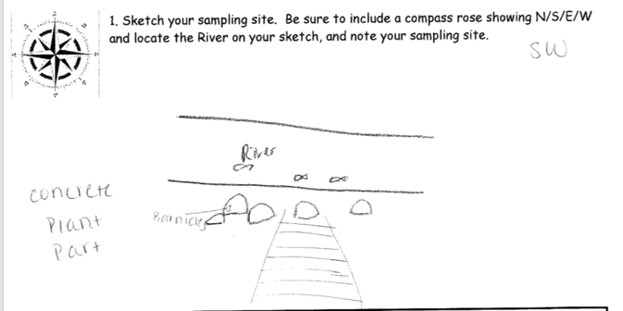
Location: Concrete Plant Park, Bronx River, NY
Area: Grassy
Surrounding Land Use: 100% Urban/Residential
Shoreline: 80% Muddy; 19% Rocky; 1% Sandy; Riprap
River Bottom: Muddy, sandy
Water: Choppy
Plants: No plants in water area.
Sampling Time: 9:00-2:00PM
ITEM |  | Time | Reading |  | Comments
Physical
Air Temperature: |  | 10:08 AM  10:09 AM  10:10 AM  11:00 AM  12:25 PM | 15 º C  13 º C  10 º C  8 º C  15 º C | 59 º F  55.4 º F  50 º F  46.4 º F  59 º F | *doubt temp changes every min.  <- Seems low
Wind Speed: |  | 11:21 AM  NR  1:30 PM | NR  13 mph  13 mph | Southwest  Southwest  Northwest
Weather Today: |  | No rain, partly cloudy (26-50%), clear by the end of the day
Weather Previous: |  | Rainfall, cold weather, low temperatures, high winds
Water Temperature |  | 10:00 AM-  10:30 AM  11:00 AM | 15 º C  Avg: 12.8 º C  15 º C | 59 º F  Avg: 55.04 º F  59 º F
Turbidity- long sight tube |  | NR  9:50-9:59  10:01 AM  10:20 AM | Avg: 56.6 cm  Avg: 51.6 cm  Avg: 35.5 cm  Avg: 18.8 cm
Chemical
Salinity- hydrometer |  | 10:00 AM  10:30 AM  11:00 AM | 6.8 ppt  6.8 ppt  6.8 ppt
DO – drop count kit  *Temp doesn’t match other water temps above for the same time & DO also seem low but Katie noted dumping in the area which has impacted the water DO and pH |  | Time | Temp | ppm DO | % saturation
 |  | 11:30 AM  1:30 PM | *7 º C (expect closer to 15 ºC)  21 º C | 5  6.5 | 40  65
pH - color match kit  Colormetric  NR |  | 10:10 AM  10:12 AM  10:14 AM  10:16 AM  NR  11:00 AM | 7, 7.5, 7  7, 7.5, 7.5  6.5, 6.5, 7  8.5, 8.5, 8  Avg: 5.67  Avg: 6.78 | <- seem low
Fish – Seine |  | Number | Name | Length of longest
 |  | 1  2 | Mummichog  Banded Killifish | 3 in  2 in
 |  | TOTAL: 3 | Diversity: 2
Boats | Time | Name | Color | North/ South | Loaded/ Light
Recreational  Recreational | 12:50  1:30 | Canoe  Canoe | Yellow  Green | Southbound  Southbound | Light  Light
Other Observations |  | Clam shells, bits of rock, a pipe, bridge, trash: lighters/cans/bottles/plastic bags

