Day in the Life of the Hudson River 10/16/18 Data
FERRY POINT PARK, BRONX
RIVER MILE: 13.5 (East River)
Salt Front: ~RM 24
Renaissance High School of Musical Theater and the Arts- Linda Ewool
16 students 9th-11th grade, Living Environment/Chemistry, 2 adults
NY DEC- Chris Bowser and Team
Latitude 40.804873 N & Longitude – 73.832189 W
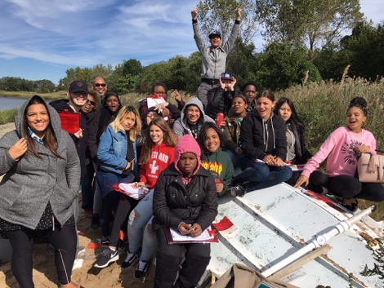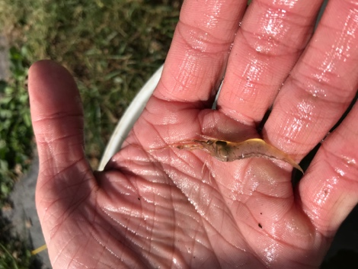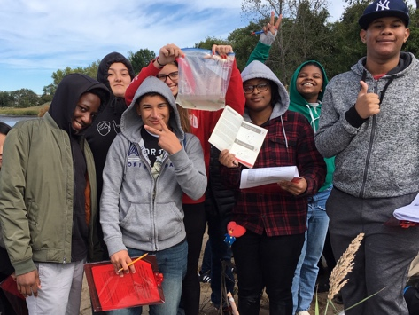
Location: Ferry Point Park beach, Bronx, NY
Area: Below the Bronx-Whitestone Bridge across the East River. Mostly used for boating and fishing. Pier with grassy area and parking lot. Large park area used for picnics and sports with spartina covered marsh along the water and forested beyond.
Surrounding Land Use: 50% Forested; 50% Beach
Sample Site: Sandy beach, tidal marsh area covered with dense spartina
Shoreline: 65% Beach; 35% Covered in vegetation
River Bottom: Muddy
Water: Calm
Plants: 30% Reed Grass
ITEM | Time | Reading |  | Comments
Physical
Air Temperature: | 12:23 PM | 13 º C | 55.4 º F
Wind Speed: | 10:40 AM | Beaufort: 3 | 12 mph | North
Weather Today: | Noon: Mostly cloudy (51-75%), no rain
Weather Previous: | Small amounts of rain October 13th and 15th
Currents Flow- | Cm/second | Knots | North/South | Ebb/Flood/Still
10:45 AM | 15.5 | 0.301 | North | Flood
Water Temperature | 12:25 PM | 16 º C | 60.8 º F
Turbidity- | NR
Chemical
Salinity- hydrometer | 12:39 PM  12:41 PM | 24 ppt  21 ppt
DO – NR | Time | Temp | ppm DO | % saturation
pH- meter | 12:34 PM | 8,  8.3,  7.4
Fish – Seine  30 foot net  11:15 AM | Number | Name | Length of longest
Fish – Seine  30 foot net  11:15 AM | 3  3  1 | Striped Killifish  Mummichog  Atlantic Silverside | 4 in  2.5 in  3 in
Fish – Seine  30 foot net  11:15 AM | TOTAL: 7 | Diversity: 3
Macroinvertebrates-  Seine | Number | Name | Length of longest
Macroinvertebrates-  Seine | 50+  3 | Blue Crab  Shrimp
Macroinvertebrates-  Seine | TOTAL: 53+ | Diversity: 2

