Day in the Life of the Hudson River 10/16/18 Data
FERRY POINT PARK, BRONX
RIVER MILE: 13.5 (East River)
Salt Front: ~RM 24
West Bronx Academy for the Future- Bethany Rigging-Walio Amadou & Meg Stewart
45 students 9th-10th grade, 2+ adults
NY DEC- Chris Bowser and Team
Latitude 40.804873 N & Longitude – 73.832189 W
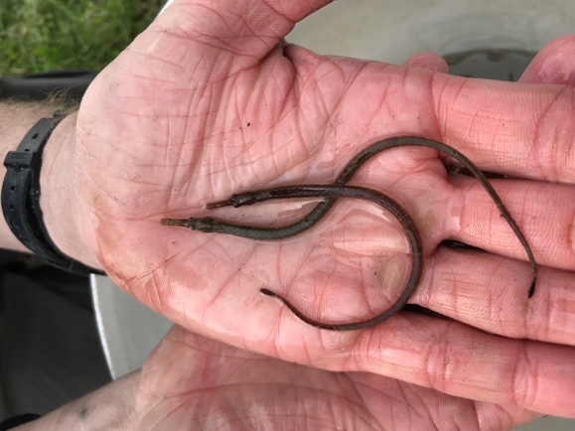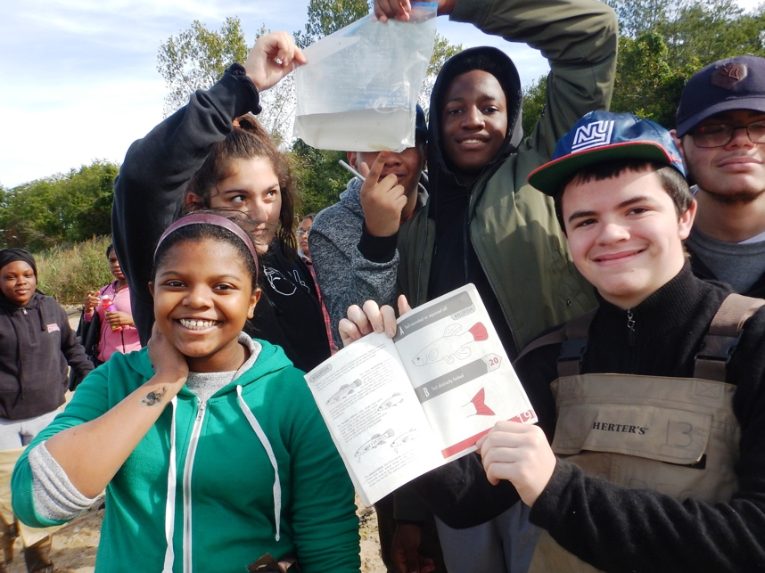
Location: Ferry Point Park beach, Bronx, NY
Area: Below the Bronx-Whitestone Bridge across the East River. Mostly used for boating and fishing. Pier with grassy area and parking lot. Large park area used for picnics and sports with spartina covered marsh along the water and forested beyond.
Surrounding Land Use: 50% Forested; 50% Beach
Sample Site: Sandy beach, tidal marsh area covered with dense spartina
Shoreline: 25% Sandy; 50% Muddy; 25% Rocky
River Bottom: Muddy
Water: Slightly choppy; ~30 cm depth
Plants: algae
ITEM | Time | Reading |  | Comments
Physical
Air Temperature: | 10:57 AM  11:45 AM | 11.56º C  11.11º C | 52.8 º F  52 º F
Wind Speed: | 10:57 AM  11:40 AM | 8 mph | 6.7 knots | South  North
Weather Today: | No rain, partly cloudy (26-50%)
Weather Previous:
Water Temperature | 11:15 AM  11:41 AM  11:43 AM  11:45 AM | 16.7º C  15.9º C  16º C  15.3º C | 62.06º F  60.62º F  60.8º F  59.54º F
Turbidity- long sight tube | 10:55 AM | 2 cm,  4 cm |  | *very low vis. potentially stirred up water before measurement
Chemical
Salinity- hydrometer | 11:45 AM  11:49 AM  11:51 AM | 16.3 ppt  15.4 ppt  15.3 ppt
DO – Hach drop kit | Time | Temp | ppm DO | % saturation
DO – Hach drop kit | Unable to obtain
pH- color match kit | 11:12 AM | 8.5 |  | *Estuary wide kit is low resolution
Nitrates- estuary kit | 12:01 PM  12:02 PM  NR | 4 ppm  2 ppm  5 ppm |  | *Estuary wide kit is low resolution
Phosphates- estuary kit | NR | 1 ppm |  | *Estuary wide kit is low resolution
Fish – Seine  25 foot net  11:30 AM | Number | Name | Length of longest
Fish – Seine  25 foot net  11:30 AM | 150  20  4  1  6 | Atlantic Silverside  Striped Killifish  Mummichog  Striped Bass  Northern Pipefish | 4 in  3 in  2 in  3 in  4 in
Fish – Seine  25 foot net  11:30 AM | TOTAL: 177 | Diversity: 5
Macroinvertebrates-  Seine | Number | Name | Length of longest
Macroinvertebrates-  Seine | 100+  60 | Shore Shrimp  Blue Crab | 1 in  2 in
Macroinvertebrates-  Seine | TOTAL: 100+ | Diversity: 2
Sediment core | Length | Oxid Top | Grain Size | Other Notes
 | 18 cm | NO | Common: mud, sand  Rare: Gravel | Sulfur smell
Other Observations | Shell pieces and full shells; pebbles; two white swans

