Day in the Life of the Hudson River 10/16/18 Data
Freshwater Feed to the Hudson River
HOOSICK RIVER,
Hoosick Falls NY
RIVER MILE: (Hoosick) 28.7
Deb Mabey, Hoosick Falls High School, AP SUNY ESF Env. Science class 7 students
Doug Reed, Hudson Basin River Watch
42.902092 Lat and -73.351249 Long
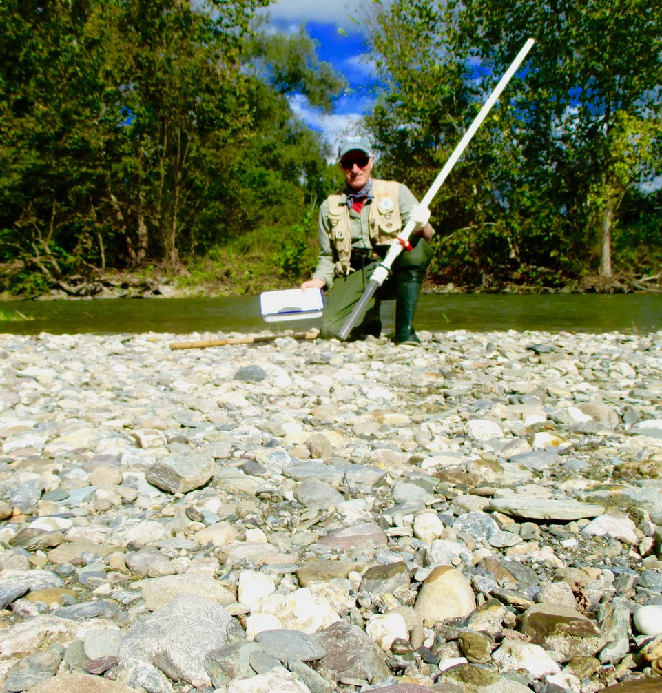
Location: Hoosick River, Hoosick Falls, Rensselaer County, NY
Area: Tributary River to the Hudson
Surrounding Land Use: Farms on the right side of the river, road on the left side of the river.
ITEM | TIME:  12:00-1:30PM |  |  | COMMENTS
Physical
Air Temperature | 16°C | 60.8°F
Weather | Partly cloudy & Windy | 25% Cloud cover
Turbidity |  |  |  | Observed medium turbidity
Chemistry | Tested positive for Nitrate, Ammonia, Hard Water, Sulfate.  Tested negative for Iron, Phosphate, Chloride, Chlorine.
Water Temperature | 12°C | 53.6°F
Dissolved Oxygen | 11 ppm | 103%
pH | 8
Fish | N/A
Current | 14.24 m/second | 1424 cm/second | 27.7 knots

