Day in the Life of the Hudson River 10/16/18
Steeplechase Pier, Coney Island, Brooklyn NY
RIVER MILE -9.1
Salt Front ~RM 24
IS 240 Magnet School of STEM- Deborah Sarria
46 students 6th– 8th grade, 4 adults
Latitude 40.571754 N & Longitude – 73.983712 W
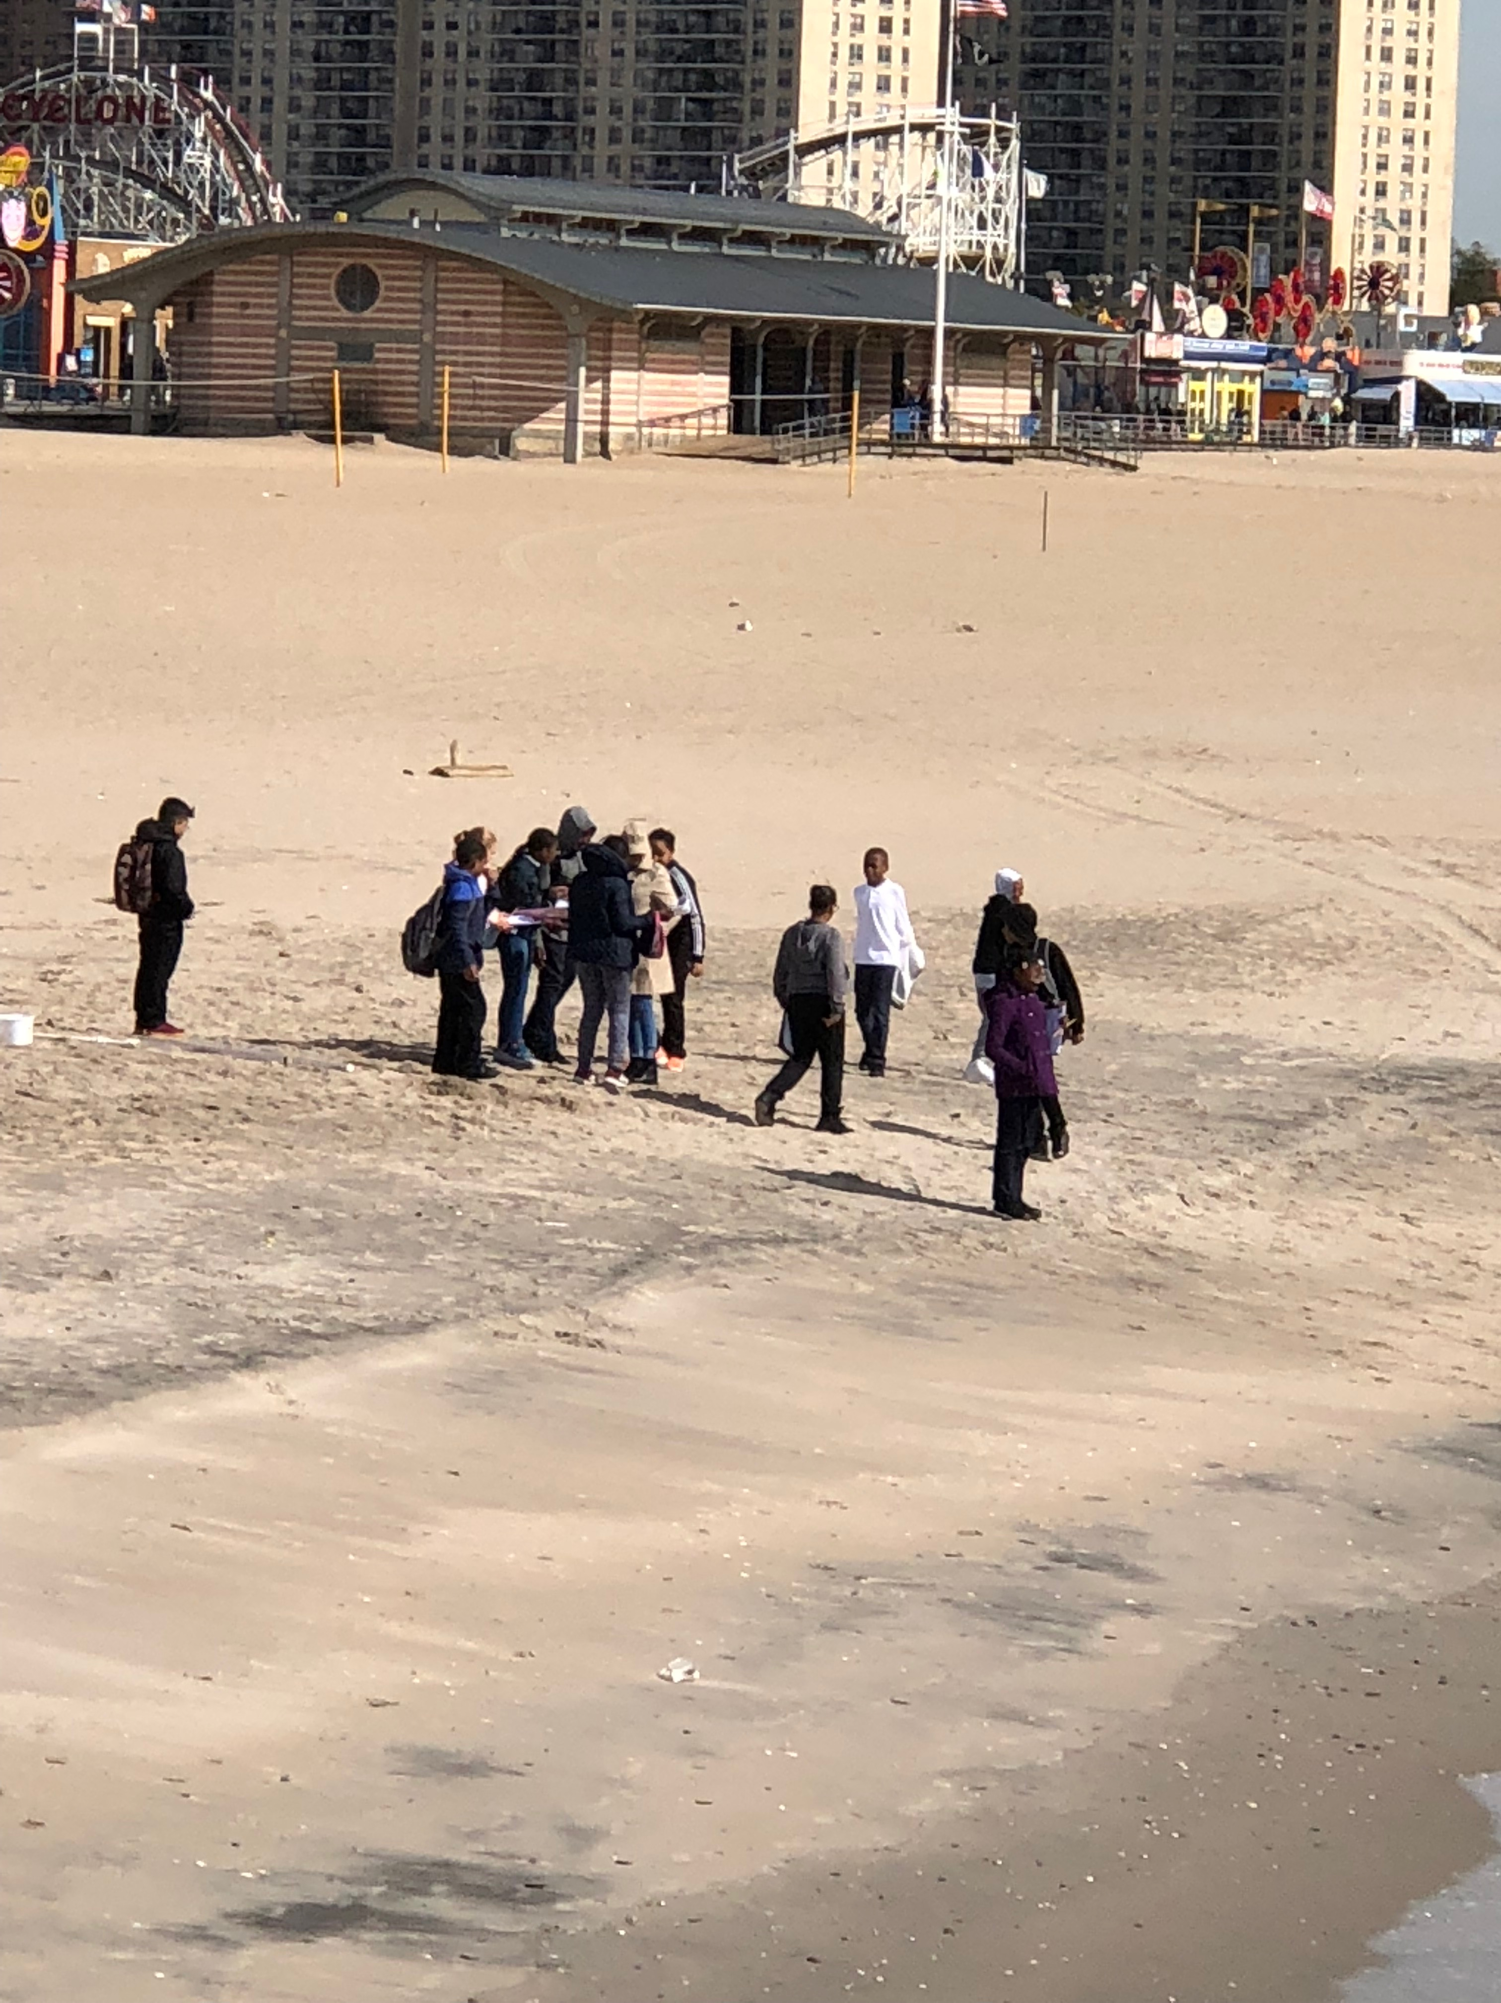 | 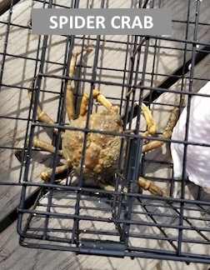 | 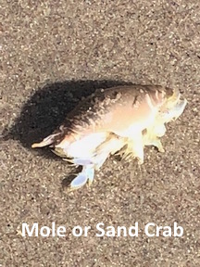 | 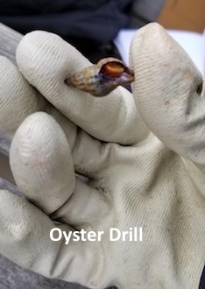

Location: Steeplechase Pier, Coney Island, Brooklyn, NY
Area: 15% Urban/Residential, 70% Beach, 15% Industrial/Commercial
Surrounding Land Use: 15% Urban/residential; 15% Industrial/Commercial; 70% Beach
Sampling Site: Beach areas with pier and riprap shoreline.
Plants in area: no plants in water area
Water: calm
River Bottom: Sandy
ITEM | Time | Reading |  | Comments
Physical
Air Temperature: | 11:10 AM  12:03 PM | 16.3 º C  14.0 º C | 61.34 º F  57.2 º F
Wind Speed: | 11:12 AM  12:05 PM | Beaufort 3  Beaufort 2 | 6.8 knots  3.4 knots | Northwest
Weather Today: | No rain, partly cloudy (26-50%)
Weather Previous: | 10/13-10/14 cool and cloudy; 10/15 rain
Current- *measured in a cove | cm/second | Rising, Falling, Unchanged | Height (cm) | Rate of Change (cm/min)
Water Temperature | 11:23 AM  12:00 PM  12:37 PM | 16.9 º C  17.3 º C  17.5 º C | 62.42 º F  63.14 º F  63.5 º F
Turbidity -  Long sight tube | 11:42 AM  12:00 PM  12:47 PM | 122 cm  122 cm  107 cm
Chemical
Salinity- hydrometer | 11:10 AM  11:30 AM  12:34 PM | 25 ppt  24.5 ppt  22 ppt
DO – meter | Time | Temp | ppm DO | % saturation
DO – meter | 11:32 AM  12:00 PM | 16.9 º C  17.8 º C | 9.9  9.4 | 102%  99%
pH - meter | 11:20 AM  11:26 AM  12:05 PM  12:34 PM | 7.38  7.0  7.64  7.27
Fish – | Number | Name | Length of longest
Fish – | N/R
Fish – | TOTAL: | Diversity:
Macroinvertebrates- trap | Number | Name | Length of longest
Macroinvertebrates- trap | 1  1  1 | Spider Crab  Mole Crab  Oyster Drill
Macroinvertebrates- trap | TOTAL: 3 | Diversity: 3
Tides- | Time | Rising, Falling, Still | Height (cm) | Rate of Tidal Change (cm/min)
 | 11:02 AM  11:23 AM  12:00 PM | -  Rising  Rising | 525 cm  510 cm  495 cm | -  0.7  0.4

