Day in the Life of the Hudson River 10/16/18 Data
MORRIS CANAL BASIN, JERSEY CITY, NJ
RIVER MILE: 0.5
Salt Front: ~RM 24
Hudson Montessori School- Grace Sanvictores & Michelle Velho
91 students 1st-6th grade, 12 adults
Latitude 40.707725 N & Longitude – 74.03447 W
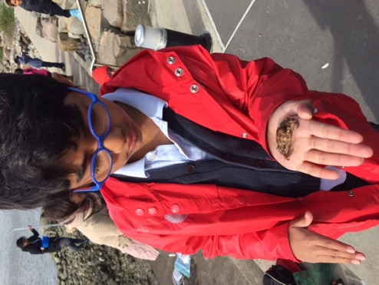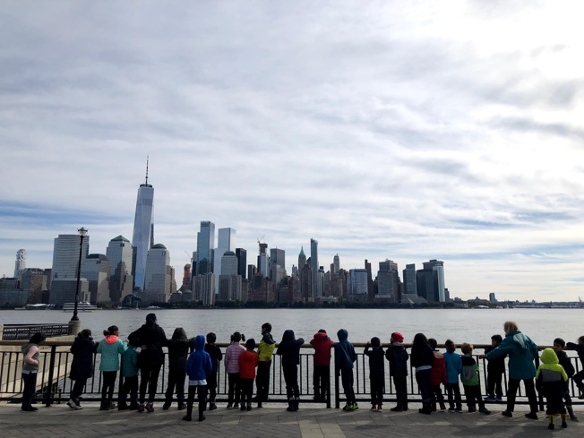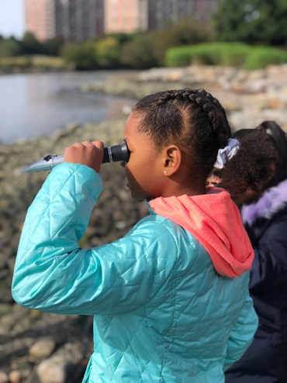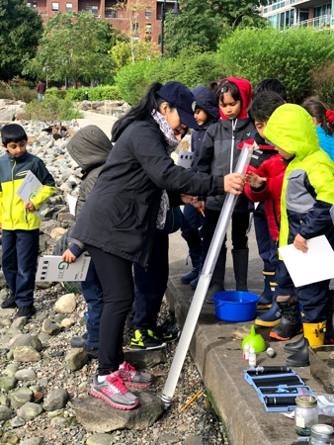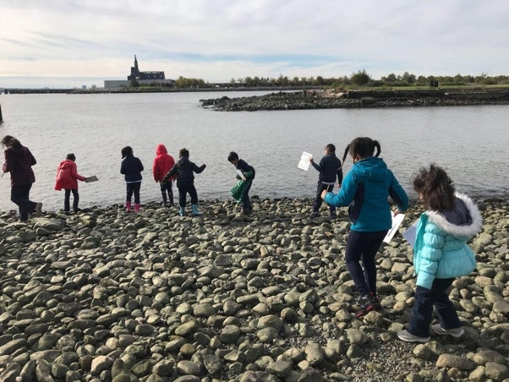
Location: Walking and fishing pier, Morris Canal Basin, Jersey City, NJ
Area: Waterfront pier along a developed area, walkway with railing
Surrounding Land Use: 100% Urban/Industrial
Sampling Site: Waterfront pier jutting out along the waterfront, surrounds a canal inlet
Plants in area: Seaweed
ITEM |  | Time |  | Reading |  | Comments
Physical
Air Temperature: |  | NR
Wind Speed: |  | NR
Weather Today: |  | NR
Weather Previous: |  | NR
Water Temperature |  | 10:00- 12:00 |  | NR
Turbidity- long site tube |  | 10:00-12:00 |  | 40-55 cm
Chemical
Salinity- refractometer |  |  | 10:00 - 12:00 | 10 ppt
DO – |  |  | Time | Temp | ppm DO | % saturation
 |  |  | 10:00-12:00 |  | 7
pH - |  |  | 10:00-12:00 | 7.5
Fish – NONE |  |  | Number | Name | Length of longest
 |  |  | TOTAL: | Diversity:
Macroinvertebrates- |  |  | Number | Name | Length of longest
 |  |  | 1 | Green Crab  Ribbed Mussels
 |  |  | TOTAL: 1+ | Diversity: 2
Tides- NR | Time |  | Rising, Falling, Still | Height (cm) | Rate of Change (cm/sec)
Currents Flow | Cm/  sec |  | Knots | North/South | Ebb/Flood/Still
 | 77.58 |  | 1.51 | South | Ebb
Boats | Time |  | Name | Color | North/ South | Loaded/Light
NR
Other Observations |  |  | NR

