Day in the Life of the Hudson River 10/16/18 Data
(Salt front ~ RM 24)
RIVER MILE 76
Tidal mouth of Fallkill Creek, Poughkeepsie, Dutchess County
Nancy Arias & Emma Sears, Poughkeepsie Day School, 26 students, Citizen Science and Environmental Outreach class & middle school students
N 41°709244’ – W -73°940203’
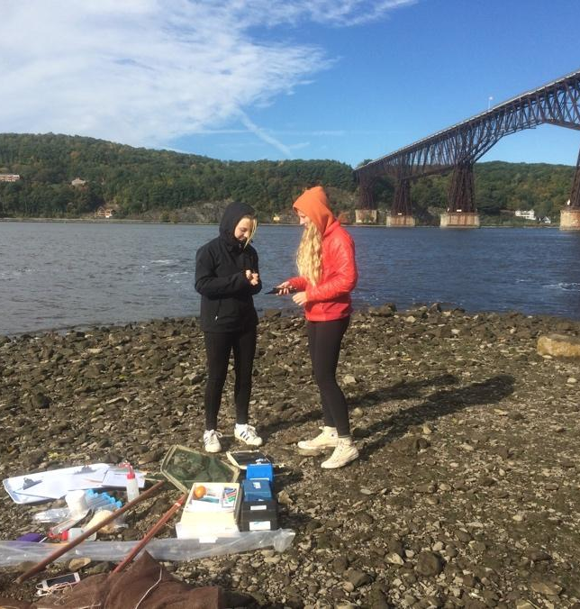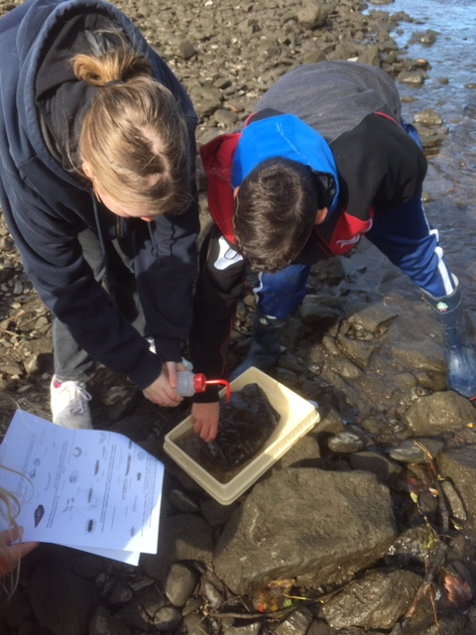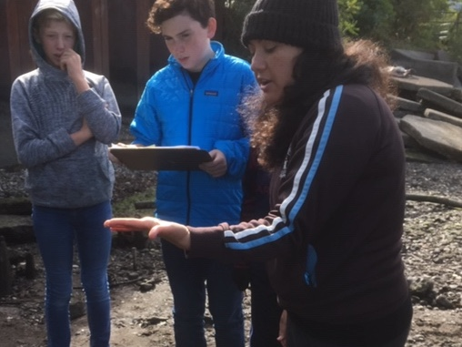
Location: West of Children’s Museum, Northern Waryas Park, Poughkeepsie, New York.
Area: North end of Public park, pier, grassy, parking lot. Park used for fishing, small boat launch, another pier for small boat launching. Erosion booms just to the north at a construction site.
Surrounding Land Use: Urban/Residential 30%, Forested 10%, industrial/commercial 10%, beach 50%.
Sampling Site: Shoreline is rocky inshore <1 ft depth with some scattered large rocks <2 ft. length, and sandy & rocky offshore <1 ft. depth,
Plants in area: No submerged rooted aquatic plants were visible but we did see periphyton (a complex mixture of algae, cyanobacteria, heterotrophic microbes, and detritus that is attached to submerged surfaces in most aquatic ecosystems) on coble size stones
River Bottom – rocky/muddy
Water depth: 3-4ft
Sampling time: 10:00 AM -11:45 AM

ITEM | Time |  | Reading 1 | Reading 2 | Comments
Physical
Air Temperature | NR |  | 60ºF | 15.8ºC
Wind Speed | NR |  | Beaufort
Cloud Cover | Overcast
Water | Slightly choppy (<1-2 in waves inshore)
Weather | Did not rain during sampling
Water Temp. | 10:25  10:30 | 15.2ºC  15.2 |  |  | Avg: 15.2ºC
Turbidity – long sight tube | 11:10 AM | 47 cm
Chemical
DO - CheMetrics | 10:40 | 16.1ºC |  | 7 ppm | 70% sat
pH – indicator solution | 10:25 AM | 7.95
Salinity - Refractometer | 10:15 AM | *3 ppt reported |  |  | *must be in error
Quantab | NR | 39 ppm CL- |  | 70 ppm TS
Alkalinity - CheMetrics | 0* |  |  |  | * probably in error
Nitrates- CheMetrics | 0
Phosphates- CheMetrics | 0
Fish Catch – 12feet net – 3 hauls | Number Caught | Species |  | Largest
 | NONE
Macroinvertebrates | NR | Amphipods  Zebra Mussels
Tides – tide stick | NR | 2 cm  6 cm |  | 10 mins | 2.5 cm/min
Currents | 11:52 | 1.111m/30sec or 1,111 cm/30 secs |  | 37cm/sec | 0.72kts  South
Core | NR
Shipping – rec. | Times | Color |  | Direction
Recreation | 10:05  10:06 | White boat  White boat |  | Northbound  Southnound
Observations | Birds | Numerous zebra mussels

