Day in the Life of the Hudson River 10/16/18 Data
CONCRETE PLANT PARK, BRONX
RIVER MILE: 4.5 (Bronx River)
Salt Front: ~RM 24
Pelham Preparatory Academy- Zachary Itzkowitz
25 students 11th-12th grade, 2 adults
Latitude 40.826677 N & Longitude – 73.884901 W
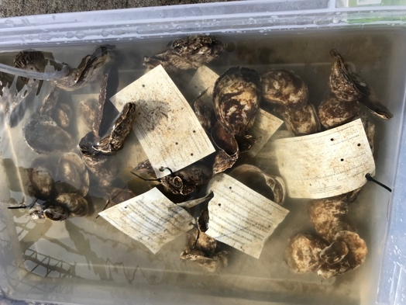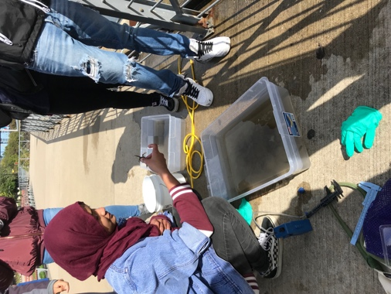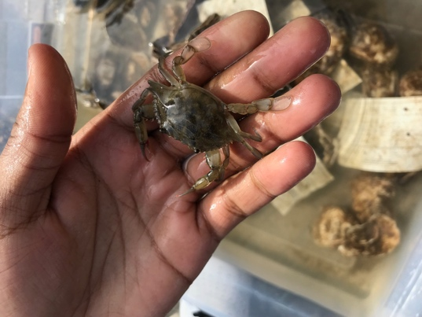
Location: Concrete Plant Park, Bronx River, NY
Sampling Time: 10:00-12:45 PM
ITEM | Time | Reading |  | Comments
Physical
Air Temperature: | NR
Wind Speed: | NR
Weather Today: | NR
Weather Previous: | NR
Water Temperature | 10:00-12:45 | 14 º C | 57.2 º F
Turbidity - long sight tube | 10:00-12:45 | 84 cm
Chemical
Salinity- hydrometer | 10:00-12:45 | 13 ppt
DO – | Time | Temp | ppm DO | % saturation
DO – | 10:00-12:45 | 14 ºC | 7 | 65
pH - | 10:00-12:45 | 6.5
Fish – Oyster Cage | Number | Name | Length of longest | Oysters in cages are growing and healthy.
Fish – Oyster Cage | 2 | Striped Killifish |  | Oysters in cages are growing and healthy.
Fish – Oyster Cage | TOTAL: 2 | Diversity: 2 |  | Oysters in cages are growing and healthy.
Macroinvertebrates- | Number | Name | Length of longest
Macroinvertebrates- | 1 | Blue Crab | Juvenile
Macroinvertebrates- | TOTAL: 1 | Diversity: 1

