Snapshot Day 10/16/18 Data
Mohawk River Valley
SCHOHARIE CREEK SITE RIVER MILE
Middleburgh, NY
RIVER MILE: (Mohawk) 53
Mollie Burgett, Middleburgh High School & 9 students 12th grade
Doug Reed, Hudson Basin River Watch, DEC fisheries representative
42.5996 Lat and -74.3368 Long
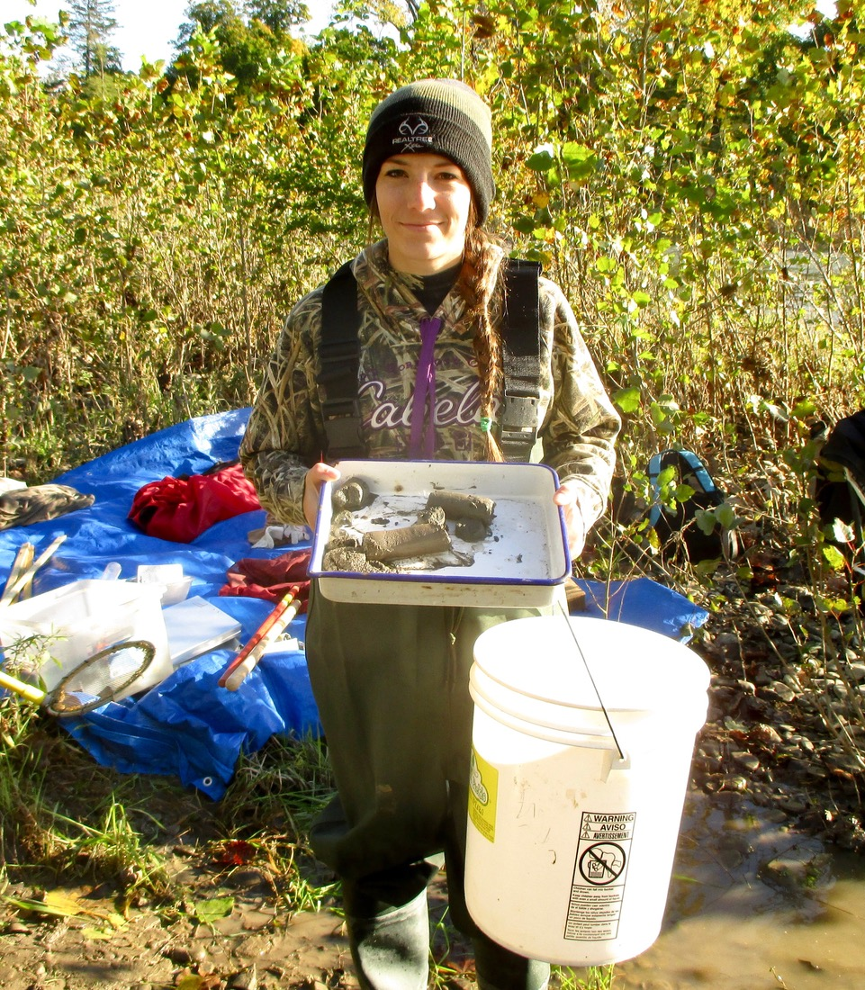
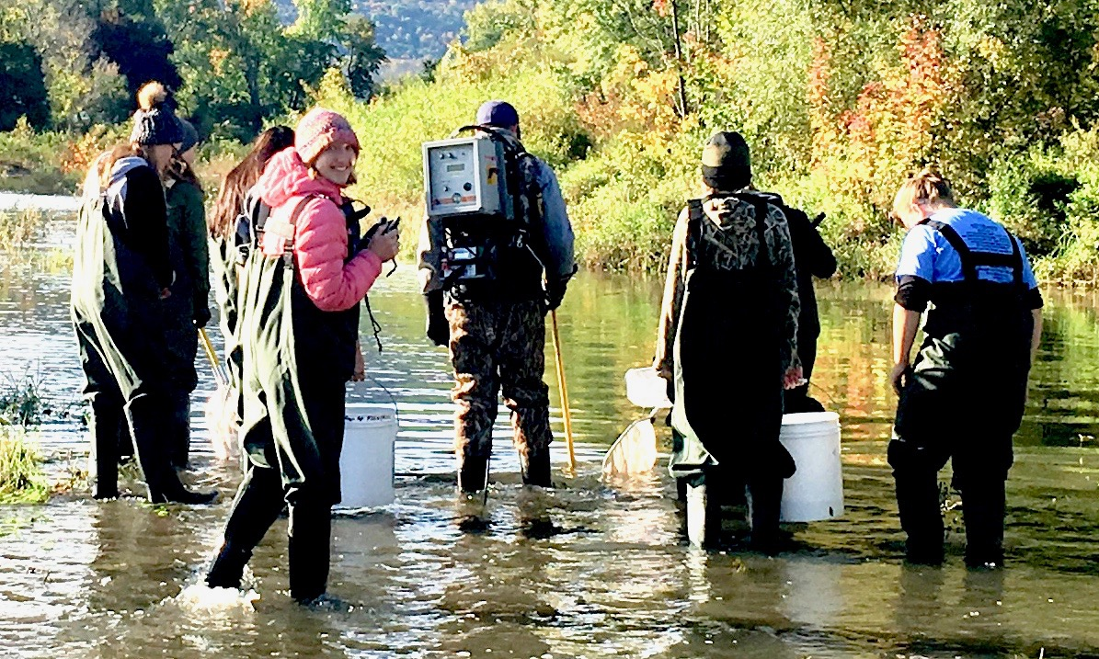
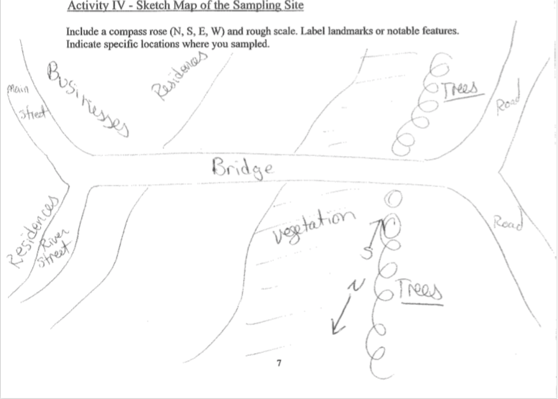
Location: On the Schoharie Creek, creek access point is north of Timothy Murphy Park Middleburgh, Schoharie County
- Fishing access on north side of bridge
Surrounding Land Use: 30% urban/residential, 70% forested, 0% beach, 5% Industrial/Commercial, 45% Agriculture
Shoreline: Rocky beach area, covered with vegetation, Strom drain outflow south of sampling, 20ft.
River Bottom: Rocky
Water Depth: 0-5ft
Water Conditions: Lots of faster flowing riffles
Plants in water: No
ITEM | Time | Reading |  |  | Comments
Physical
Air Temperature | 1:13 PM  1:20 PM  1:25 PM  1:50 PM | 9ºC  13ºC  14ºC  18ºC | 48.2ºF  55.4ºF  57.2ºF  64.4ºF
Wind Speed |  | Beaufort Force: 2, South  Water is slightly choppy
Weather today | Morning- No Rain, partly cloudy and sunny. Midday- full cloud cover. Late afternoon- mostly clear and sunny.
Weather recently | Colder, steady rain the day before, creek is higher than years past.
Water Temperature | 11:12 AM  1:20 PM  2:05 PM | 12ºC  13.85ºC, 13ºC Average=13.425ºC  13.9ºC | 53.6 ºF  56.93 ºF, 55.4 ºF  57.02ºF
Turbidity - Secchi Disk | 1:13 PM | 50 cm | >60 cm |  | Average 55 cm
Chemical
DO - meter | Time | Temp |  | ppm DO | % saturation
 | 1:18 PM  1:19 PM  2:05 PM | 13.85 ºC  13.9 ºC  13 ºC |  | 10.08  10.8  10.59 | 95%  104%  105%
pH – test strips | 1:20 PM | 6, 6 ,6.5 |  |  | Average: 6.17
Nitrates | 11:29 AM  1:34 PM  1:41 PM | 0  2.5  0 |  |  | Average 0.83 ppm
Fish | Number | Name |  | Length of longest
One attempt at seining was made (20ft net/100ft pull) but only resulted in crayfish. Two DEC staff however ran 2 electroshock runs (one that lasted 20-30 minutes + another that lasted 5 minutes which is where the fish results came from. | 2  28  1  2  3  21  1  1  6  1 | Yellow Perch  Common Shiner  Walleye  Rock Bass  Rainbow Darter  Chub  Largemouth Bass  Smallmouth Bass  Blacknose Shiner  Sculpin |  | 122mm  74mm  58mm  152mm  66mm  76mm  64mm  51mm  77mm  66mm
Fish Totals | TOAL: 66 | Diversity: 10
Macroinvertebrates | Number | Species
Seine Net  _________  Kick Net | Some  ________  33  110  5  3  1 | Crayfish  ________  Stonefly  Mayfly  Caddisfly  Dobsonfly (Cranefly)  Aquatic worm
 | TOTAL: 152+ | Diversity: 6
Flow rates Current | 1:00 PM  1:10 PM  1:13 PM | 90.9 cm/second **  125 cm/second*  86.9 cm/second ** |  | 1.77 knots  2.43 knots  1.69 knots | *Fast riffle ** smoother water; main channel moving faster

