Day in the Life of the Hudson River 10/16/18 Data
FERRY POINT PARK, BRONX
RIVER MILE: 13.5 (East River)
Salt Front: ~RM 24
KIPP Academy Elementary School- Fatima Wilson
90 students 4th grade, 20 adults
NY DEC- Chris Bowser and Team
Latitude 40.804873 N & Longitude – 73.832189 W
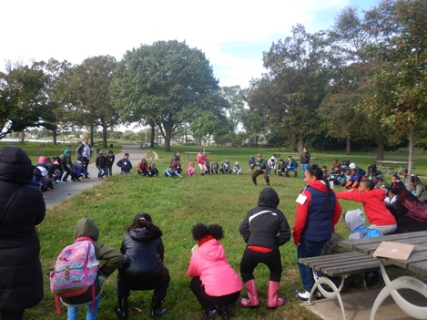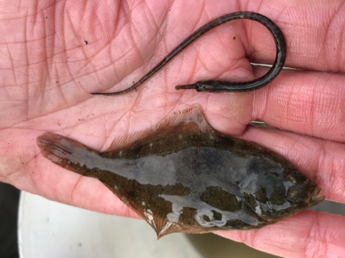
Location: Ferry Point Park beach, Bronx, NY
Area: Below the Bronx-Whitestone Bridge across the East River. Mostly used for boating and fishing. Pier with grassy area and parking lot. Large park area used for picnics and sports with spartina covered marsh along the water and forested beyond.
Surrounding Land Use: Beach/park
Sample Site: Sandy beach, tidal marsh area covered with dense spartina
Shoreline: 50% sandy, 25% rocky, 25% muddy
River Bottom: Sandy, Rocky
Water: Choppy
Plants: Parts of the shoreline was covered with green water plants.
ITEM |  | Time | Reading |  | Comments
Physical
Air Temperature: |  | 12:09 PM |  | 46 º F
Wind Speed: |  | 12:09 PM | Light breeze | West
Weather Today: |  | No rain, clear, no clouds, sunny
Weather Previous: |  | Rainy, windy
Currents Flow- |  | Cm/second | Knots | North/South | Ebb/Flood/Still
12:21 PM |  | 2.456 | 0.0477 | South | Ebb
Water Temperature |  | NR
Turbidity- |  | NR
Chemical
Salinity- hydrometer |  | NR
DO – NR |  | Time | Temp | ppm DO | % saturation
pH- NR
Fish – Seine |  | Number | Name | Length of longest
 |  | 30  6  1 | Striped Killifish  Northern Pipefish  Winter Flounder
 |  | TOTAL: 37 | Diversity: 3
Boats | Time | Name | Color | North/ South | Loaded/Light
Commercial |  | Carrier Ship |  |  | Loaded w. trash
Other Observations |  | The water was dark blue and choppy. We could not see the bottom. Saw swans and birds. There was garbage that was left here or washed up.

