Day in the Life of the Hudson River 10/16/18 Data
BROOLYN BRIDGE PARK (WEST), MANHATTAN
RIVER MILE: East River 2.3
Salt Front: ~RM 24
Leman Manhattan Preparatory School- Bill Livingston
60 students 10th -12th grade, 6 adults
BioBoat & BioBus- Mollie and James
Latitude 40.7076 N & Longitude – 73.99982 W
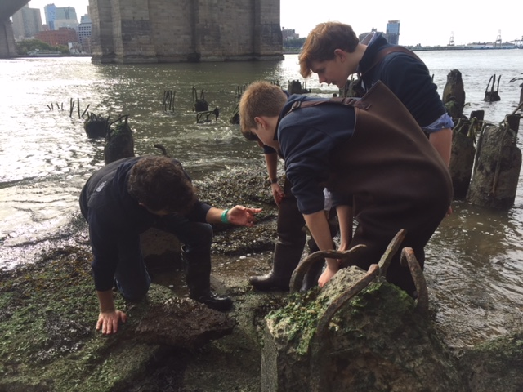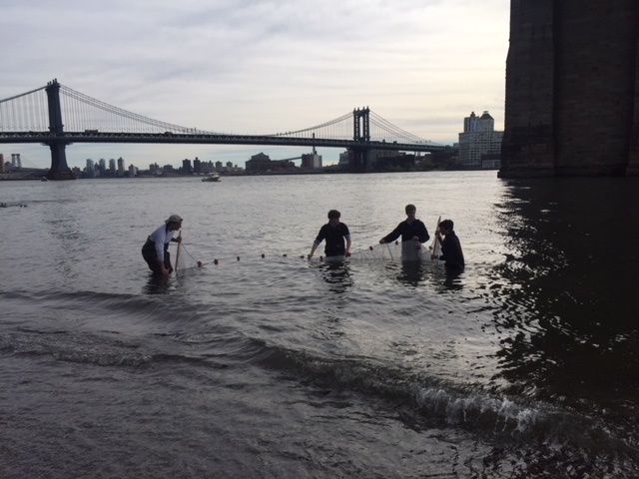
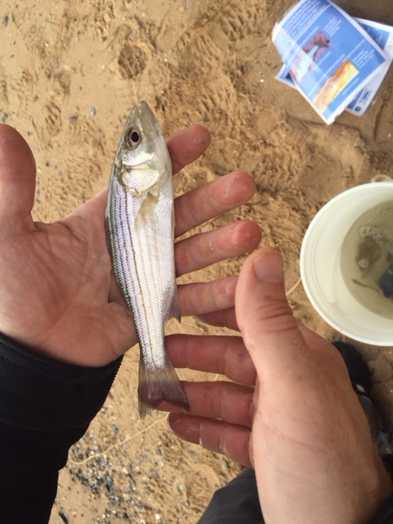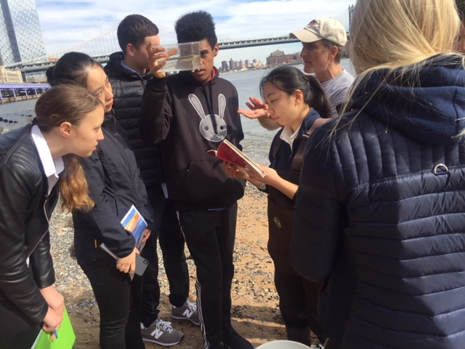
Location: Brooklyn Promenade- Brooklyn Bridge, Manhattan, NY
Area: Beach under the Brooklyn Bridge- 125 feet north of Dover street, west side of the East river. Pier and path for recreational walking, jogging, bike riding, and fishing. Surrounding land is a sandy beach with water. Water used for fishing and boating; beach is open to the public but no swimming; lots of rocks and sand; near parking lot.
Surrounding Land Use: 60% Urban Residential; 30% Industrial/Commercial; 10% Beach
Sampling Site: Sandy, beach, covered in vegetation, pier; banks altered; bulkhead with timbers; debris in area such as broken concrete, docking; riprap; pipe entering river (south CSO ~40 meters- not visible).
Water: Choppy, 4 feet deep
River Bottom: Sandy, rocky (pebbles and stones)
Plants: 3% plants covering the water area: Irish moss and Gracela
ITEM | Time | Reading |  | Comments
Physical
Air Temperature: | 10:00 AM  11:00 AM | 13.1 º C  18.61 º C | 55.5 º F  65.5 º F
Wind Speed: | 10:00 AM  11:00 AM  1:00 PM  2:00 PM | Beaufort: 4  Beaufort: 3  Beaufort: 2  Beaufort: 3 | South  East  East  Southwest
Weather Today: | No Rain; Partly cloudy (26-50%)
Weather Previous:
Water Temperature | 10:00 AM  11:00 AM  2:00 PM | 17 º C  16 º C  14.9 º C | 62.6 º F  60.8 º F  58.82 º F
Turbidity -  Long site tube | 9:40 AM  10:20 AM  1:10 PM  1:50 PM | Avg: 72.8 cm  Avg: 68 cm  Avg: 100 cm  Avg: 145 cm
Chemical
Salinity- hydrometer | 9:40 AM  10:20 AM  1:30 PM  2:10 PM | 28 ppt  19 ppt  18.5 ppt  17.7 ppt | *Big adjustment between first and second reading; falling salinity with a rising tide is an interesting phenomena that may be due to a the excessive rain this fall.
DO – | Time | Temp | ppm DO | % saturation
DO – | 10:00 AM  1:50 PM  2:20 PM |  | 7  7.2  7 | 80  70  68
pH - pH strips | 9:40 AM  10:20 AM  1:30 PM  2:20 PM | 8  7  7  7
Nitrates – Flinn/Lamotte Color Comparator Kits | 9:40 AM  10:20 AM  1:40 PM  2:20 PM | 8.8 ppm  4.4 ppm  4.4 ppm  8.8 ppm |  | * Bill noted teacher had double-checked the results but kits are low resolution. These readings are really high
Phosphates – Flinn/LaMotte Color Comparator Kits | 9:40 AM  10:20 AM  1:40 PM  2:20 PM | 8.8 ppm  4.4 ppm  4.4 ppm  8.8 ppm
Fish – Seine  Length of seine: 20’  Width of seine: 4’  Length of seine pull: 20’  Number of seines: 6 | Number | Name | Length of longest
 | 26  9 | Striped Bass  Atlantic Silverside | 18 cm  8.5 cm
 | TOTAL: 35 | Diversity: 2
Macroinvertebrates- hand net in tide pool | Number | Name | Length of longest | 2 F, 3 M
Macroinvertebrates- hand net in tide pool | 2  5  20+  Encrusting 50% of rocks | Hermit Crab  Asian Crab  Sand Shrimp  Barnacles |  | 2 F, 3 M
Macroinvertebrates- hand net in tide pool | TOTAL: 27 | Diversity: 4 |  | 2 F, 3 M
Tides- | Time | Rising, Falling, Still | Height (cm) | Rate of Tidal Change (cm/min)
 | 9:40 AM  10:00 AM  10:40 AM  11:00 AM  1:40 PM | Falling  Rising  Rising  Rising |  | -  0.05  0.0375  0.46  0.1238
Current- *measured in a cove | cm/second | Rising, Falling, Unchanged | Height (cm) | Rate of Change (cm/min)
Currents Flow | Cm/second | Knots | North/South | Ebb/Flood/Still
10:00 AM  10:20 AM  10:40 AM  1:30 PM  1:40 PM | 7.2  12.1  3.8  8.6  19.2 | 0.140  0.235  0.074  0.167  0.373

