Day in the Life of the Hudson River 10/16/18 Data
LITTLE BAY, FORT TOTTEN PARK, RIVER MILE: 15.2
Salt Front: ~RM 24
John Bowne High School- Michelle Theodorou
34 students 11th -12th grade, 3 adults
NYC Parks- Martha Brodylo
Latitude 40.793339 N & Longitude -73.78072 W
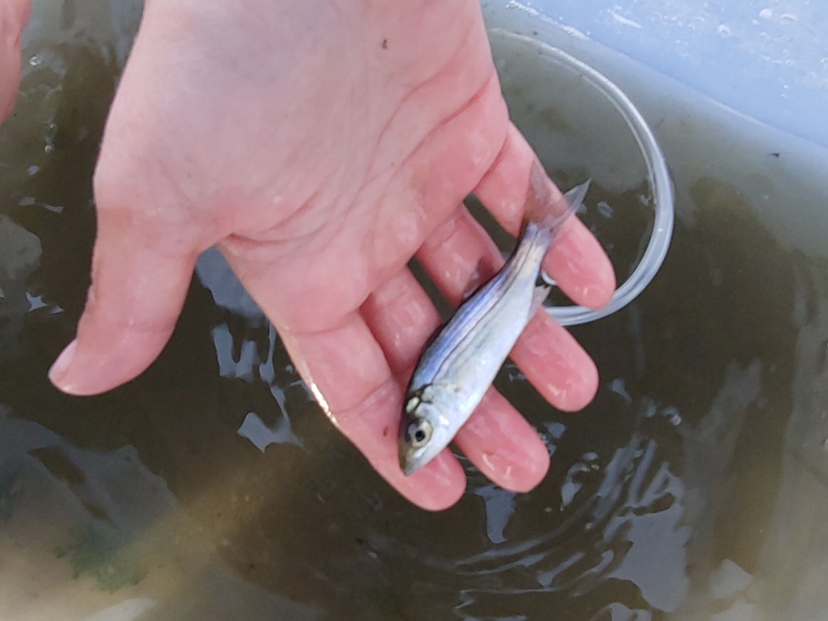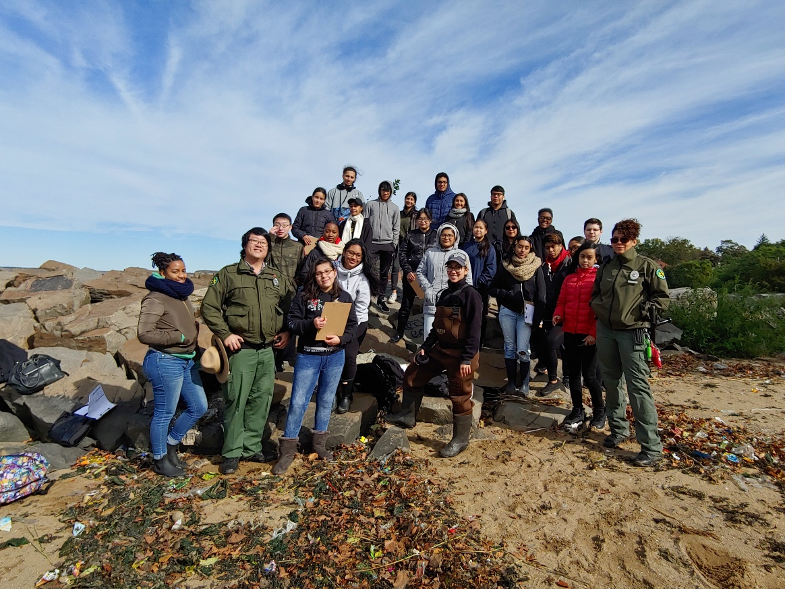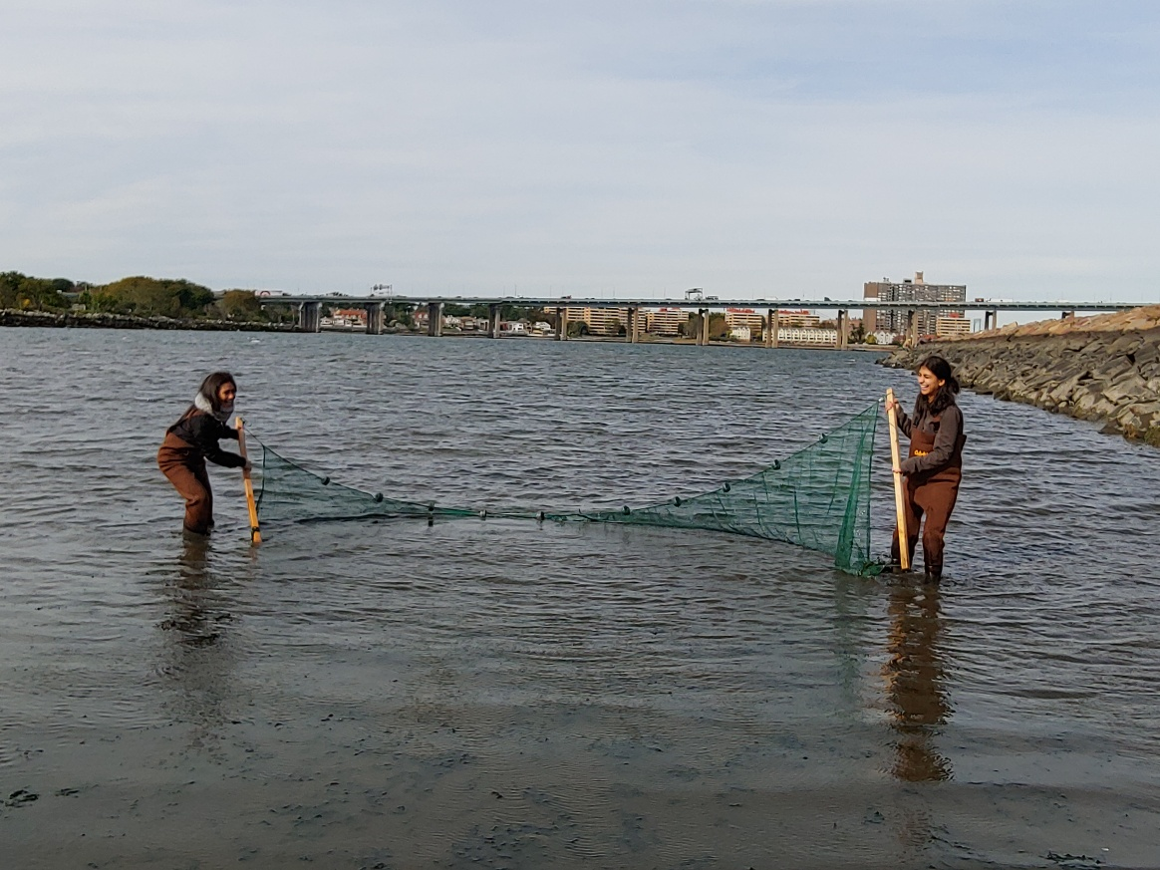
Location: Little Bay, Fort Totten Park, Queens, NY
Area: Jetty, grassy area, parking lot
Surrounding Land Use: Urban/Residential; Industrial/Commercial; Beach
Sampling Site: Beach, covered in vegetation, banks altered, riprap (large rocks)
Shoreline: 60% Sandy; 20% Muddy; 20% Rocky
Water: Shallow, Choppy
River Bottom: Muddy, weedy, sandy

ITEM | Time | Reading |  | Comments
Physical
Air Temperature: | 10:06 AM  10:08 AM  10:10 AM | 53.4 º F  52.9 º F  52.5 º F | 11.89 º C  11.61 º C  11.39 º C
Wind Speed: | 10:10 AM | 12 mph | South
Weather Today: | NA
Weather Previous: | Rain all day yesterday
Water Temperature | 10:40 AM | 14 º C  13 º C  13.5 º C | 57.2 º F  55.4 º F  56.3 º F
Turbidity - | NA
Chemical
Salinity- Hydrometer | 10:10 AM | 22 ppt
DO – | Time | Temp | ppm DO |  | % saturation
DO – | 10:30 AM | 13 º C | 8 |  | 77%
pH – API Master Kit pH drops | 10:30 AM | 7.6
Nitrates | 10:45 AM | 0 ppm
Ammonia- API Master Test Kit- drops and color match | 10:45 AM | 0.25 ppm
Fish | Number | Name | Length of longest
Fish | 4  11  18  6 | Sculpin  Atlantic Silversides  Mummichog  White Perch | 2 inches  4 inches  6 inches  3 inches
Fish | TOTAL: 39 | Diversity: 4
Macroinvertebrates | Number | Name | Length of longest |  | All male crab
Macroinvertebrates | 1  5  100+ | Quahog- hard clam  Blue Crab  Shrimp | 4 inches  2 inches  2 inches |  | All male crab
Macroinvertebrates | TOTAL: 106+ | Diversity: 3 |  |  | All male crab

