Day in the Life of the Hudson River 10/16/18 Data
RANDALL’S AND WARD’S ISLAND, MANHATTAN
RIVER MILE: 1
Salt Front: ~RM 24
The Dwight School- Emma Ryan & Michelle Watch, 45 students 7th grade, 6 adults
Randall’s Island Park Alliance- Chris Girgenti
Latitude 40.789087 N & Longitude – 73.932869 W
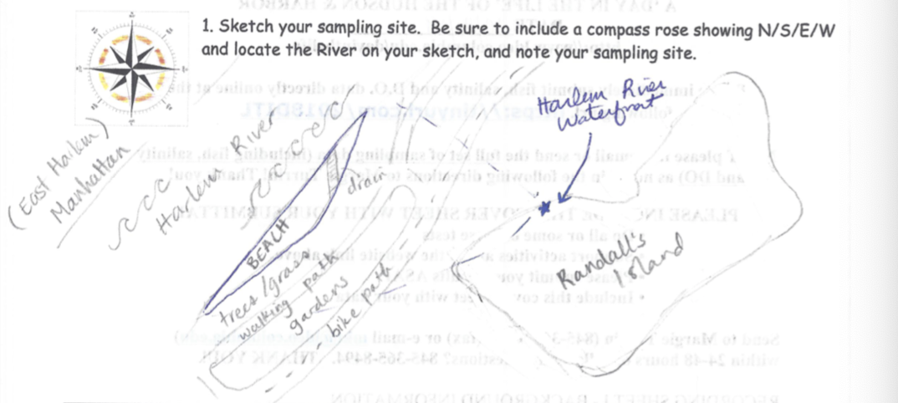
Location: Randall’s Island Park, Manhattan, NY
Area: Randall’s Island Park, Harlem River Waterfront (North of 103rd St. Bridge/Ward’s Island Bridge), sandy adjacent to shore, increasingly muddy with depth; sporadic rocks
Surrounding Land Use: 100% Park
Sampling Site: Grassy; beach; concrete bulkhead; pipe entering the water.
Shoreline: 90% Sandy; 10% Rocky
Plants in area: 2% sea lettuce (Ulva sp.)
Water: Choppy, ~30 foot depth
River Bottom: muddy, sandy, rocky
ITEM |  | Time | Reading |  |  | Comments
Physical
Air Temperature: |  | 11:05 AM  11:40 AM  12:15 PM | 11.4 º C  11.4 º C  11.4 º C |  | 52.5 º F  52.5 º F  52.5 º F
Wind Speed: |  | 11:09 AM  11:50 AM  12:20 PM  12:42 PM | 4.8 mph  2 mph  0.8 mph  0.8 mph |  | Beaufort 2
Weather Today: |  | No Rain, Mostly cloudy (60-75%)
Weather Previous: |  | Slight rain the past few days
Water Temperature |  | 10:49 AM  11:25 AM  12:05 PM  12:45 PM | 17 º C  18.9 º C  18.9 º C  19 º C |  | 62.6 º F  66.02 º F  66.02 º F  66.2 º F
Turbidity -  Long sight tube |  | 10:49 AM  11:25 AM  12:05 PM | 10.3 cm  11.3 cm  24.6 cm
Chemical
Salinity- hydrometer |  | 10:49 AM  11:25 AM  12:05 PM  12:45 PM | Avg: 16.7 ppt  Avg: 15 ppt  Avg: 14.5 ppt  Avg: 14 ppt
DO – |  | Time | Temp |  | ppm DO | % saturation
 |  | 11:25 AM  12:05 PM  12:45 PM | 18.9 º C  19.18 º C  18.90 º C |  | 6  6.66  7.33 | 46  52  62
pH - test strips |  | 10:49 AM  11:25 AM  12:05 PM  12:45 PM | 7  7  6  7
Nitrates- LaMotte Estuary Kit |  | 10:49 AM  11:25 AM  12:05 PM  12:45 PM | 0 ppm  5 ppm  8.3 ppm  10 ppm |  |  | * Estuary kit is low resolution. 2nd, 3rd, and 4th readings are very high
Phosphates- LaMotte Estuary Kit |  | 10:49 AM  NR  12:25 PM  12:45 PM | 1.75 ppm  0.5 ppm  2 ppm  10 ppm |  |  | * Estuary kit is low resolution. Last reading is very high
Fish – Seine |  | Number | Name |  | Length of longest
 |  | 1  107  3 | Oyster Toadfish  Atlantic Silverside  Striped Bass
 |  | TOTAL: 111 | Diversity: 3
Macroinvertebrates |  | Number | Name |  | Length of longest | Male blue crabs
 |  | 4  1  4  13 | Shrimp  Moon Jelly  Comb Jelly  Blue Crab (M) |  |  | Male blue crabs
 |  | TOTAL: 22 | Diversity: 4 |  |  | Male blue crabs
Tides- tide stick |  | Time | Rising, Falling, Still |  | Height (cm) | Rate of Tidal Change (cm/min)
 |  | 10:45 AM  11:00 AM  11:15 AM  11:45 AM  12:00 PM  12:15 PM  12:30 PM | -  Still  Still  Falling  Falling  Falling  Falling |  | 28  27  27  24  21  17  15 | -  0.067  0  0.1  0.2  0.267  0.133
Currents Flow |  | Cm/second | Knots |  | North/South | Ebb/Flood/Still
10:50 AM  11:30 AM |  | 14.73  13.20  2 | 0.29  0.26  0.04 |  | South  South  Still | Ebb  Ebb  Still
Sediment Core –  Time |  | Description -  Length cm | Grain Size  Abundant | Grain Size Common | Other Items  Common | Other Items  Rare
10:45  NR |  | 20.32  ______-  25.4 | mud, sand, gravel  _______  mud, sand, gravel, pebbles | clay, pebbles  _____  clay | shells/oysters  __________  brick,  coal | brick,  coal,  slag,  living vegetation  _________  wood, shells/oysters
Boats | Description | # | Type |  | North or South | Loaded or Light
Group 1  Group 2  Group 3  Group 4 | Commercial  Recreational  Commercial  Recreational  Recreational  Commercial  Recreational | 2  2  2  2  5  2  1 | NYPD Boat  Tour boat  NR  NR  Speed boat, tour  NYPD, cargo  Speed Boat
Other Observations |  | Use to have factories; lots of waste and trash; tall buildings and houses

