Day in the Life of the Hudson River 10/16/18 Data
VALENTINO PIER, BROOKLYN
RIVER MILE: -2
Salt Front: ~RM 24
The Brooklyn New School (PS 146)- Barbara Taragan
120 students 4th grade, 20 adults
Latitude 40.678656 N & Longitude – 74.018311 W
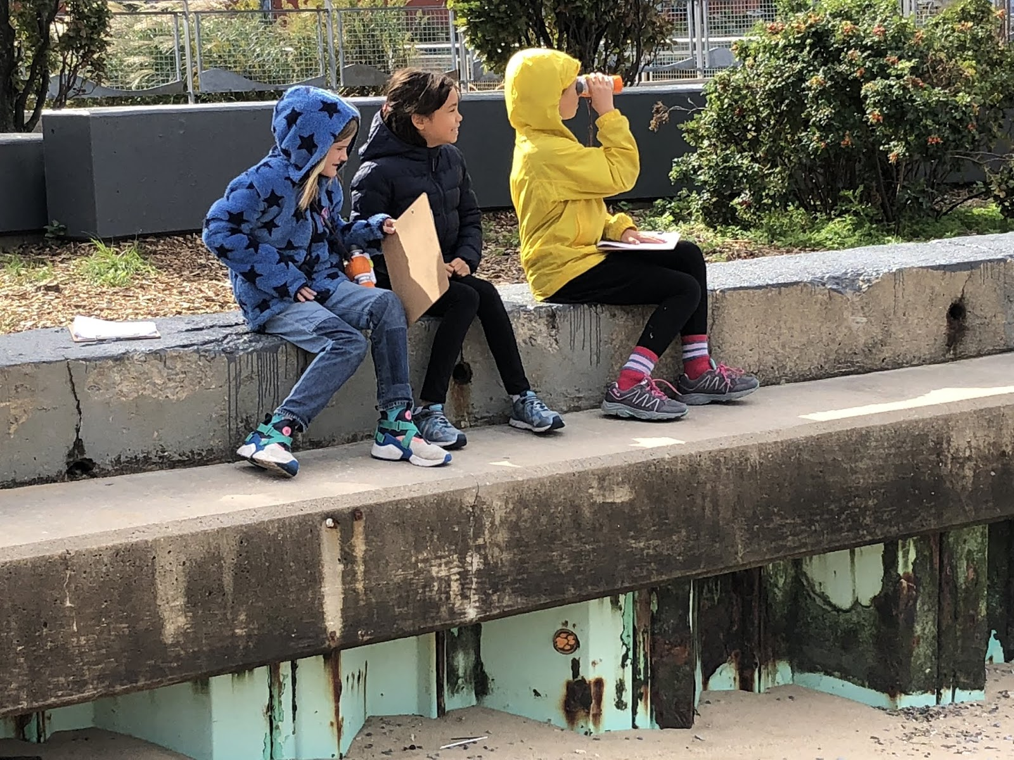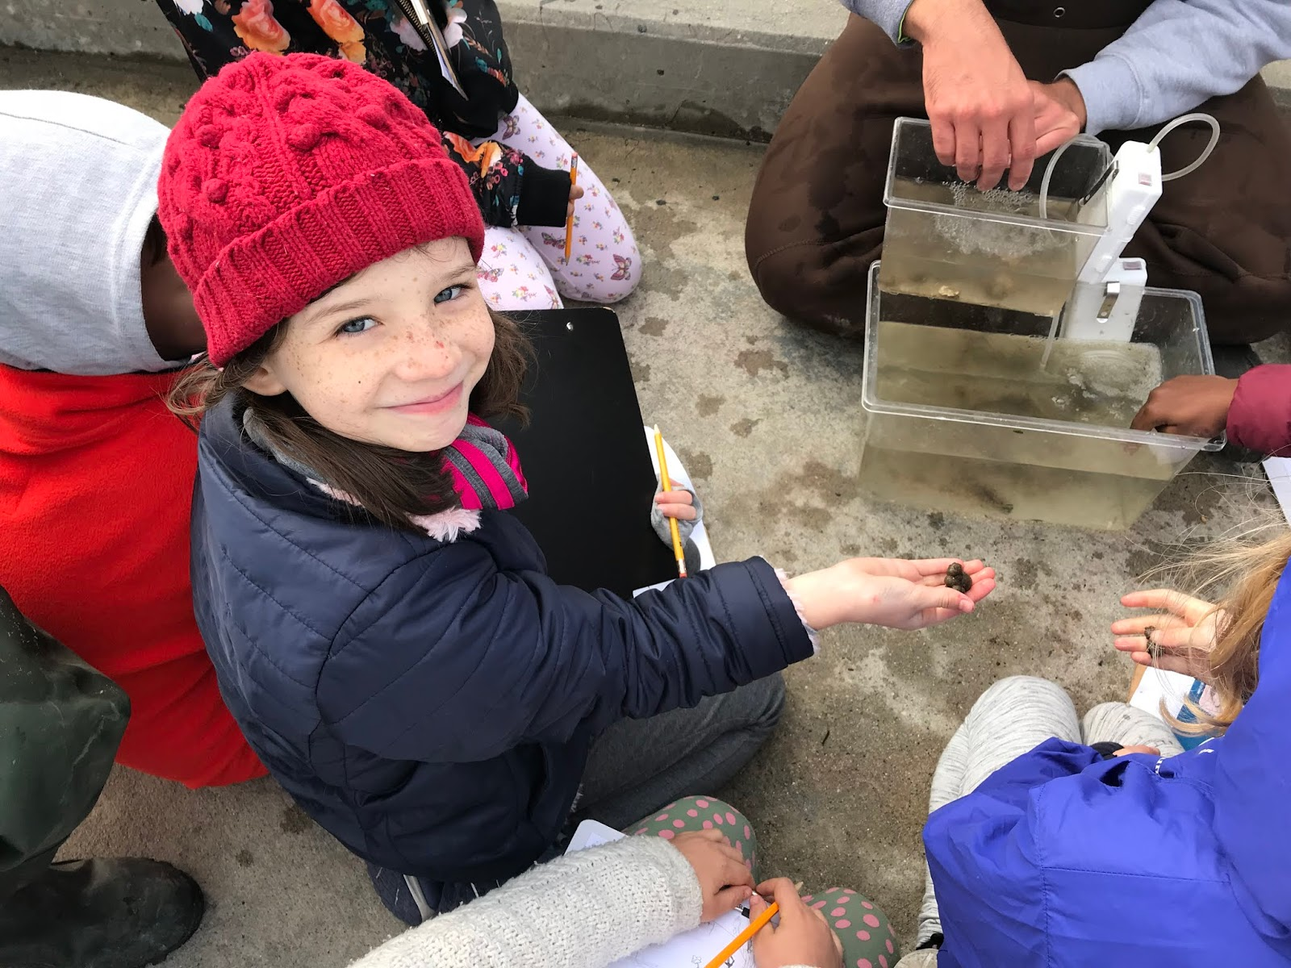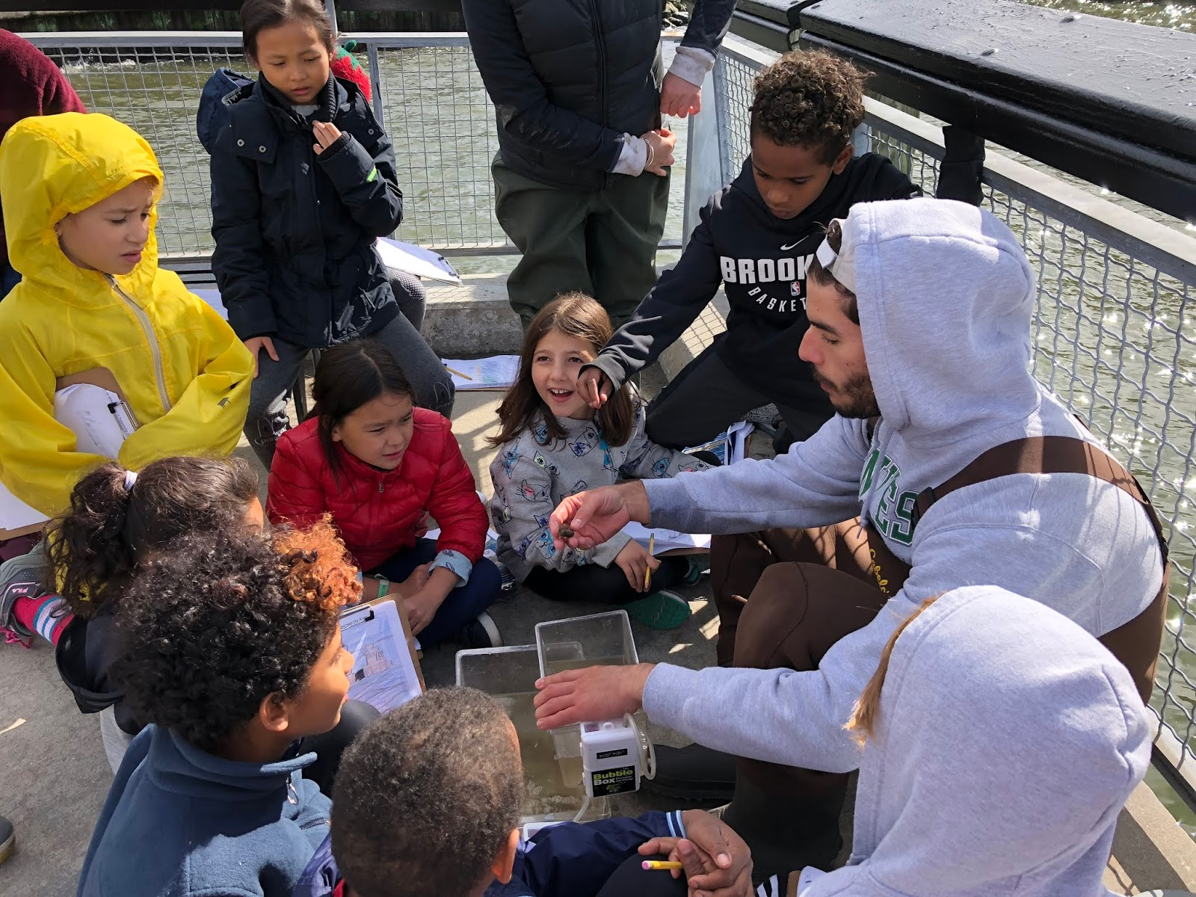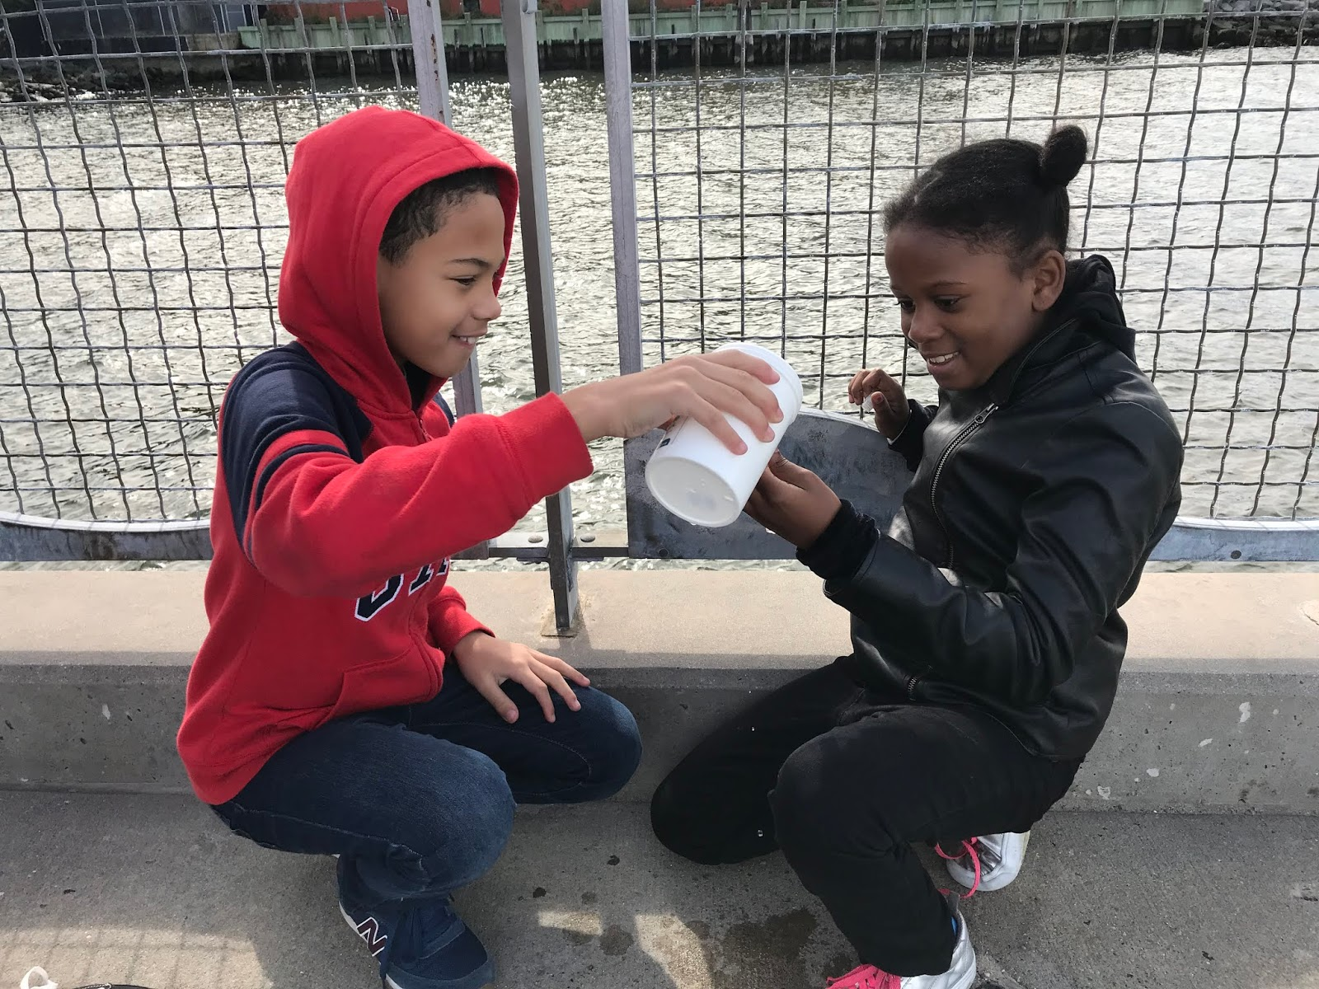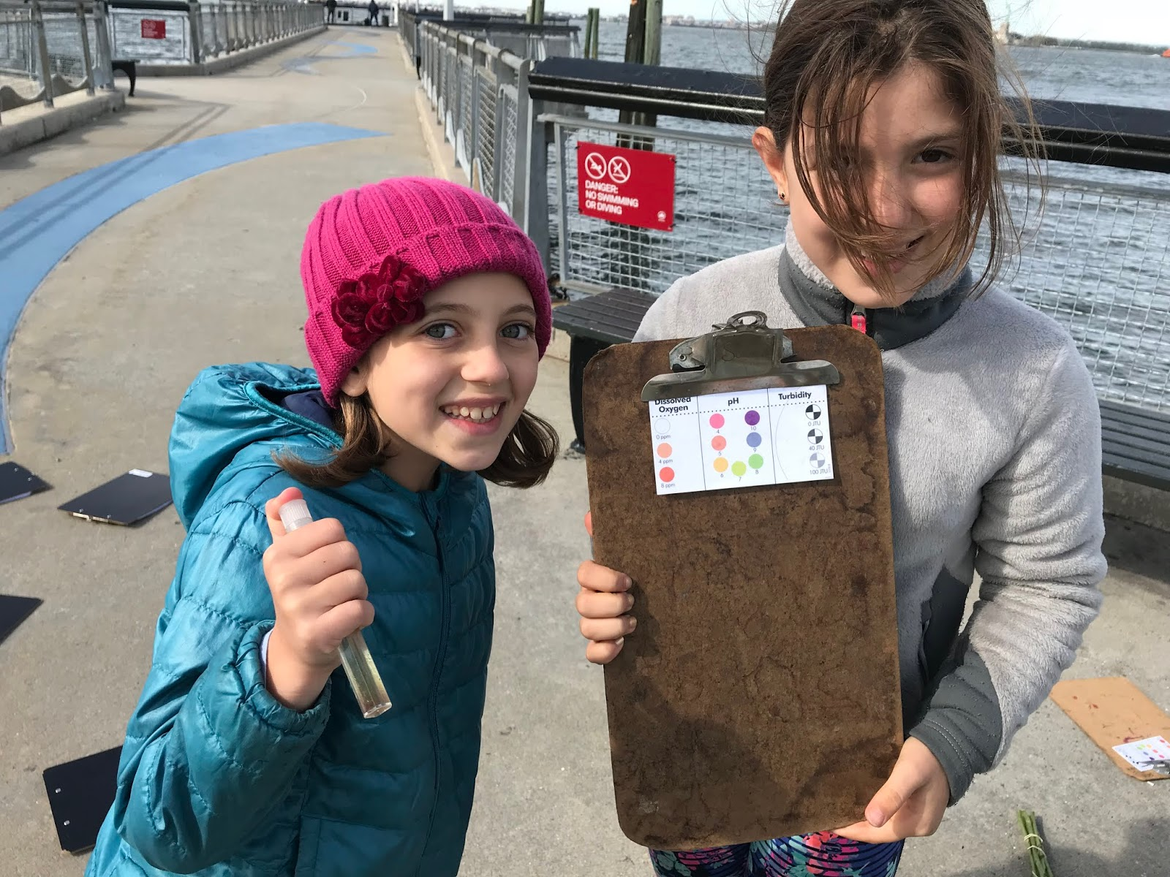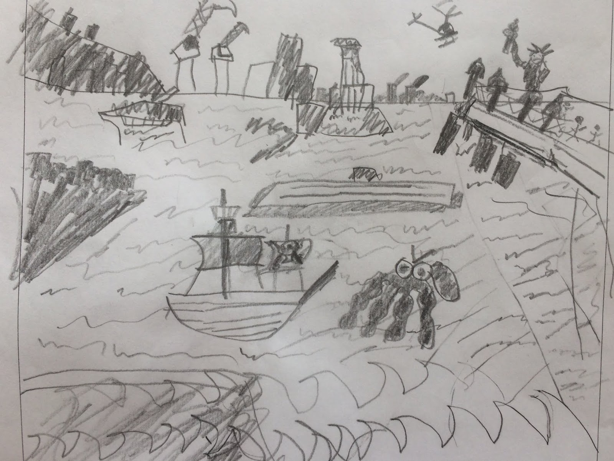
Location: Valentino Pier, Redhook, Brooklyn, NY
Area: A Large pile of rocks with a small rocky beach; large pier
Surrounding Land Use: 5% Beach; 10% Urban/Residential; 75% Industrial/Commercial; 10% other- surrounding area landscaped with seagrasses. Fishing at the end of the pier
Sampling Site: Beach, pier
Shoreline: Riprap
River Bottom: Sandy and Rocky near the little beach area.

ITEM | Time | Reading |  | Comments
Physical
Air Temperature: | NR
Wind Speed: |  | 8-24 mph
Weather Today: | NR
Weather Previous: | NR
Water Temperature | NR
Turbidity - | NR
Chemical
Salinity- hydrometer |  | 10 ppt
pH - Lamotte pH tablets |  | 7
Fish – *From oyster cages | Number | Name | Length of longest | *Seining unsuccessful- high tide and net had a tear
Fish – *From oyster cages | 1 | Tautog |  | *Seining unsuccessful- high tide and net had a tear
Fish – *From oyster cages | TOTAL: 1 | Diversity: 1 |  | *Seining unsuccessful- high tide and net had a tear
Macroinvertebrates | Number | Name | Length of longest
Macroinvertebrates | 1  1  1 | Sea squirts  Snails  Scud  Shore shrimp  Mud Crab
Macroinvertebrates | TOTAL: 3+ | Diversity: 5
Other Observations | Trawled and found plastic and microplastic in all 16 trawls.

