Day in the Life of the Hudson River 10/16/18 Data
VETERANS’ MEMORIAL PIER, BROOKLYN
RIVER MILE: -5
Salt Front: ~RM 24
International School of Brooklyn- Alicia Smith
27 students 5th grade, 4 adults
Latitude 40.6397 N & Longitude – 74.0387 W
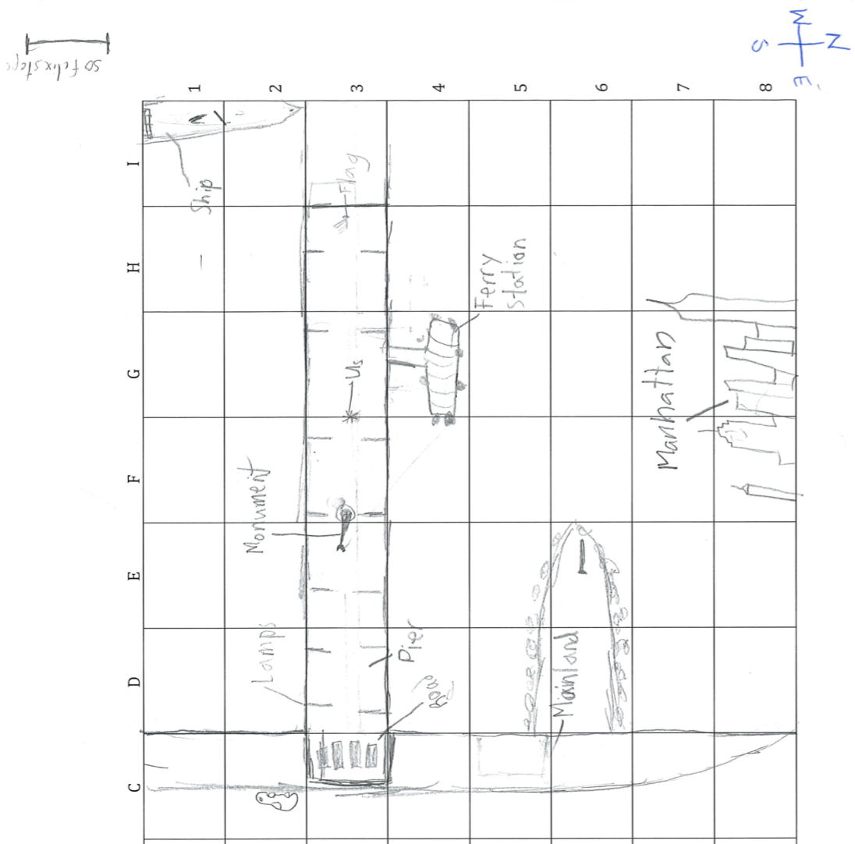
Location: American Veterans’ Memoria Pier, Brooklyn, NY
Area: Veteran’s Pier by the highway; bulkhead- mainly concrete &wood; 2 parks- Owl’s head and Shore Road Park; 2 water treatment plants <0.5 miles to the NE, ferry dock present, highway present, park near by
Surrounding Land Use: 85% Urban/Residential; 5% Industrial/Commercial; 5% Park; 5% Highway
Sampling Site: Saltwater bay; Recreational pier with bulkhead- rocks near the edge, banks altered/riprap; all hard edged, steep wall dividing water from land; pipe entering water from treatment plant.
Shoreline: Rocky
Plants in area: 25% of rocks on the shoreline are covered in vegetation
Water: 9-10 foot depth, choppy

ITEM |  | Time | Reading |  | Comments
Physical
Air Temperature: |  | 10:55 AM  11:38 AM  11:54 AM | 12.4 º C  11.5 º C  15 º C | 54.32 º F  52.7 º F  59 º F
Wind Speed: |  | 11:38 AM | Beaufort 4 | 16 knots | Southwest
Weather Today: |  | No Rain; Overcast (75%+)
Weather Previous: |  | Rain the night before; rain over the weekend prior; cool
Water Temperature |  | 10:49 AM  11:11 AM  11:35 AM | 16 º C  19 º C  18 º C | 60.8 º F  66.2 º F  64.4 º F
Turbidity -  Long sight tube |  | 11:00-12:00 PM | 53.7 cm
Chemical
Salinity- hydrometer |  | 10:49 AM  11:11 AM  11:35 AM | 16 ppt  16 ppt  16 ppt
DO – drop count kit |  | Time | Temp | ppm DO | % saturation
 |  | 11:11 AM | 19 º C | 5 | 52%
pH - meter |  | 10:49 AM  11:11 AM  11:35 AM | 7.6  7.59  7.5
Nitrates |  | 10:49-11:48 AM | <5 ppm |  | LaMotte Estuary wide kit is low resolution
Phosphates |  | 10:49-11:11 AM | <1 ppm |  | LaMotte Estuary wide kit is low resolution
Tides- dock to water |  | Time | Rising, Falling, Still | Height (cm) | Rate of Tidal Change (cm/min)
 |  | 10:55 AM  11:13 AM  11:37 AM  11:55 AM | -  Still  Falling  Still | 212.5  212.5  200  200 | -  0  0.521  0
Currents |  | Cm/second | Knots | North/South | Ebb/Flood/Still
10:55 AM  11:17 AM |  | 12.19  26.42 | 0.237  0.512
Boats | Time | Name | Color | North or South | Loaded or Light
Commercial  Commercial  Commercial Commercial  Commercial  Commercial  Recreational  Recreational | 11:26 AM  11:26 AM  11:26 AM  11:26 AM  11:54 AM  12:00 PM  11:54 AM  12:00 PM | Cruise ship  Ferry  Cargo  Tugboat  Water Taxi  Water Taxi  Speed boats  Speed boats
Other Observations |  | 2 people fishing

