Day in the Life of the Hudson River 10/16/18 Data
DUBO POINT WILDLIFE SANCTUARY, THE ROCKAWAYS
RIVER MILE: -7.1
Salt Front: ~RM 24
QALC Patrick Mohamed & Lileen Ferraro, 34 students, 9-10th grade
Juli Schroeger and staff, Rockland Waterfront Alliance
Latitude 40.599505 N & Longitude – 73.794940 W
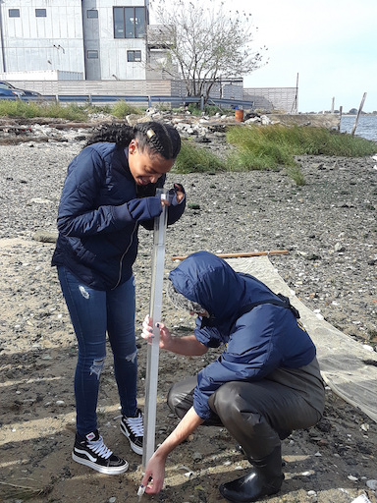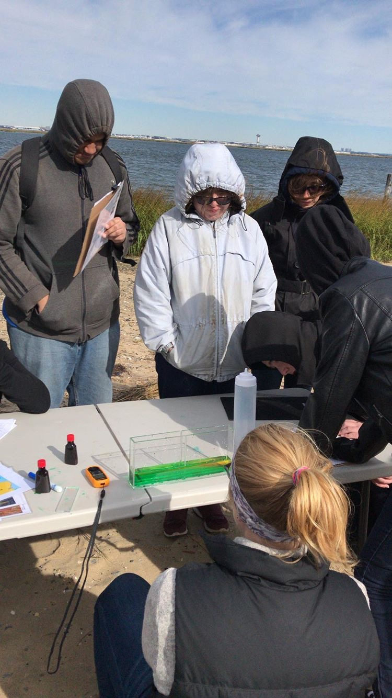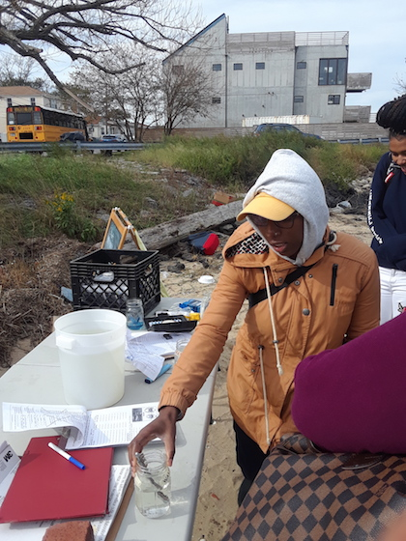

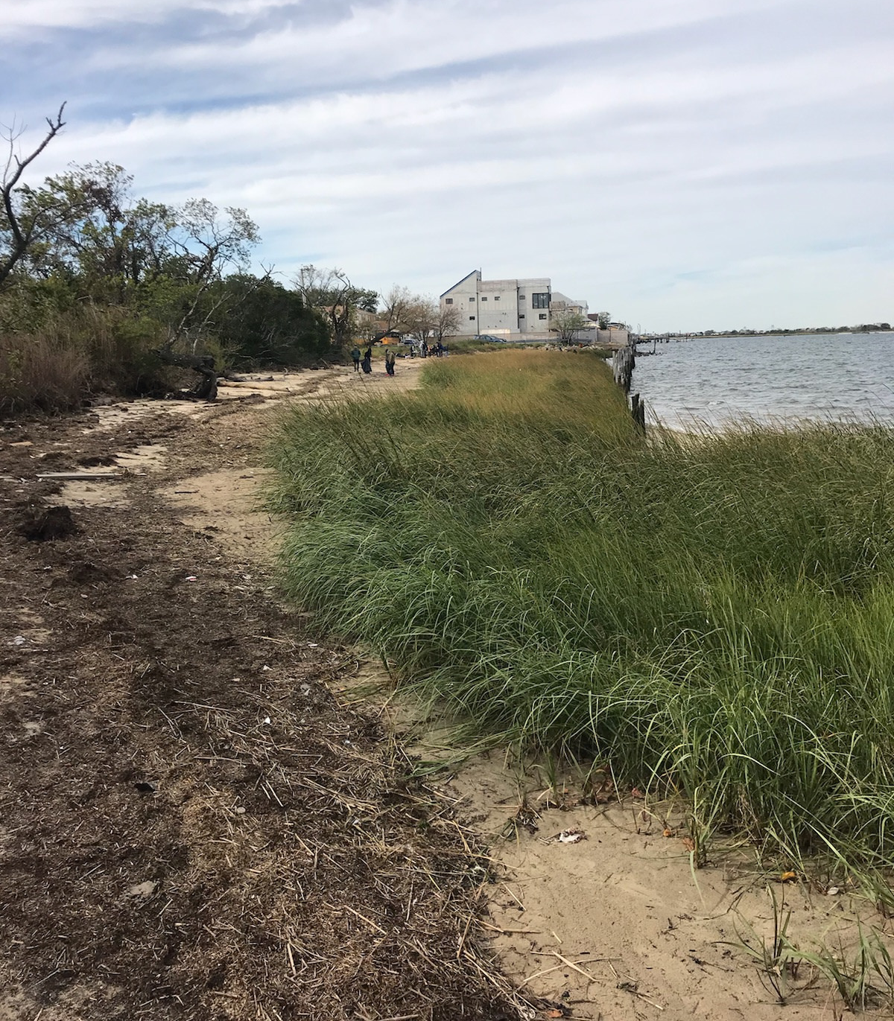
Location: Dubo Point Wildlife Sanctuary, Queens, NY
Area: Wildlife sanctuary; a point that juts out into Jamaica Bay due south of Kennedy International Airport
Surrounding Land Use: 70% Urban/Industrial; 30% Beach
Sampling Site: Open beach area in a wildlife sanctuary set along the waterfront of the Rockaways community
Water: Choppy
Plants in area: 70-80% saltwater cordgrass; 20-30 % reed grass (not identified as phragmites)
River Bottom: Sandy area
Sampled: 10 AM –12 noon
ITEM | Time | Reading |  | Comments
Physical
Air Temperature: | NR | 12.3 º C
Wind Speed: | NR | Beaufort 6 | 11 mph | Water choppy
Weather Today:
Weather Previous:
Water Temperature | NR
Turbidity -  Long sight tube | NR | 35 cm  41 cm  40 cm |  |  | Average 38.67 cm
Chemical
Salinity- hydrometer | Time | Chloride | Total Salinity
Salinity- hydrometer | 10-12 noon |  | 25 ppt
DO – | Time | Temp | ppm DO |  | % saturation
DO – | 10-12 noon | N/R | 8 ppm
pH - used litmus paper which is not an accurate metric for outdoor waterbodies | 10-noon | 6  6  6 | Average 6
Nitrates
Phosphates
Fish - seine | Number | Name | Length of longest
Fish - seine | 11 | Atlantic Silverside
Fish - seine | TOTAL: 11 | Diversity: 1
Macroinvertebrates | Number | Name | Length of longest
Macroinvertebrates | 1  8 | Moon Jelly  Ctenaphore
Macroinvertebrates | TOTAL: 9 | Diversity: 2

