Day in the Life of the Hudson River 10/16/18 Data
FALLING WATERS PRESERVE, RIVER MILE: 100.5
Salt Front: ~RM 24
Saugerties High School- Brian Robinson
20 students 11th -12th grade, 1 adults
Latitude 42.046752 N & Longitude - 73.933907 W
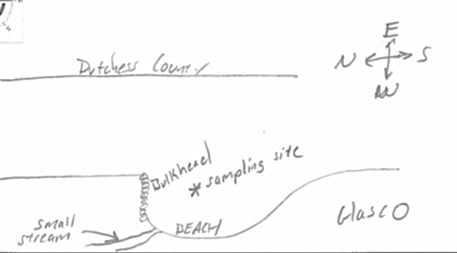
Location: Falling Waters Preserve (protected area), Saugerties, Ulster County, NY
Area: Forested, cove with a shallow beach
Surrounding Land Use: 50% Forested; 50% Beach- mostly forested with a viewing area overlooking the beach/cove area
Sampling Site: Parkland, beach, wood bulkhead, lots of rocks where we sample so not much plant growth
Shoreline: Sandy
Water: depth- 2 feet, calm
Plants in area: 10% water celery; duckweed
River Bottom: Sandy

ITEM |  | Time | Reading |  | Comments
Physical
Air Temperature: |  | 8:20 AM  8:40 AM | 6.8 ºC  6.2 ºC | 44.24 º F  43.16 º F
Wind Speed:

Weather Today: |  | No Rain, Clear (<25% cloud cover)
Weather Previous: |  | Rained yesterday, cold
Current- *measured in a cove |  | cm/second | Rising, Falling, Unchanged | Height (cm) |  | Rate of Change (cm/min)
Water Temperature |  | 8:20 AM  8:27 AM  8:45 AM | Avg: 15.5 ºC  Avg: 14 ºC  Avg: 12 ºC | Avg: 59.9 ºF  Avg: 57.2 ºF  Avg: 53.6 ºF
Turbidity - secchi disk |  | 8:30 AM | 66 cm
Chemical
Salinity- LR Quantabs |  | 8:30 AM - | *51 ppm Cl⁻ | 92 ppm total sal. |  | *Recorded .8ppm so maybe 0.008 %NaCl
DO – drop count kit |  | Time | Temp | ppm DO |  | % saturation
 |  | 8:30 AM | 15 ºC | 10 |  | 96%
Alkalinity- test strips |  | 8:30 AM | 60 ppm
Nitrates |  | 8:30 AM | 2 ppm
Phosphates |  | 8:30 AM | 0.2 ppm
Fish- Seine- 30 feet |  | Number | Name | Length of longest
8:30 AM |  | 4  10  1 | Spottail Shiner  Banded Killifish  Pumpkinseed | 8 cm  7 cm  6 cm
Fish Totals |  | TOTAL: 15 | Diversity: 3
Macroinvertebrates |  | Number | Name | Length of longest
Seine- 30 feet |  | 2 males  1  2 | Blue Crab  Leech  Snails (Eastern Mud)  Tiny mussels
Macroinvertebrate Totals |  | TOTAL: 5 | Diversity: 4
Plankton |  | 20 | Copepods
Currents Flow |  | Cm/second | Knots | North/South |  | Ebb/Flood/Still
8:30 AM |  |  |  | South |  | Ebb
Boats | Time | Name | Color | North or South |  | Loaded or Light
Commercial |  | Independence | White | Northbound |  | Loaded
Other Observations |  | Lots of bricks, few small shell bits, water chestnuts

