Day in the Life of the Hudson River 10/16/18 Data
125th STREET PIER, MANHATTAN
RIVER MILE: 10
Salt Front: ~RM 24
High School of Language and Innovation- Eugene Viderman
20 students 11th -12th grade, 2 adults
Scott Koen, Baylander Ship
Latitude 40.819303 N & Longitude – 73.961445 W
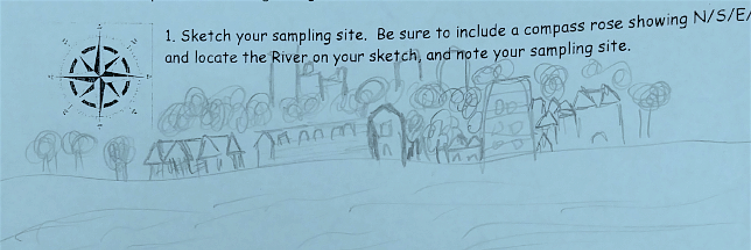
Location: 125th Street Pier, Manhattan, NY
Area: Concrete pier used for boating and fishing, beach
Surrounding Land Use: 100% Urban/Residential
Shoreline: Rocky, Beach
Sampling Site: On the pier
Plants in area: No plants in the water area
Water: Choppy
River Bottom: Muddy

ITEM |  | Time | Reading |  | Comments
Physical
Air Temperature: |  | 12:01 PM | 11.1 º C | 52 º F
Wind Speed: |  | 12:01 PM | Beaufort 2 | 10 mph | Northeast
Weather Today: |  | Mostly Cloudy (51-75%)
Current- *measured in a cove |  | cm/second | Rising, Falling, Unchanged | Height (cm) |  | Rate of Change (cm/min)
Water Temperature |  | 10:50 AM | 12 º C | 53.6 º F
Chemical
Salinity- Hydrometer |  | Time | Total Salinity
 |  | 10:50 AM | Hydrometer is broken
Fish |  | Number | Name | Length of longest |  | *No fish
 |  | TOTAL: | Diversity: |  |  | *No fish
Macroinvertebrates |  | Number | Name | Length of longest
 |  | 1  14  14  84 | Blue Crab  Grass Shrimp  Harris Crab  Edotea Isopod | Male
 |  | TOTAL: 113 | Diversity: 4
Currents Flow |  | Cm/second | Knots | North/South |  | Ebb/Flood/Still
12:30 PM  12:32 PM |  | 1.2  1.3 | 0.0233  0.0253 | South  South |  | Ebb  Ebb
Sediment Core |  | Description | Abundant | Common |  | Rare
 |  | Length 39 cm  Sulfur Smell  Oil visible | Clay  Mud | None listed |  | Sand
Boats | Time | Name | Color | North or South |  | Loaded or Light
Commercial | 11:30 |  | Black | North |  | Loaded
Other Observations |  | Seagulls, shell pieces, full shells, crab carapaces

