Day in the Life of the Hudson River 10/16/18 Data
COHOTATE PRESERVE
Coxsackie, NY - RIVER MILE: 115
Salt Front: ~RM 24
Coxsackie Athens High School, Environmental Science
18 students 12th grade, 1 adults
Andrew Randazzo, Cornell Cooperative Extension of Greene County
Anthony Loughran, Coxsackie Athens HS
Latitude 42º14.642’ N & Longitude 73º 50.359’W
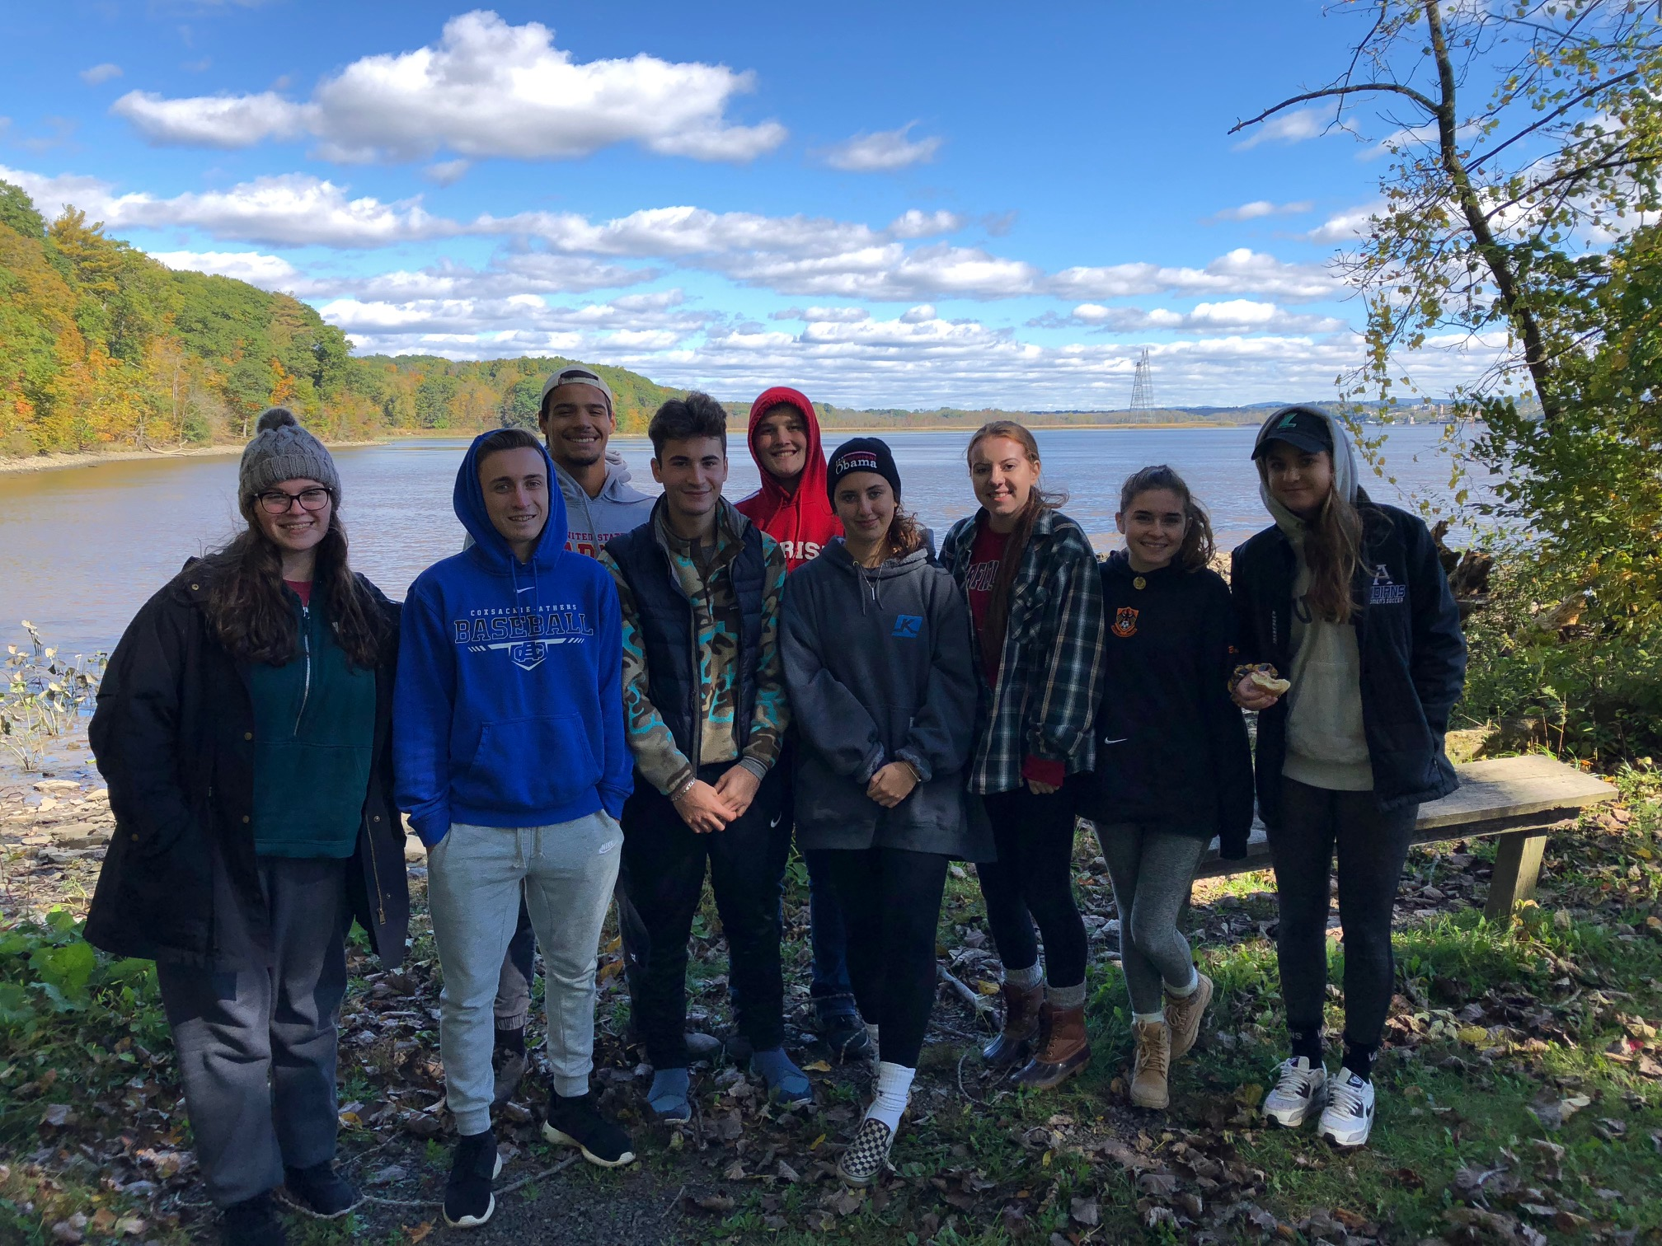

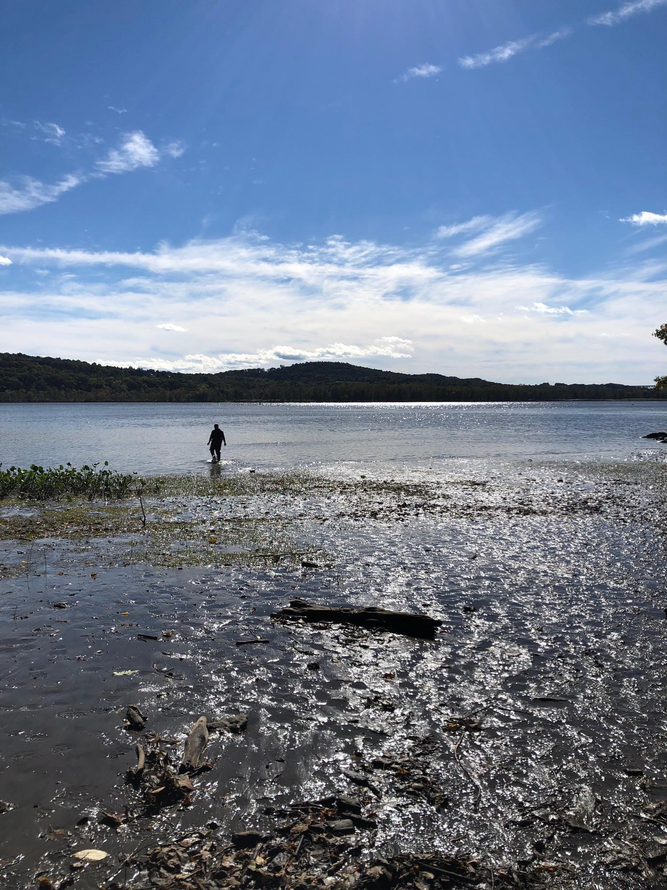
Location: Cohotate Preserve- Ice house site
Area: The ice house is flat, grassy, and on the river with several cotton wood trees. It is situated at the bottom of a forested hill. Large waterfront vegetation. The artificial shoreline of the bulkhead dominates the eastern shore. Shoreline is characterized by tidal mudflats. Area is used recreationally for picnicking, hiking, and fishing. Ice house is approximately ½ mile walk from the parking area.
Surrounding Land Use: 85% forested, 10% beach, 5% urban/residential
Sampling Site: Beach area, shoreline includes tidal mud flats in the southeast and a rocky shore further south. To the north of the tidal mud flat there is an old bulkhead with another tidal flat to the nor of the bulkhead, riprap in sections. The banks have been altered at the bulkhead (entire ice house area is likely dredge spoil), wood and debris are collected in the southern mudflat, there is a lot of vegetation and no pipes entering the water. Brick pieces on the shoreline.
Strong winds caused ‘blow out’ tides in some areas of the estuary exposing large mudflats along the riverfront.
Shoreline: 10% sandy, 45% muddy, 45% rocky
Water Depth: 2 feet
Plants in area: 5% Spatterdock, water chestnut seeds
River Bottom description: muddy, weedy

ITEM | Time | Reading |  | Comments
Physical
Air Temperature | 9:15 AM  10:59 AM  12:00 PM | 10 ºC  13.34 ºC  15.56 ºC | 50 º F  56 º F  60 º F
Wind Speed: anemometer |  | 3 mph | 2.6 knots
Weather today | No rain, clear
Weather recently | Rain
Water Temperature | 9:30 AM | 15 º C | 59 º F
Turbidity - long sight tube | 10:00 AM | 75cm, 78cm, 76cm |  | Average: 76.5cm
Chemical
Salinity- Low Range Quantabs | 9:30 AM | 38-48 ppm Cl⁻ | ~77.68 ppm Total salinity
DO – Sparkview Pasco Probe | Time | Temp | ppm DO | % saturation
 | 9:40 AM  9:50 AM | 15 º C  15 º C | 8.05  8.17 | 80%  80%
pH – meter | 9:25 AM | 7.69 | 7.59 | Average 7.65
Fish | Number | Name | Length of longest
Seine | 72  1  2  14  13  7  2  11 | Spottail Shiner  Brown Bullhead  Channel Catfish  American Shad  Banded Killifish  White Perch  Striped Bass  Tessellated Darter |  | Comment:  *Site reported one Striped Killifish which would be unrealistic so we added to the banded killifish total.
Fish Totals | TOTAL: 122 | Diversity: 8
Macroinvertebrates | Number | Name | Length of longest
 | 18 | Blue Crab
Macroinvertebrate Totals | TOTAL: 18 | Diversity: 1
Boat Traffic | Name | Color | North or South | Loaded or Light
9:50 AM  11:27 AM | Boat  Boat | Gray  Blue and White | North  North | Light  Light

