Day in the Life of the Hudson River 10/16/18 Data
SCHODACK ISLAND
Schodack Landing, Rensselaer County, NY
RIVER MILE: 133.4
Salt Front: ~RM 24
Berkshire Waldorf High School, Earth Science Class-
12 students 10th grade, 2 adults
Lee Magadini, Berkshire Waldorf HS
Latitude 42.499487 N & Longitude – 73.776702 W

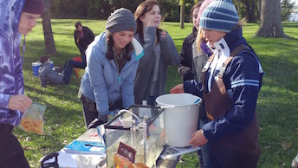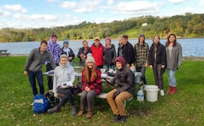
Location: Schodack Island State Park, Schodack Landing, Rensselaer County, NY
Area: 1052 acres- park and boat launch area- grassy area with concrete walkway, parking lot, and boat launch.
Surrounding Land Use: 100% parkland for recreation
Sampling Site: Boat landing
Shoreline: Rocky; banks altered, riprap, concrete bulkhead, pipe entering the water.
Water Depth: Deep drop off from the bank; choppy
Plants in area: No plants in the water area.
River Bottom description: rocky (sharp drop off beyond bulkhead)

ITEM | Time | Reading |  | Comments
Physical
Air Temperature | 10:09 AM  10:35 AM  11:17 AM | 10 ºC  10 ºC  10 ºC | 50 ºF  50 ºF  50 ºF
Wind Speed: | 9:45 AM | Beaufort: #2 | West
Weather today | No rain, partly cloudy (26-50%)- Strato-cumulous
Weather recently | 10/14 sunny; 10/15 rain, heavy at times; 10/16 sunny with clouds
Water Temperature
Turbidity - secchi disk | 10:55 AM | 54 cm, 60 cm, Avg: 57 cm |  | Muddy, brown, and murky; reading taken from floating dock at boat launch.
Chemical
Salinity- Low Range Quantabs | 10:01 AM | 31 ppm Cl⁻ | Total salinity  56 ppm
DO – | Time | Temp ºC | ppm DO | % saturation
 | 9:57 AM  10:10 AM | 7.5  10 | 12  13 | 100%  116%
pH – color match test kit | 10:26 AM | 7.6
Nitrate - Drops -personal kit | 10:40 AM | 0 ppm
Nitrite – Drops -personal kit | 10:40 AM | 0.5 ppm
Ammonia – Drops -personal kit | 10:40 AM | 0 ppm
Fish – seine net from DEC | Number | Name | Length of longest
10:55 AM  (2 seines total) | 3 | Banded Killi | 10 cm
Fish Totals | TOTAL: 3 | Diversity: 1
Boat Traffic Commercial | Name | Color | North or South | Loaded or Light
Tides- tide stick tied to post in the water | Time | Rising, Falling, Unchanged | Height (cm) | Rate of Tidal Change (cm/min)
 | 10:36 AM  11:04 AM  11:33 AM | -  Falling  Falling | NA  -10 cm  -10 cm | -  0.36  0.34
Current- | cm/second | Knots | North/South | Ebb/Flood/Still
9:49 AM  10:37 AM  11:15 AM | 14.3  29.4  28 | .28  .57  .54 | South  South  South | Ebb  Ebb  Ebb
9:36 AM | Panvision | Black/Red- US flag | North | Huge Commercial Freighter!
Recreational | Name | Color | North or South | Loaded or Light
9:47 AM | Island | White/Green | South | Sailboat
Other Observations | 10:58 AM Bald Eagle flying over river south of launch | Full shells of 3-5 mm clams at boat launch

