Day in the Life of the Hudson River 10/16/18 Data
RENSSELAER RIVERFRONT PARK
Rensselaer County, NY
RIVER MILE: 144.5
Salt Front: ~ RM 24
Poestenkill Elementary School & Delaware Community School-
120 students 4th grade and a total of 24 adults:
John Bishop and 3 other teachers, Poestenkill ES &
Willow Zielenski and 7 other teachers, Delaware Community School
Alene Onion, Sarah Rickard and 10 other NYS DEC Staff
2 Fish Biologist from Region 4
Latitude 42.642375 N & Longitude – 73.746393 W
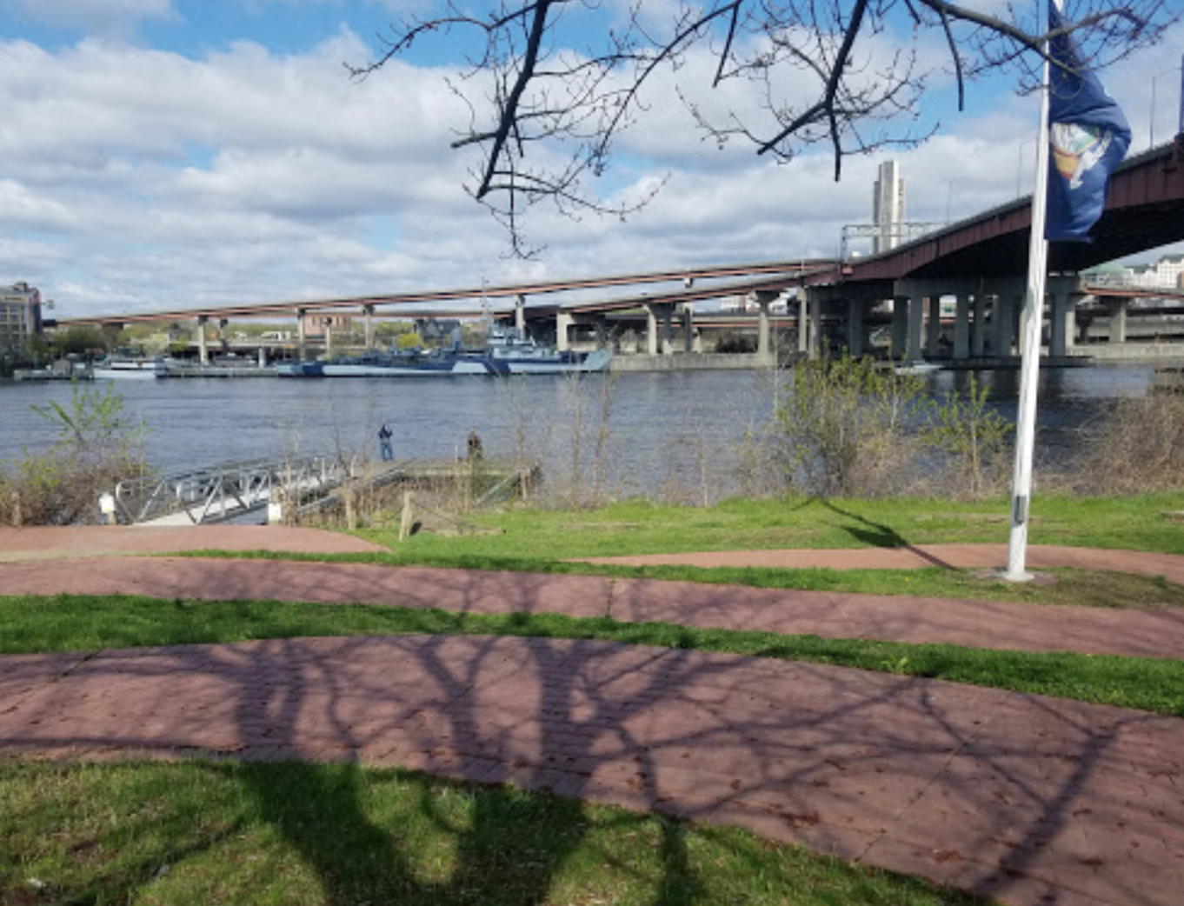
(photo shows dock and waterfront – by Michael Clark on Google maps)

Location: Rensselaer Riverfront Park, Rensselaer County, NY
Area: East side of the Dunn Memorial Bridge, 1.5 acre grassy park with walking esplanade, a few trees, fishing dock
Surrounding Land Use: Parkland (1.5 acre), Industrial/commercial, urban residential
Sampling Site: Off of the dock and waterfront
Shoreline: Sections with banks altered, sections left more natural
Sample Timeframe 10:00 AM – 1:00 PM

ITEM | Time | Reading |  | Comments
Physical
Air Temperature | 10:00 AM – 1:00 PM | 13 ºC  15.2 ºC  15.5 ºC | 55.4 ºF  59.36 ºF  59.9 ºF | Temperature at 4.6 meters
Wind Speed: Beaufort Force | 10:30 AM  11:00 AM  11:30 AM  12:00 PM  12:30 PM | 4-7 mph  -  -  4-7 mph  4-7 mph | Beaufort: #2 | Southeast  Southeast  -  Southeast  Southeast
Water Temperature | 10:00 AM – 1:00 PM | 14.43 ºC  14.4 ºC  14.43 ºC  14.50 ºC  14.54 ºC | 57.97 ºF  57.92 ºF  57.97 ºF  58.1 ºF  14.54 ºF
Turbidity - secchi disk | 10:00 AM- 1:00 PM | 180 cm, 190 cm, 230 cm, 180 cm |  | Avg: 195 cm
Chemical
Salinity- Low Range Quantabs | 10:00 AM – 1:00 PM | <1.4 quantab units | <32 ppm Cl⁻ | Below Detection for this instrument
DO – | Time | Temp | ppm DO | Specific conductivity
 | 10:00 AM – 1:00 PM | 14.43 ºC  14.4 ºC  14.43 ºC  14.50 ºC  14.54 ºC | 8.29  -  8.36  8.45  8.37 | 210.9  -  213.9  216.0  217.3
pH – | 10:00 AM – 1:00 PM | 7.47, 7.63, 7.81, 7.68
Fish | Number | Name | Length of longest
Fish Totals | TOTAL: | Diversity:
Macroinvertebrates | Number | Name | Length of longest
Overall assessment of water quality using macro community is GOOD! | 2  2  1  1  1 | Mayfly  Riffle Beetle  Damselfly  Dragonfly  Worm | High Quality  High Quality  Moderate  Moderate  Low Quality | Pollution Intolerant  Pollution Intolerant  Moderately Tolerant  Moderately Tolerant  Pollution Tolerant
Macroinvertebrate Totals | TOTAL: 7 | Diversity: 5
Tides- | Time | Rising, Falling, Unchanged | Height (cm) | Rate of Tidal Change (cm/min)
 | 10:30 AM  11:00 AM  11:30 AM  12:00 PM  12:30 PM | -  -  Rising  Rising  Falling | 360  -  390  450  390 | -  -  .5  2  2
Current- | cm/second | Knots | North/South | Ebb/Flood/Still
 | 25  28  19.5  18.7 | 0.49  0.54  0.38  0.36 | South  South  South  South | Ebb  Ebb  Ebb  Ebb
Boat Traffic Totals | Name | Color | North or South | Loaded or Light
5 Boats Total

