Day in the Life of the Hudson River 10/16/18 Data
RENSSELAER BOAT LAUNCH
Forbes Road, Rensselaer, NY
RIVER MILE: 146
Salt Front: ~ RM 24
Tech Valley High School & Troy’s School 2-
76 students 9th & 5th grade, 7 adults
Dawn Baldwin, The Children’s Museum of Science and Technology
Ashley Phillips, Tech Valley
Ann Jabour, School 2
42.658 Lat and -73.735 Long

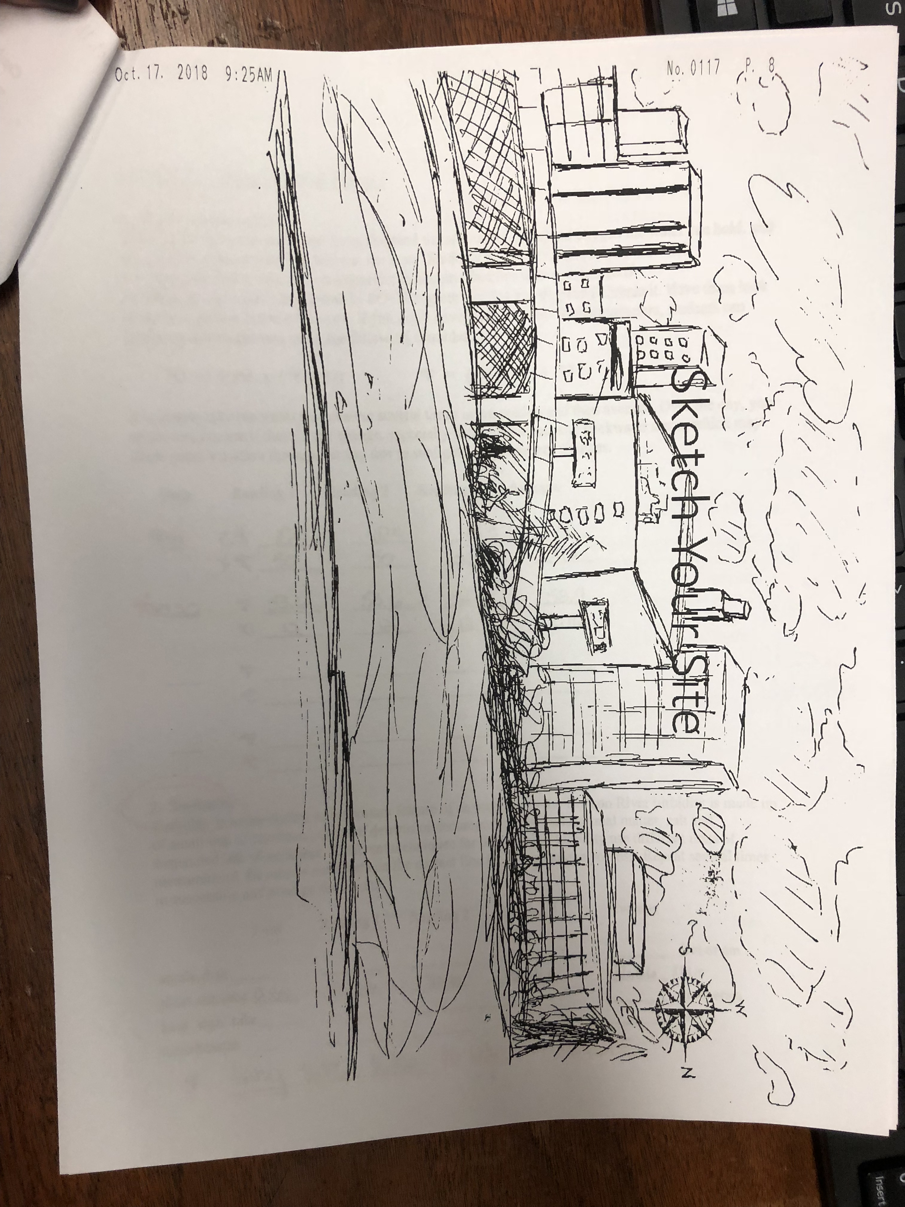
Location: Rensselaer Boat Launch
Area: Boat Launch with small beach area , wooded, landscaped, adjacent to urban residential area
Surrounding Land Use: 30% urban/residential, 10% forested, 15% beach, 30% industrial/commercial, 15% park
Sampling Site: Concrete boat launch with beach (sandy, small rocks)
Shoreline: Beach area, concrete boat launch
Plants in area: No visible plants in water, but a few water chestnut seeds on the beach
Water Depth: 2-4 feet
River Bottom description: sandy, rocky
Other: Flock of 50+ Canadian Geese landed on the river and rested for a few minutes
ITEM | Time | Reading |  |  | Comments
Physical
Air Temperature | 8:45 AM  10:15 AM | 6.1 ºC  8.3 ºC | 43ºF  47 ºF
Wind Speed: Beaufort | Morning  Afternoon | 1  2 | Southwest  Southwest
Weather today | Partly cloudy
Weather recently | Rainy Saturday and Monday; cool temperatures with rain overnight.
Water Temperature | 9:41 AM  10:30 AM | 10 ºC, 10 ºC, 13 ºC  12 ºC, 12 ºC, 12.5 ºC | 50 ºF, 50 ºF, 55.4 ºF  53.6 ºF, 53.6 ºF, 54.5 ºF | Avg: 11.6 ºC  Avg: 51.8 ºF  Avg: 12.17 ºC  Avg: 53.9 ºF
Turbidity - short sight tube | 9:30 AM | 40 JTU, 30 JTU, 40 JTU |  |  | Avg: 36.67 JTUs
Chemical
Salinity | 10:00 AM | <1 quantab unit | (Below Detection) | LR Quantabs
DO – drop count | Time | Temp | ppm DO | % saturation
 | 9:40 AM | 10 ºC | 5 | 44%
pH – test strips | 10:23 AM | 6.3, 6.4, 6.4 |  |  | Avg: 6.37
Nitrate | 9:45 AM | .01 ppm, .01 ppm, .01 ppm |  |  | Avg: .01 ppm
Phosphate | 9:40 AM | 1 ppm X 3 |  |  | Avg. 1.0 ppm
Fish – seined with DEC fisheries team – 12 ft. net | Number | Name | Length of longest
Seine 1:  Seine 2: | 20  1  ________  40  1 | Spottail Shiner  Tesselated Darter  ______  Spottail Shiner  Banded Killifish | (Total Spottail – 60)
Fish Totals | TOAL: 62 | Diversity: 3
Tides | Rising, Falling, Unchanged | Height (cm) | Rate of Tidal Change (cm/min)
8:30 AM  10:00 AM  10:30 AM | Rising  Rising  Rising |  |  | No place to put the tide stick.
Currents | Cm/second | Knot | North/South | Ebb/Flood/Still
9:30 AM  9:45 AM  10:00 AM  10:15 AM | 9.14  15.24  9.14  11.17 | 0.178  0.296  0.178  0.217 | South  South  South  South | Ebb  Ebb  Ebb  Ebb
Other Observations | Flock of 50 plus Candian Geese landed on the river and rested for a few minutes at 8:30 AM |  | 2 car CSX train on the track behind the group at 10:38
“Forty-five 9th graders from Tech Valley high became the teachers today to a group of 32 5th graders from Troy’s School 2. Friends were made, lessons were learned, fish were caught. Science and fresh air made for a great day at the Rensselaer Boat Launch”

