Day in the Life of the Hudson River 10/16/18 Data
HUDSON SHORES PARK, WATERVLEIT
Albany County, NY
RIVER MILE: 152
Salt Front: ~RM 24
North Colonie CSD Learning Enrichment Program-
49 students 5th grade, 4 adults
Amy Parks & Stacey Shepard, North Colonie
Latitude 41.471 N & Longitude - 74.016 W
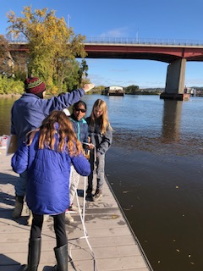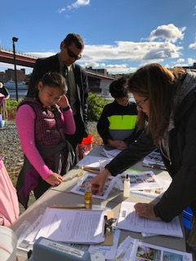

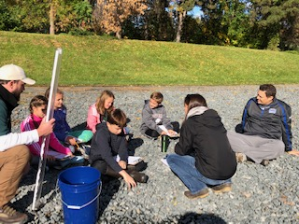
Location: Hudson Shores Park, Watervleit, Albany County, NY
Area: Rowing dock at park right on the river’s edge
Surrounding Land Use: Fishing launch, dock, parking lot, rocky, trees, bushes
Sampling Site: 10% Beach at low tide; 70% Park/Parking area; 20% Planted/forested; (across the river) 100% Industrial/Commercial. Noisy from the highway.
Shoreline: Rocky and muddy, vegetation, riprap
Water Depth: 8+ feet, calm
Plants in area: No plants in water area
River Bottom description: sand/mud, rocky
Other: Geese, turkey vultures

ITEM | Time | Reading |  | Comments
Physical
Air Temperature | 9:19 AM  9:55 AM  10:19 AM  10:55 AM  11:38 AM  12:03 PM  12:29 PM  12:50 PM | 15 ºC  15 ºC  15 ºC  13 ºC  13 ºC  12 ºC  14 ºC  20 ºC | 59  59  59  55.4  55.4  53.6  57.2  68
Wind Speed: Beaufort Force | 9:36 AM  9:55 AM  10:25 AM  11:00 AM  11:47 AM  12:05 PM  12:29 PM  12:52 PM | #1  #4  #2  #3  #2  #2  #1  #1
Weather today | Partly to mostly cloudy (56-75%)
Weather recently | 0.5” rain
Water Temperature
Turbidity - long sight tube | 9:15 AM  9:45 AM  10:14 AM  10:50 AM  11:30 AM  11:50 AM  12:20 PM  12:41 PM | 80 cm, 81.5 cm, 96 cm = 86 cm  74 cm, 80.8 cm, 86 cm= 81 cm  80 cm, 82 cm, 90 cm= 84 cm  75 cm, 74 cm =74.5 cm  72.8 cm, 69.2 cm, 78.9cm=73.6 cm  72 cm, 72 cm, 72 cm = 72 cm  76 cm, 90 cm, 94 cm= 86.7 cm  84 cm, 89 cm = 86.5 cm
Chemical
Salinity- Low Range Quantabs | 10:15 AM  12:27 PM | Quantab Unites  1.2  1.2 | Chloride  32 ppm Cl⁻  32 ppm Cl⁻ | Total Salinity  57.9 ppm  57.9 ppm
DO – drop count kit | Time | Temp | ppm DO | % saturation
 | 9:18 AM  9:49 AM  10:17 AM  10:47 AM  11:34 AM  12:03 PM  12:28 PM  12:52 PM | 14 ºC  13 ºC  13 ºC  15 ºC  14 ºC  12 ºC  13 ºC  13 ºC | 7  6  8  9  11  9  8  9 | 69 %  55 %  75 %  85 %  110 %  84 %  75 %  85 %
pH – color match test kit | 9:31 AM  10:02 AM  10:30 AM  10:57 AM  11:48 AM  12:13 PM  12:40 PM | 7.5  7.5  7.3  7.4  7.5  6.9  7.5
Fish | Number | Name | Length of longest (cm)
Seine- 12 ‘ | 1 | Banded Killifish | 2 cm
Fish Totals | TOTAL: 1 | Diversity: 1
Tides- | Time | Rising, Falling, Unchanged | Change (cm) | Rate of Tidal Change (cm/min)
Note: measured from the edge of the water to tape on the ground  HT in Troy was noted as 11:22 AM | 8:45 AM  9:16 AM  10:03 AM  10:56 AM  11:36 AM  12:16 PM  12:27 PM  12:49 PM | -  Unchanged  Falling  Rising  Falling  Falling  Falling  Falling | 100  100  120  *92  356  468  510  550 | -  0  0.43  *mistake or wave?  2.8  3.8  1.8
Current- | cm/second | Knots | North/South | Ebb/Flood/Still
9:27 AM  9:50 AM  10:30 AM  10:54 AM  11:45 AM  12:12 PM  12:37 PM  12:56 PM | 24.7  17.7  28  24  34  23.6  25.4  32 | 0.48  0.34  0.54  0.47  0.66  0.46  0.49  0.62 | South  South  South  South  South  South  South  South | Ebb  Ebb  Ebb  Ebb  Ebb  Ebb  Ebb  Ebb
Boat Traffic – commercial | Name | Color | North or South | Loaded or Light
9:20 AM  10:20 AM  12:59 PM | Tugboat  Corning Glass Barge  Erie Canal Cruise Boat | Black/white  White/black  White | Northbound  Southbound  Southbound | Light  Light  Light

