Day in the Life of the Hudson River 10/16/18 Data
GREEN ISLAND PARK
Green Island, NY
RIVER MILE: 153
Salt Front:~ RM 24
Rensselaer Polytechnic Institute- 16 students, undergraduates
Classical Conversations- 11 students 6th – 10th grade, 5 adults
Sarah Cadieux, RPI
Eleni Solar, Classical Conversations
Latitude 42.7481671 N & Longitude – 73.6889391 W

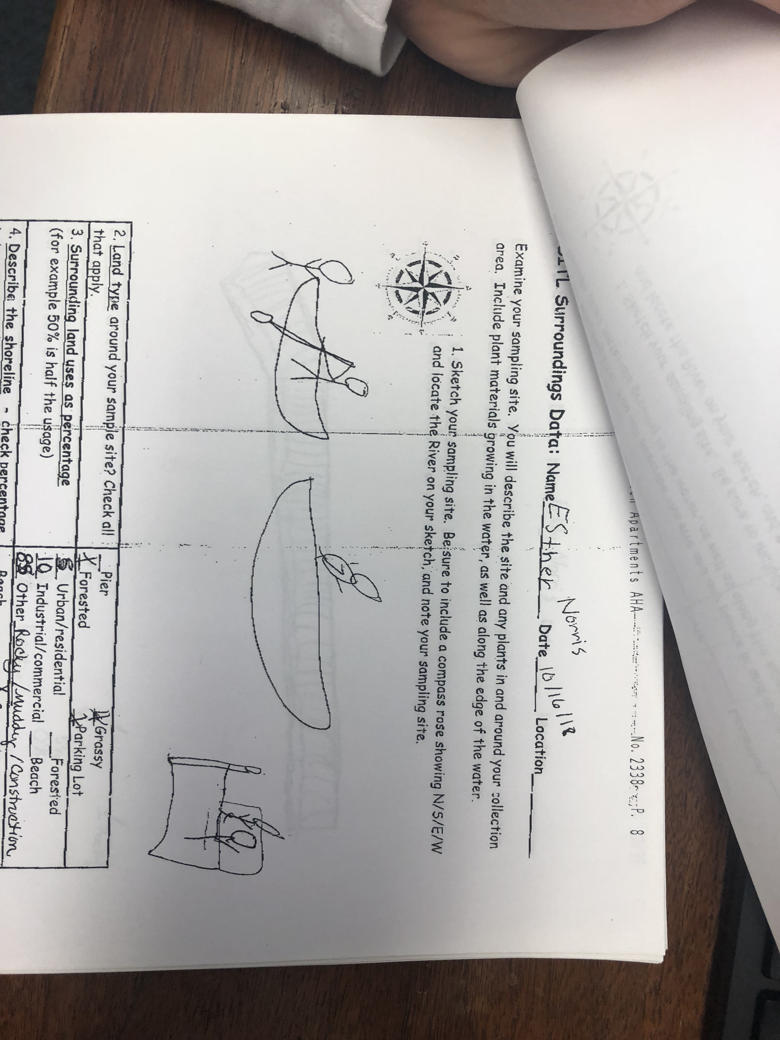
Location: Green Island Park boat ramp, below the Troy Dam, Albany County, NY
Area: Beach area with a lot of vegetation, very muddy and rocky. The Troy dam is directly to the north.
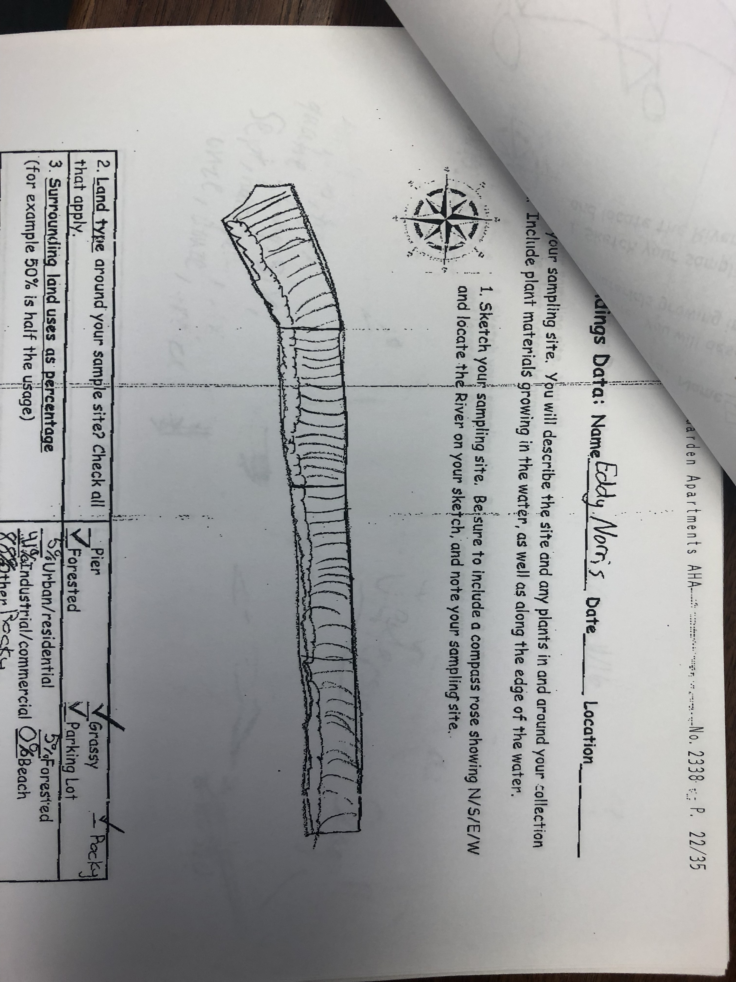
Surrounding Land Use: 88% Rocky; 41% Industrial/Commercial; 5% Urban/Residential, 5% Forested
Sampling Site: Beach; banks altered; riprap (large rocks); concrete bulkhead; pipe entering the water
Shoreline: 80% Rocky; 20% Muddy
Water Depth: 2-4 feet
Plants in area: No plants in water area; leaf litter on ground
River Bottom description: muddy, weedy, rocky
Troy Dam

ITEM | Time | Reading |  | Comments
Physical
Air Temperature | 2:39 PM | 12 ºC | 53ºF
Wind Speed: anemometer | 2:40 PM  2:41 PM  2:41 PM  2:41 PM  2:45 PM  2:45 PM  2:45 PM | 3.1 knots  3.0 knots  2.7 mps = 5.2 kts  3.1 kts  2.7 mps= 5.2 kts  4.8 mps= 9.3 kts | Beaufort #2  Beaufort #1  Beaufort#0.5  Beaufort #1  Beaufort #1 | North  North  North  Northwest
Weather today | No rain, partly cloudy (26-50%)
Weather recently
Turbidity - long sight tube | 3:00 PM  3:07 PM  3:10 PM  3:15 PM  3:15 PM | 66.4 cm  66.4 cm  66.4 cm  66.4 cm, 40.8 cm  66.4 cm, 70.8 cm
Chemical
Salinity- Low Range Quantabs | 3:30 PM | <32 ppm Cl⁻ |  | *Below Detection
pH – Test strips | 3:15 PM  3:20 PM  3:24 PM | 7, 6, 6, Avg: 6.33  6, 6, 7, Avg: 6.33  6, 7, 6, Avg: 6.33
Fish | Number | Name | Length of longest
DEC electro-shocker | 3  1  1  3  2  1  1 | Catfish  Shorthead Red Horse (Sucker)  Sunfish  American Eel  Walleye  Striped Bass  Small Mouth | YOY | * Each group looked at the bucket of fish that the DEC caught with an electro-shocker. They didn’t have enough time to do a comprehensive fish count.
Fish Totals | TOTAL: 12 | Diversity: 7
Macroinvertebrates | Number | Name | Length of longest
 | 1 | Crayfish
Macroinvertebrate Totals | TOTAL: 1 | Diversity: 1
Tides- tide stick | Time | Rising, Falling, Unchanged | Height | Rate of Tidal Change (cm/min)
 | 2:10 PM  3:30 PM | -  Falling | -  8” lower | -  0.1
Current- | cm/second | Knots | North/South | Ebb/Flood/Still
2:55 PM  3:10 PM | 38.1  33.2 | 0.74  0.65 | South  South | Ebb  Ebb
Boat Traffic | Name | Color | North or South | Loaded or Light
2:21 PM | Dutch Apple Cruise | White | North | People on boat

