Day in the Life of the Hudson River 10/16/18 Data
SARAH LAWRENCE COLLEGE CURB: BECZAK, RIVER MILE: 18.3
Salt Front: ~RM 24
High School for Environmental Studies – Sean Abbot-Klafter
30 students 11th -12th grade, 5 adults
Elisa Caref, SLL CURB
Latitude 40.938483 N & Longitude -73.90291 W
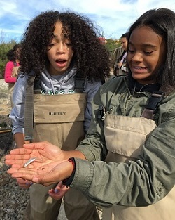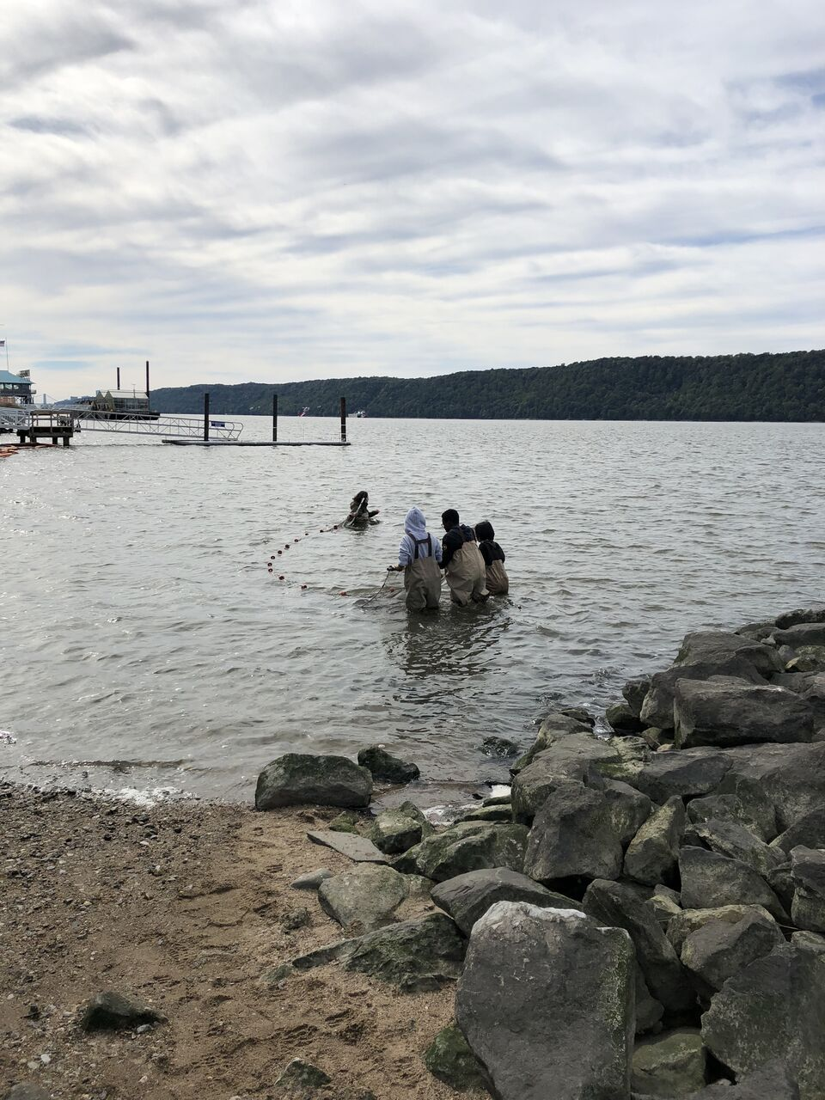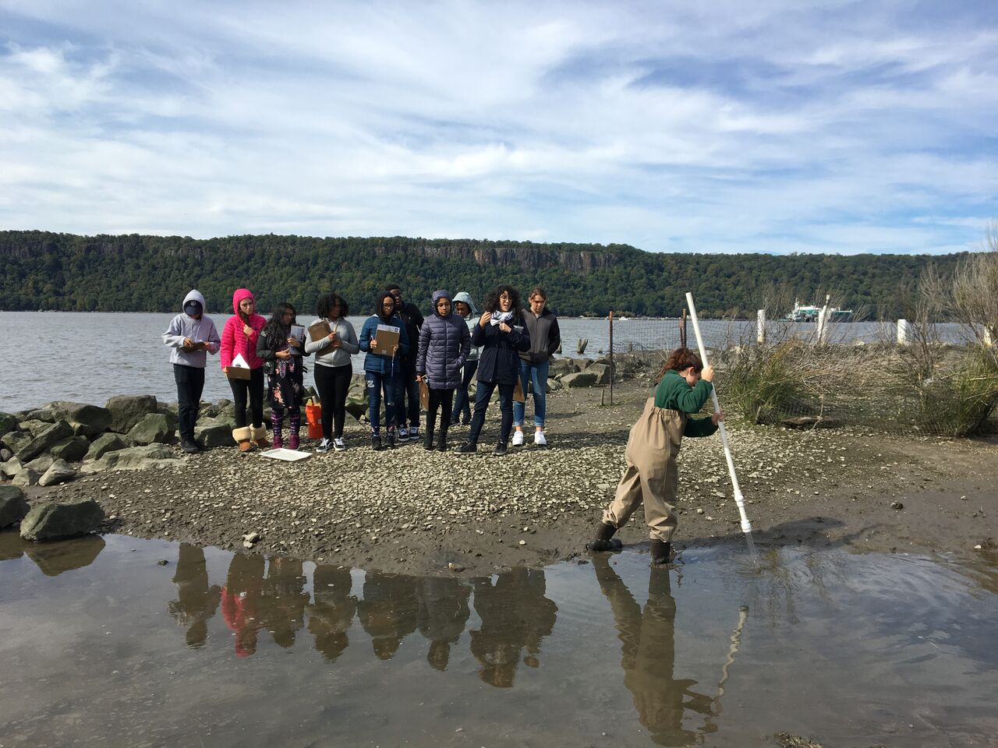
Location: Sarah Lawrence College CURB at Beczak, Habirshaw County Park, Yonkers, Westchester County, NY
Area: 2 acre riverfront county park covered mostly by a grass lawn leading down to the river where it meets a tidal wetland and sandy beach. Property used for fishing, boats, seining, field trips and some education programs.
Surrounding Land Use: 75% Urban/Residential; 25% Beach/Waterfront
Sampling Site: Sandy beach, tidal marsh area covered with vegetation, banks altered, large riprap on shoreline, collected wood/debris in area
Plants in area: No plants in the water area; however in the marsh, there is mud wort, reed grass, salter cordgrass, big cordgrass
River Bottom: Muddy
ITEM | Time | Reading |  | Comments
Physical
Air Temperature: |  | 17 º C | 60 º F
Wind Speed: | 12:11 AM  12:40 PM  1:02 PM | Beaufort 2 Beaufort 2  Beaufort 2 | Northwest Northwest  Northwest
Weather Today: | No rain, partly to mostly cloudy
Water Temperature-  YSI Probe  Thermometer | 11:59 AM  12:40 PM  1:10 PM  11:59 AM  12:40 PM  1:10 PM | 15.6 º C  16.1 º C  16.1 º C  15 º C  15 º C  15 º C | 60.08 º F  60.98 º F  60.98 º F  59 º F  59 º F  59 º F
Turbidity -  YSI Probe  Long site tube | 11:59 AM  12:40 PM  1:10 PM  11:59 AM  12:40 PM  1:10 PM | 10.4 NTU  10.8 NTU  8.3 NTU  35 cm  35 cm  40 cm
Chemical
Salinity-  YSI Probe  ____________________  *Hand tool - hydrometer or Refractometer? | Time | Total Salinity |  |  | *hydrometer is low resolution in comparison to YSI. 0 ppm isn’t realistic; maybe it was out of hydrometer range.
 | 11:59 AM  12:40 PM  1:10 PM | 1.15 ppt  1.08 ppt  0.950 ppt
 | 11:59 AM  12:40 PM  1:10 PM | 3 ppt  0 ppt  1 ppt
DO – YSI Probe | Time | Temp | ppm DO |  | % saturation
DO – YSI Probe | 11:59 AM  12:40 PM  1:10 PM | 15.6 º C  16.1 º C  16.1 º C | 9.77 ppm  9.66 ppm  9.84 ppm |  | 90  91  93
pH – YSI Probe | 11:59 AM  12:40 PM  1:10 PM | 8.14  8.14  8.21
Fish- Seine  15 Total Hauls | Number | Name | Length of longest
Fish- Seine  15 Total Hauls | 80  8  2  1  12  2 | Atlantic Silverside  Blueback Herring  Atlantic Menhaden  Alewife  Striped Bass  White Perch
Fish- Seine  15 Total Hauls | TOTAL: 105 | Diversity: 6
Tides- | Time | Rising, Falling, Still | Height (cm) |  | Rate of Tidal Change (cm/min)
Group 1  Group 2  Group 3 | 11:52 AM  12:20 PM  12:31 PM  12:52 PM  12:58 PM  1:20 PM | -  Rising  Rising  Rising  Still  Rising | 27  38  40  48  48  53 |  | -  0.39  0.18  0.38  -  0.23
Currents Flow | Time | North/South | Ebb/Flood/Still
 | 12:45 PM | North | Flood
Sediment Core | Description | Abundant | Common |  | Rare
7 cm long core | H2S (Sulfur smell)  Oxidized top | Mud | Clay,  Sand,  Pebbles |  | Gravel  Wood  Macroinvertebrates

