Day in the Life of the Hudson River 10/16/18 Data
HUDSON RIVER PARK PIER 40, MANHATTAN
RIVER MILE: 2.9
Salt Front: ~RM 24
NYC Museum School- Scott Wassmuth
40 students 10th grade, 5 adults
River Project- Melissa Rex & Toland Kister
Latitude 40.72842 N & Longitude – 74.01379 W

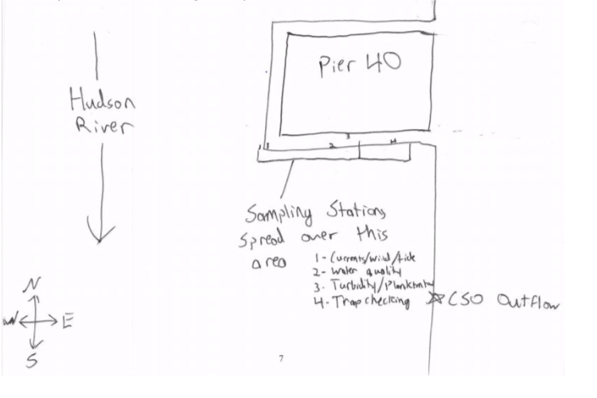
Location: Hudson River Park, Pier 40, Manhattan, NY
Area: Off southern side of Pier 40 about 600-800 feet down the pier from shore.
Highly urban site just west of the busy Westside Highway. It is the largest pier in the Hudson River Park (with a 14 acre footprint); Pier 40 is used for recreation: athletic fields, fishing, and kayaking; benches, picnic tables, and parking for the public; there are 3 public boathouse; seasonal moorings available; there are many people by the river’s edge jogging, biking, and walking.
Surrounding Land Use: 50% Urban/residential; 50% Industrial/Commercial
Sampling Site: Bulkhead, Banks altered with concrete and wood pilings, large pier extends into river/cement bulkhead south ~100 meters.
Shoreline: Rocky
Plants in area: no plants in water area
Water: Choppy, 15-20 foot depth
River Bottom: Soft sediment habitat, muddy

ITEM |  | Time | Reading |  | Comments
Physical
Air Temperature: |  | 10:37 AM | 11 º C | 51.8 º F
Wind Speed: |  | 10:37 AM | Beaufort: 4 | 15 mph, 13 knots | South
Weather Today: |  | No Rain, Partly cloudy (26-50%)
Weather Previous:
Water Temperature |  | 10:28 AM  11:10 AM | 18 º C  18 º C | 65 º F  65 º F
Turbidity -  Secchi disk |  | 10:30-12:30 PM | 71 cm  80 cm  70 cm | Avg: 73.6 cm
Chemical
Salinity- hydrometer |  | 10:30-12:30 PM | 5.3 ppt  2 ppt  2.3 ppt | Avg: 3.2 ppt
DO – |  | Time | Temp | ppm DO | % saturation
 |  | 10:30 AM | 18 º C | 6.8 | 70
pH - indicator solution |  | 10:30-12:30 PM | 7.4
Nitrates |  | 10:30-12:30 PM | 0 ppm
Phosphates |  | NR
Fish – minnow trap |  | Number | Name | Length of longest
 |  | 1 | Black Sea Bass | 19 cm
 |  | TOTAL: 1 | Diversity: 1
Macroinvertebrates |  | Number | Name | Length of longest
 |  | NR  NR  NR | Grass Shrimp  Mud Crab  Isopods- Idotea metallica
 |  | TOTAL: | Diversity: 3
Tides- distance from pier to water |  | Time | Rising, Falling, Still | Height (cm) | Rate of Tidal Change (cm/min)
 |  | 10:28 AM  11:11 AM  12:19 PM  1:02 PM | -  Rising  Rising  Falling | 360  340  300  310 | -  .47  .59  .23
Current- *measured in a cove |  | cm/second | Rising, Falling, Unchanged | Height (cm) | Rate of Change (cm/min)
Currents Flow |  | Cm/second | Knots | North/South | Ebb/Flood/Still
10:37 AM  11:28 AM  12:29 PM  1:13 PM |  | 69.3  47.6  23.8  0 | 1.35  0.925  0.463  0 | North  North  North  - | Flood  Flood  Flood  Still
NR
Boats | Time | Name | Color | North or South | Loaded or Light
NR
Other Observations |  | NR

