Day in the Life of the Hudson River 10/16/18 Data
HUDSON RIVER PARK PIER 45, MANHATTAN
RIVER MILE: 3.2
Salt Front: ~RM 24 (Between Piermont & Dobbs Ferry)
Ellis Preparatory Academy- Michele Weintraub
25 students 11- 12th grade , 3 adults
Tania Goicechea & Hanyu Lu & Mary Leou - NYU’s Wallerstein Collaborative for Urban Environmental Education
Latitude 40.733342 N & Longitude – 74.013938 W
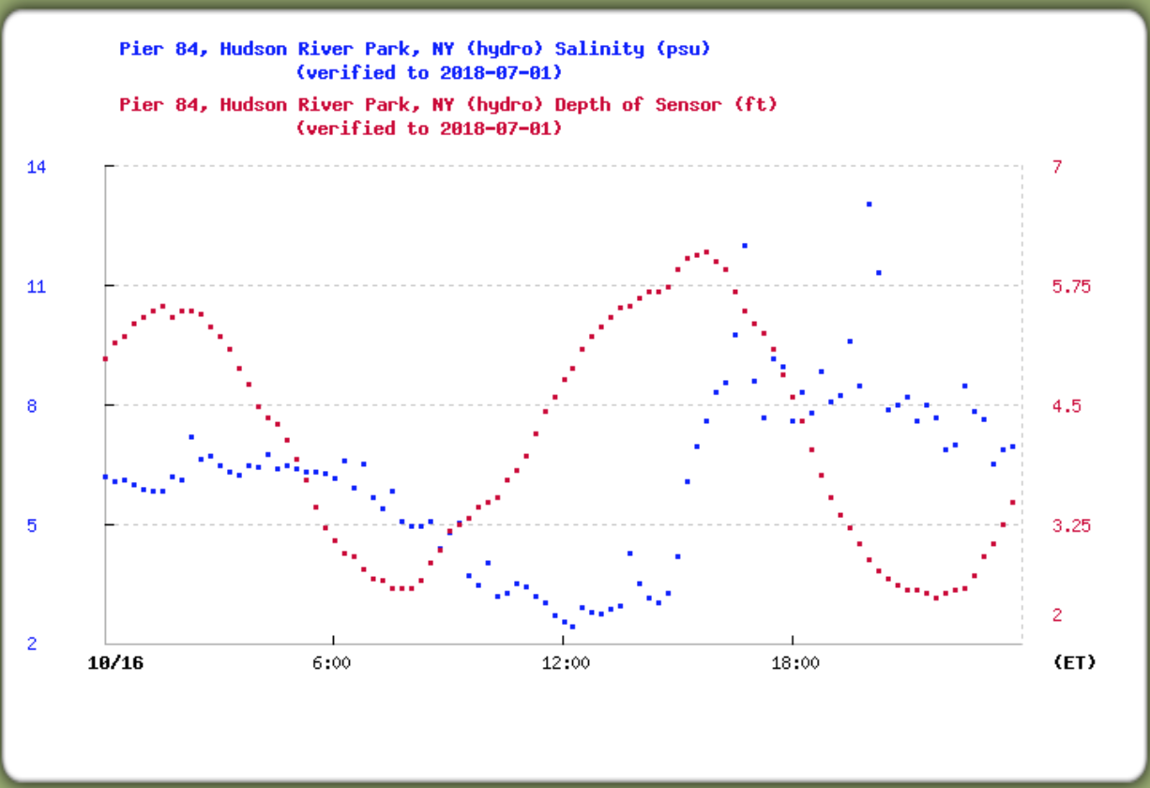
Location: Hudson River Park, Pier 45, Manhattan, NY
Area: Christopher Street Pier at the southside end of the pier where the “gazebo” is at the foot of the pier
Surrounding Land Use: 50% Urban/residential; 50% Lawn
Sampling Site: Recreational Pier
Shoreline: Banks altered with bulkhead, mainly metal and wooden pier.
Water: choppy, 1 meter deep
River Bottom: Muddy
ITEM |  | Time | Reading |  | Comments
Physical
Air Temperature: |  | 11:30 AM  11:41 AM  11:50 AM  12:01 PM | 12 º C  11 º C  11 º C  11.5 º C | 53.6 º F  51.8 º F  51.8 º F  52.7 º F
Weather Today: |  | No Rain; Partly cloudy (26-50%); AM: cloudy and windy. PM: sunny and gentle breeze
Weather Previous: |  | Rainy and calm yesterday
Current- *measured in a cove |  | cm/second | Rising, Falling, Unchanged | Height (cm) |  | Rate of Change (cm/min)
Water Temperature |  | 11:32 AM  11:42 AM  11:50. AM  12:00 PM | 12 º C  11 º C  11 º C  10.5 º C | 53.6 º F  51.8 º F  51.8 º F  50.9 º F
Turbidity - secchi disk |  | 11:32-12:10 PM | 39.2 cm, 36.2 cm, 32.2 cm, 33.3 cm | Avg: 35.23 cm
Chemical
Salinity- hydrometer |  | 11:30-12:15 PM | 6 ppt  3 ppt  3 ppt  3 ppt | Avg: 3.8 ppt  * see HRECOS print out below |  | Salinity falling as the tide rises – a function of all the rain.
DO – ampules |  | Time | Temp | ppm DO |  | % saturation
 |  | 11:32 AM  11:42 AM  11:50 AM  12:00 PM | 12 º C  11 º C  11 º C  10.5 º C | 7  7  7  8 |  | 64.93  63.46  63.46  71.69
pH – |  | 11:32-11:58 AM | 7.25, 7, 6.81, 7.24 | Avg: 7.08
Boats | Time | Name | Color | North or South |  | Loaded or Light
 | 11:48 AM | Boat observed…
Other Observations |  | The water looks greenish, but didn’t see macroplants growing in water.

