Day in the Life of the Hudson River 10/16/18 Data
UPPER NYACK STATE PARK- LOWER BEACH
Nyack, NY
RIVER MILE: 30.4
Salt Front: ~ RM 24
Blue Rock School-
52 students 4th -8th grade, 10 adults
Laurie Seeman & Joanna Dickey, Strawtown Studios
Charlotte Jack, Lorraine Madden, Blue Rock School
Latitude 41.119759 N & Longitude – 73.912429 W

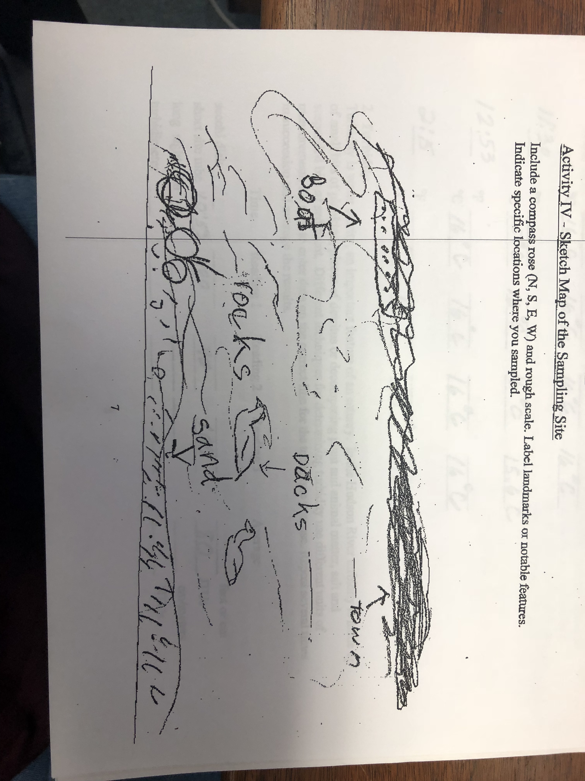
Location: Upper Nyack State Park, South Beach, Nyack, Rockland County, NY
Area: Near Hook Mountain Sandy Beach right side of riverfront area, park/boat launch, sandy beach area on the point with riprap
Surrounding Land Use: 30% forested, 50% beach, 20% parking lot
Sampling Site: Sandy beach with retaining wall enclosing it and behind a lot of trees, picnic tables, sandy and rocky at edges, covered with vegetation beyond the beach, stone wall, riprap shore, concrete docking. Boat launch spits the site and steep bank behind picnic tale area. Sandy beach is only available during lower to mid tide. Pipe enter river ~25 ft. south of sampling area.
Shoreline: Beach area, shoreline riprap (large rocks), concrete docking
Water Depth: 1 foot
Plants in area: 5% of area is covered with plants in the water (Vallisneria Americana/water celery)
River Bottom description: sandy, muddy

ITEM | Time | Reading |  | Comments
Physical
Air Temperature | 10:30 AM  12:00 PM | 15 º C  15.56 º C | 60 º F  59 º F
Wind Speed: Beaufort Force |  | 6 | North | Water choppy
Weather today | No rain, partly cloudy
Weather recently | The last three days it was humid, cloudy, cold, and drizzly
Water Temperature | 10:45 AM  11:30 AM  12:53 PM  2:15 PM | 16, 16, 16  15, 16, 16  16, 16, 16  15, 16, 15 | Avg: 16 º C  Avg: 15.6 º C  Avg: 16 º C  Avg: 15.3 º C | 60.8 º F  60.08 º F  60.8 º F  59.54 º F
Turbidity - short sight tube | 12:53 PM | 100 JTUs, 40 JTUs, 100 JTUs |  | Average: 80 JTUs
Chemical
Salinity- High Range Quantabs | 10:45 AM | 1.0, 0.8  Estimation of Quantab Units |  | * Below Detection for this method
DO – Indicator Tabs | Time | Temp | ppm DO | % saturation
 | 10:15 AM | 16 º C | 4 | 88%
pH – Indicator solution | 10:45 AM | 7.5, 7.5
Nitrates-Estuary Wide Sampling Kit (low resolution kit) | 10:45 AM | 5, 5, 5 Avg: *5 ppm |  | *5ppm NO₃⁻ is very high;
Phosphates- Estuary Wide Sampling Kit  (low resolution ) |  | 1, 1, 2 Avg: 1.3 ppm |  | * Estuary wide kit is
Fish | Number | Name | Length of longest
Seine- 28 foot net | 3  7  1  3 | American Eel  Striped Bass  Brown Bullhead  Alewife
Fish Totals | TOTAL: 14 | Diversity: 4
Macroinvertebrates | Number | Name | Length of longest
 | 21  6  5 | Mud Crab  Blue Crab  Shore Shrimp |  | 1 female  3 females
Macroinvertebrate Totals | TOTAL: 32 | Diversity: 3
Tides- | Time | Rising, Falling, Unchanged | Height (cm) | Rate of Tidal Change (cm/min)
 | 10:30 AM  10:45 AM  11:10 AM  11:30 AM  11:50 AM  1:15 PM  1:34 PM  1:54 PM | Rising  Rising  Rising  Rising  Rising  Rising  Rising  Rising | 1  3  3  6.5  20  30  34  45 | -  0.133  -  0.175  0.675  0.118  0.211  0.55
Current- | cm/second | Knots | North/South | Ebb/Flood/ Still
11:48 AM  1:34 PM | 4.8  9 | 0.093  0.175 | South  North | Ebb  Flood
Boat Traffic- recreational | Name | Color | North or South | Loaded or Light
10:35 AM  12:00 PM  12:00 PM | Recreational  Recreational  Recreational |  | South  North  South | Light  Light  Light

