Day in the Life of the Hudson River 10/16/18 Data
LOUIS ENGEL PARK
Ossining, NY
RIVER MILE: 32.5
Salt Front: RM 24
Ossining High School, AP Environmental Science-
7 students 11th – 12th grade, 1 adults
Artie Carlucci, Ossining HS
Latitude N 41º 9’ & Longitude W 73º 51’
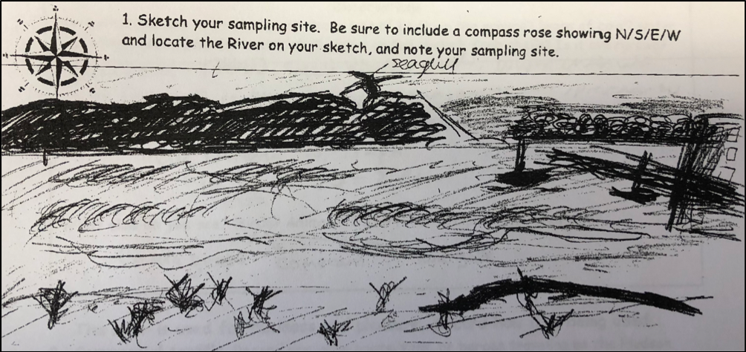

Location: Wading beach at Lewis J. Engel Park, Ossining, NY
Area: Beachfront area with a ferry pier, paved sidewalk & parking lot, slightly grassy, rock wall lining the river
Surrounding Land Use: 50% beach, 15% park, 25% industrial/commercial
Sampling Site: bulkhead lines the shoreline with pier, altered banks with rock wall, beach, riprap, rocky, and weedy. Used for picnics and boats. Pipe enters the river North of the sample site.
Shoreline: 50% sandy, 10% muddy, 60% rocky
Water Depth: 1-4 feet
Plants in area: weeds and water chestnuts
River Bottom description: muddy, rocky, sandy
Other: Canadian geese, cormorants, sea gulls

ITEM | Time | Reading |  | Comments
Physical
Air Temperature | 10:00 AM  11:00 AM  12:00 PM | 8.89 ºC  10.56 ºC  11.67 ºC | 48ºF  51 ºF  53 ºF
Wind Speed: Wind Meter | 10:00 AM  2:00 PM | 17 mph  11 mph | 14.77 knots  9.56 knots
Weather today | 12:00 PM Clear
Weather recently | Rain showers over the weekend and it rained Monday night.
Water Temperature | 10:00 AM  12:00 PM  1:00 PM | 15 ºC  16 ºC  16 ºC | 59ºF  60.8 ºF  60.8 ºF
Turbidity - long sight tube | 10:00 AM | 9.5 cm, 10.5 cm, 11 cm, 11 cm
Chemical
Salinity-  11:00 AM  1:00 PM  2:00 PM | Chloride:  -  35 ppm Cl⁻  28 ppm Cl⁻ | Total Salinity:  6000 ppm  63.23 ppm  50.58 ppm | *Hydrometer  LR Quantabs  LR Quantabs | *6000 ppm with hydrometer is not realistic this year at this site
DO – Tabs from Estuary wide monitoring kit | Time | Temp | ppm DO | % saturation
DO – Tabs from Estuary wide monitoring kit | 10:00 AM  1:00 PM | 16ºC  16 ºC | 4  4 | 40%  40%
pH – color match test kit and test strips | 10:00 AM  1:00 PM | 6, 6.5, 7  6, 6.5, 7
Nitrates-LaMotte Estuary wide Test Kit | 12:00 PM | 5 ppm
Phosphate- LaMotte Estuary wide Test Kit | 1:30 PM | 1 ppm
Fish | Number | Name | Length of longest
Seine- 30 foot net | 1  7  11  1 | Atlantic Silverside  Bay Anchovies  Alewife  Catfish- dead | 4 inches  10 cm  15 cm  50 cm
Fish Totals | TOTAL: 20 | Diversity: 3
Macroinvertebrates | Number | Name
Seiner- 30 foot net | 2 | Asian Shore Crab
Macroinvertebrate Totals | TOTAL: 2 | Diversity: 1
Tides- tide stick | Rising, Falling, Unchanged | Height (cm) | Rate of Tidal Change (cm/min)
10:00 AM  11:00 AM  12:00 AM  1:00 PM  1:30 PM  2:00 PM | Unchanged  Unchanged  Flood  Flood  Flood  Flood | -  -  6  40  55  65 | 0  0  .1  .567  .5  .33
Boat Traffic commercial | Name | Color | North or South | Loaded or Light
11:05-11:25 AM | Tanker | Red and Black | North | Light
Core Sampling | Description | Rare | Common | Abundant
 | 28 cm long | Clay  Wood  Shells  Freshwater Mussels | Gravel  Pebbles  Brick | Sand
Other Observations | Water chestnut with small bugs in them

