Day in the Life of the Hudson River 10/16/18 Data
STEAMBOAT DOCK, VERPLANCK
RIVER MILE: 41
Salt Front: ~RM 24
Mahopac High School- Scott Rizzo, Trisha Johnson, Jason Zides
25 students 9th-11th grade, 3 adults
Latitude 41.24936 N & Longitude -73.936474 W
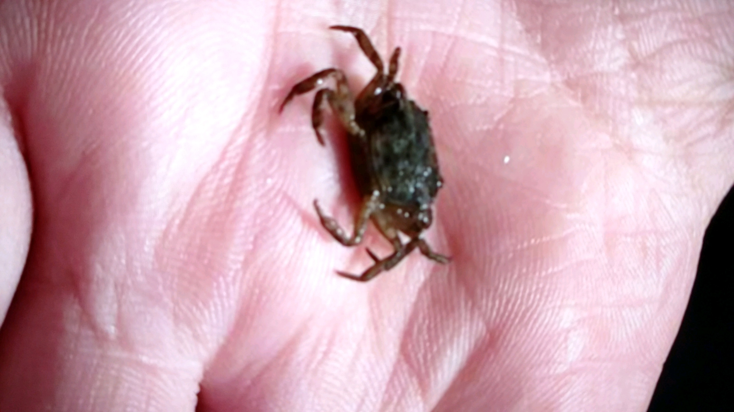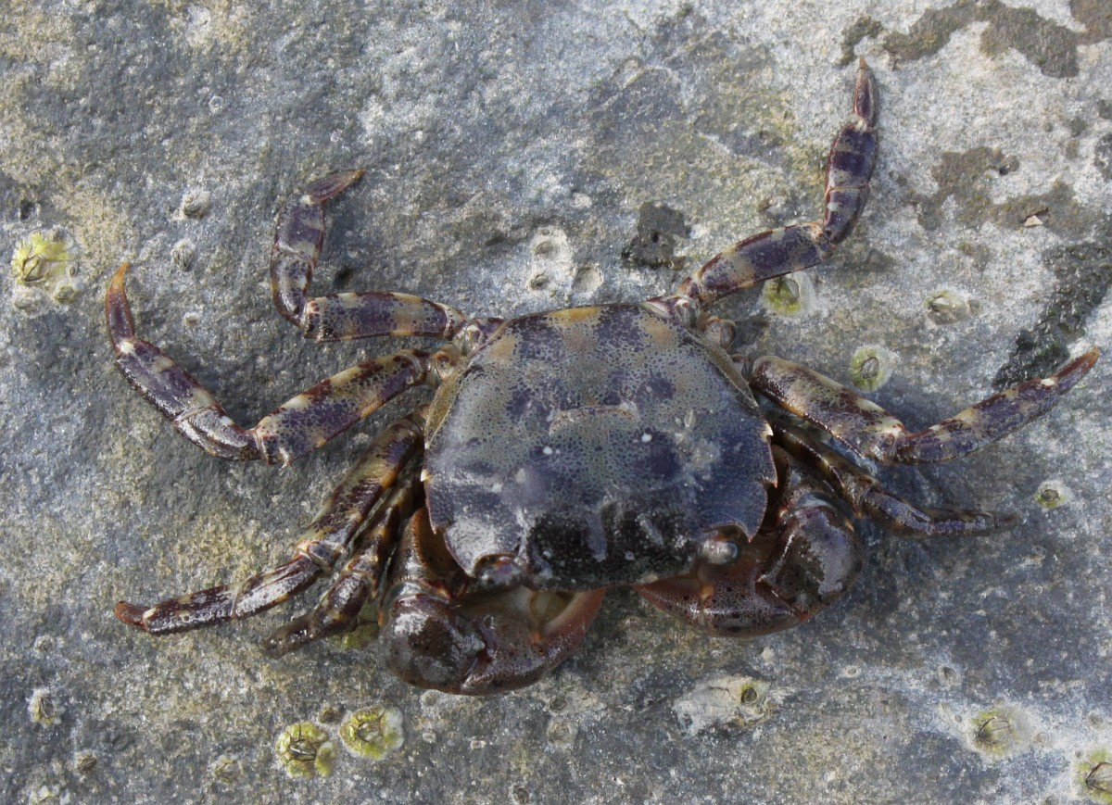

Location: Steamboat Dock Park Beach, City of Verplanck, Westchester County, NY
Area: located in a small cov between a point and a bulkhead- pier, grassy, parking lot
Surrounding Land Use: 30% Urban/Residential; 35% Beach; 35% Parking lot
Sampling Site: Beach and parking lot
Shoreline: sandy, rocky
Plants in area: No plants in water area
Water: 2 feet deep
River Bottom: Sandy; muddy; rocky
ITEM |  | Time | Reading |  |  | Comments
Physical
Air Temperature: |  | 10:25 AM | 8 º C |  | 48 º F
Wind Speed: |  | 10:27 AM | Beaufort 4 |  | 13 MPH NE
Weather Today: |  | 11:53 AM partly cloudy (26-50%), no rain
Weather Previous: |  | Rained Monday
Water Temperature |  | 9:39 AM  9:53 AM  11:15 AM | 18.1 º C  18 º C  18 º C |  | 64.58 º F  64.4 º F  64.4 º F
Turbidity -
Long sight tube
Chemical
Salinity- YSI Pro30 Conductivity Meter – Total Salinity |  | 9:39 AM  9:53 AM  11:15 AM | 0.1 ppt OR 100 ppm  0.1 ppt OR 100 ppm  0.1 ppt OR 100 ppm
DO – |  | Time | Temp |  | ppm DO | % saturation
 |  | 9:55 AM  10:15 AM | 18 º C  18 º C |  | 8  8 | 90%  90%
pH- color match test kit |  | 9:53 AM  10:45 AM  11:15 AM | 7.5  8  7.5
Nitrates- |  | 9:39 AM  11:15 AM | 1.4 ppm  2.79 ppm |  |  | *readings seem high
Alkalinity |  | 9:39 AM  9:53 AM  11:15 AM | 80 ppm  120 ppm  100 ppm
Phosphates |  | 9:53 AM  10:10 AM | 0.5 ppm  0.61 ppm
Fish – seine 25 feet  7:30 AM  10:15 AM  11:00 AM |  | Number | Name |  | Length of longest
 |  | 1  1  5  1  1  1  1 | American Shad  Striped Bass  Striped Bass  White Perch  American Shad  Sunfish  Striped Bass |  | 7.62 cm  10.16 cm  10.16 cm  20.32 cm  6.35 cm  1.5 inches  10.16 cm
 |  | TOTAL: 11 | Diversity: 4
Macroinvertebrates- Seine |  | Number | Name |  | Length of longest
 |  | 20 | Asian Shore Crab
 |  | TOTAL: 20 | Diversity: 1
Tides- tide stick |  | Time | Rising, Falling, Still | Height (cm) | Rate of Tidal Change (cm/min)
 |  | 9:42 AM  10:00 AM  10:13 AM  10:26 AM  10:49 AM  11:01 AM  11:11 AM | Still  Still  Rising  Rising  Rising  Rising  Rising | 52  52  55  58  63  65  66 | -  0
Currents Flow |  | Time | Cm/second | Knots | North/South | Ebb/Flood/Still
*Wind picked up |  | 9:50 AM  10:17 AM  10:30 AM  10:50 AM | 2.67  6.2  4.8  3.6 | 0.052  0.121  0.093  0.070
Sediment Core |  | Water depth | Length | Oxid Top | Grain Size | Other
Boats | Time | Name | Color |  | North/South | Loaded/Light
Commercial  Commercial  Commercial  Commercial  Commercial | 10:13 AM  10:14 AM  11:12 AM  11:15 AM  11:45 AM | Tugboat  Tug  Tug/Barge RTCB9 | Light Gray  Red/White  Light Gray  Red/White  Red |  | North *same  North +same  South *same  South +same  North | Light  Light  Light  Light  Loaded
Other Observations |  | Brick and water chestnuts on beach; two different road runoff inputs; 10 mallard ducks; 24 Canadian geese, 1 bald eagle

