Day in the Life of the Hudson River 10/16/18 Data
HUDSON RIVER PARK PIER 84, MANHATTAN
RIVER MILE: 5.6
Salt Front: ~RM 24
PS 51 Elias Howe- Kate Gutwillig, 64 students, 4th grade, 7 adults
Gateway School- Vickie Karkazis, 30 students, Middle School, 5 adults
Tina Walsh and staff, Hudson River Park
Gerrie Bay Hall & Michael Stevens, Intrepid Museum
Latitude 40.764316 N & Longitude – 74.002065 W

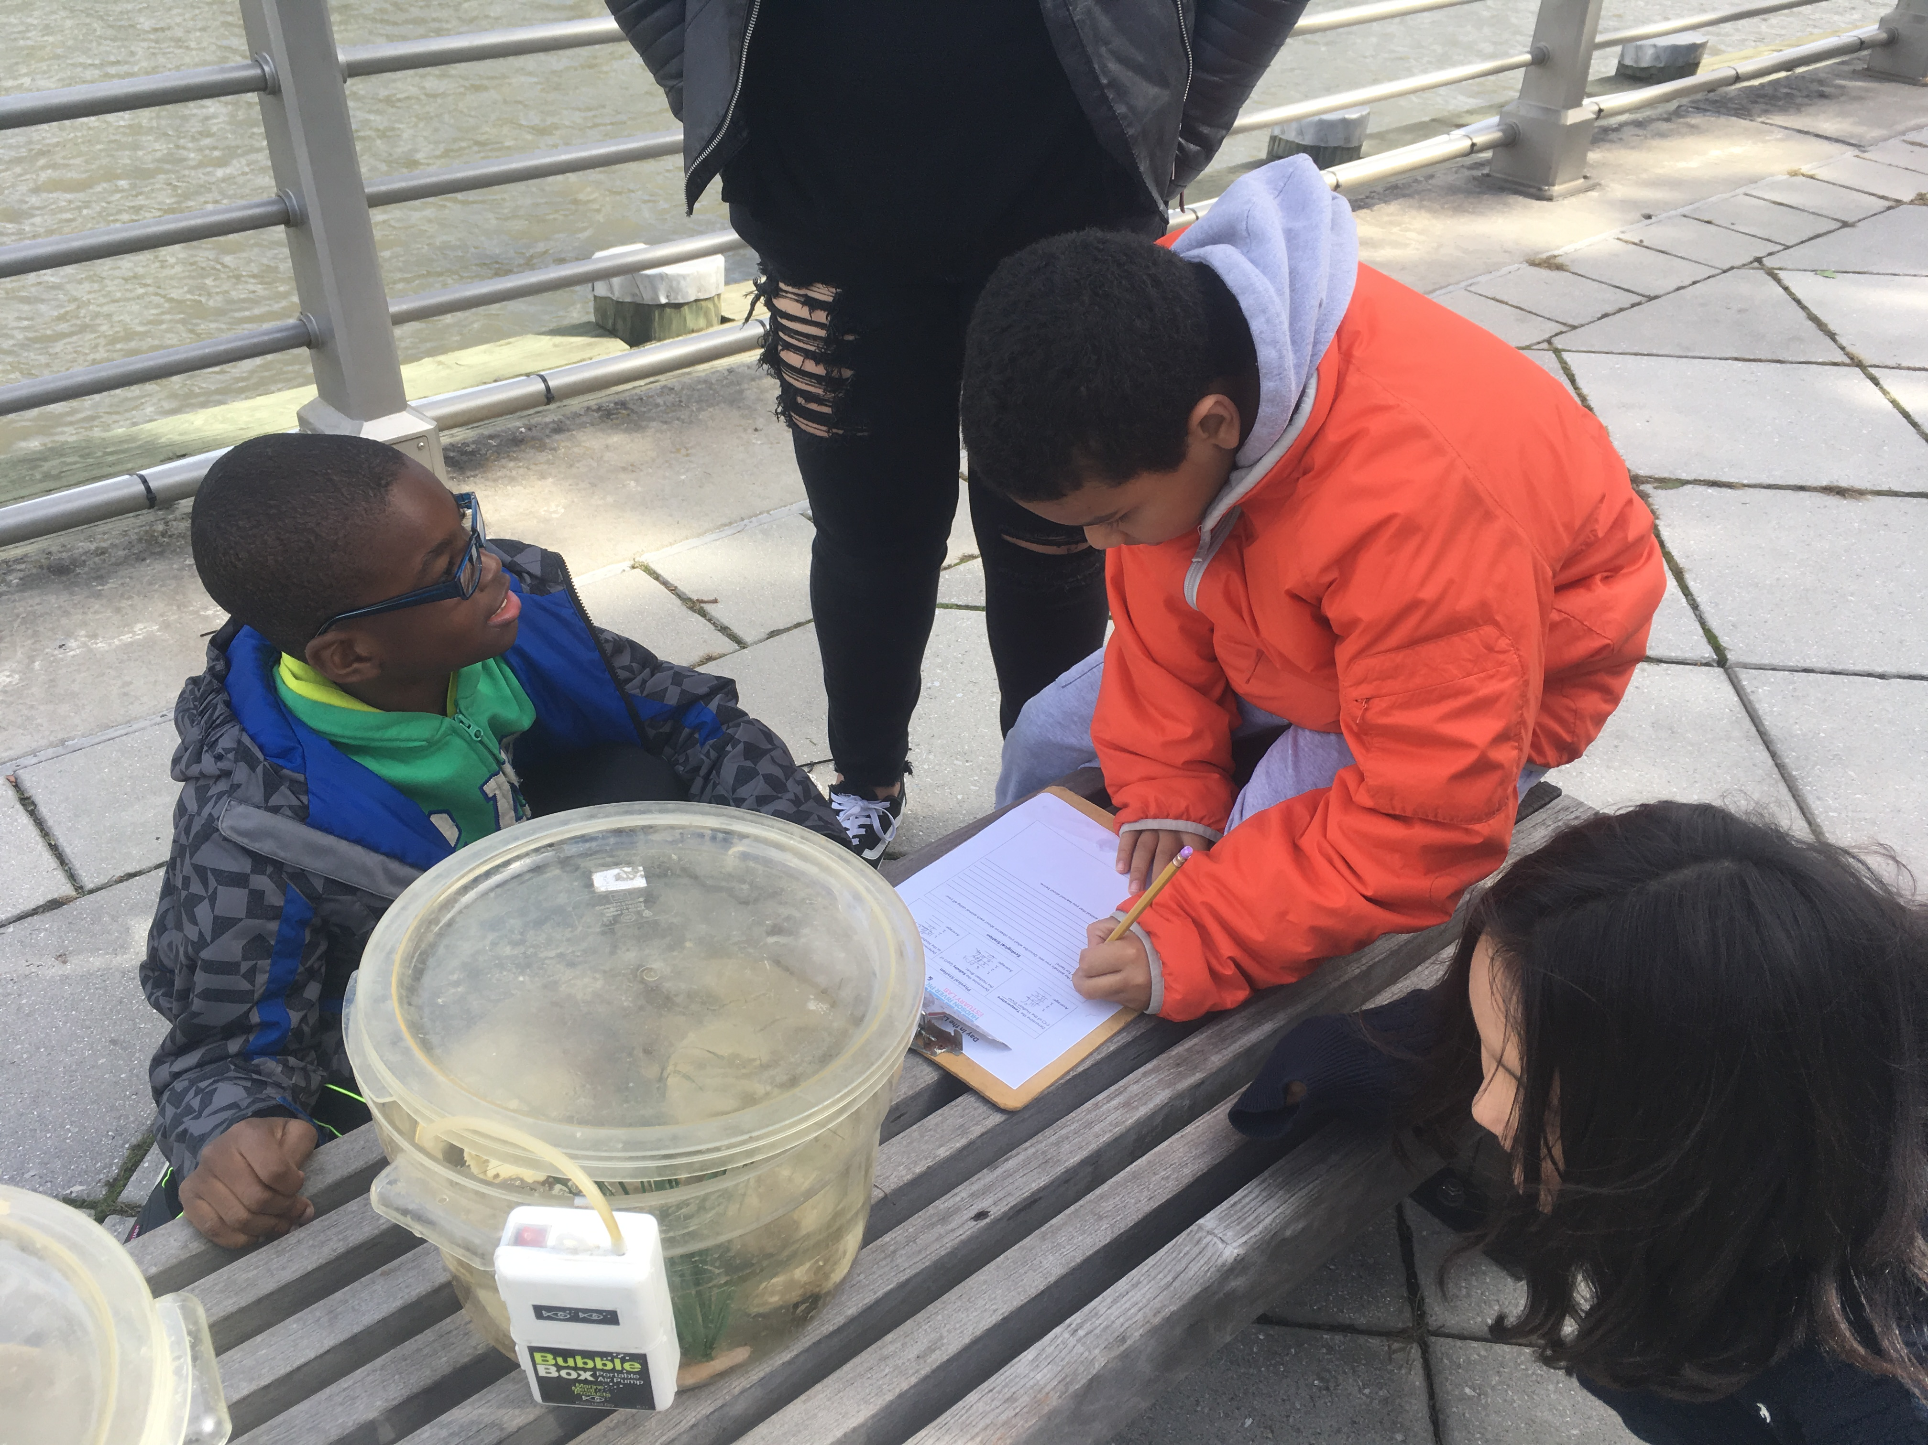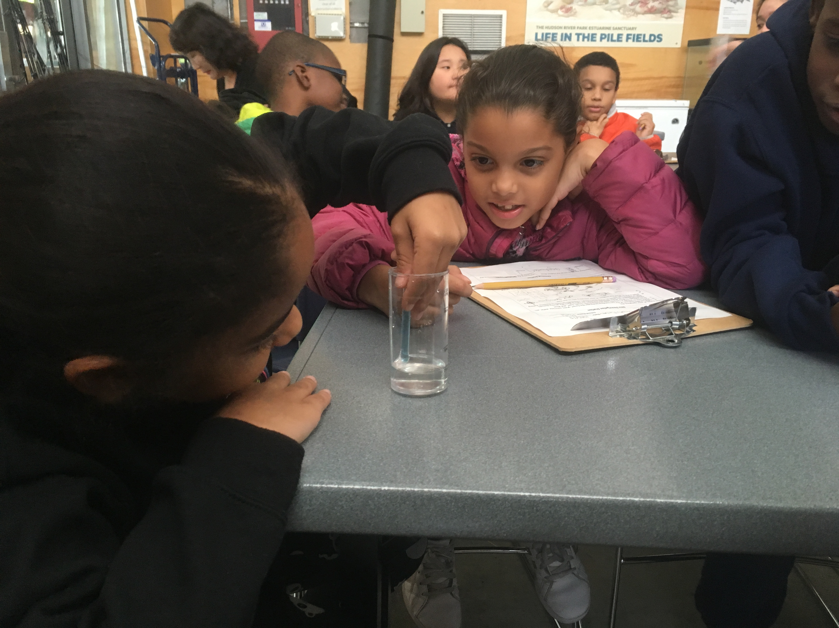
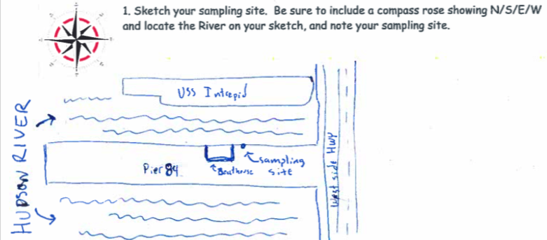
Location: Hudson River Park Pier 84, Manhattan, NY
Area: Pier 84 is an educational pier used for picnics, boating, jogging, and fishing. Pier; bulkhead; grassy
Surrounding Land Use: 40% Industrial/Commercial; 60% Urban/Industrial
Sampling Site: Recreational pier- concreate bulkhead, rocks near the edge, banks altered (all hard edged), pipe entering the water
Water: ~20 feet off pier; calm
Plants in area: No plants in the water area
River Bottom: Muddy

ITEM | Time | Reading |  | Comments
Physical
Air Temperature: | 10:00 AM  1:00 PM  2:00 PM | 10.56 ºC  12.22 ºC  13.89 ºC | 51 ºF  54 ºF  57 ºF
Weather Today: | No rain, partly cloudy (26-50%)
Weather Previous: | Light rain 3 days ago
Current- *measured in a cove | cm/second | Rising, Falling, Unchanged | Height (cm) |  | Rate of Change (cm/min)
Water Temperature | 10:30 AM  12:00 PM | 16 ºC  16 ºC | 60.8 ºF  60.8 ºF
Turbidity - long site tube | 10:30 AM  2:00 PM | 28, 31, 30  27, 30, 31 | Avg: 29.67 cm  Avg: 29.3 cm
Chemical
Salinity- | Time | Hydrometer
Salinity- | 10:30 AM  12:00 PM  2:00 PM | 6 ppt  4 ppt  6 ppt
DO – color match kit | Time | Temp | ppm DO |  | % saturation
DO – color match kit | 11:00 AM  1:30 PM | 16 ºC  18 ºC | 8  8 |  | 80  85
pH - meter | 11:00 AM  2:00 PM | 7.9, 8, 8.1  8, 8, 8.1 | Avg: 8  Avg: 8.03
Fish- Traps | Number | Name | Length of longest |  | Caught in the trap
Fish- Traps | 3 | Oyster Toadfish | 2 inches |  | Caught in the trap
Fish- Traps | TOTAL: 3 | Diversity: 1 |  |  | Caught in the trap
Macroinvertebrates- Eel Mop | Number | Name | Length of longest |  | Male Crabs
Macroinvertebrates- Eel Mop | 10+  1  5  10+  10+ | Sea squirts  Blue Crabs  Grass Shrimps  Isopods  Amphipods |  |  | Male Crabs
Macroinvertebrates- Eel Mop | TOTAL: 36+ | Diversity: 5 |  |  | Male Crabs
Tides- | Time | Rising, Falling, Still | Height (cm) |  | Rate of Tidal Change (cm/min)
 | 10:00 AM  2:00 PM | -  Rising | 350 cm  550 cm |  | -  0.83
Other Observations | Local fisherman caught 2 white perch before we arrived (8+ inches).

