Day in the Life of the Hudson River 10/16/18 Data
CORNWALL LANDING
Orange County, NY
RIVER MILE: 57
Salt Front: ~RM 24
Willow Avenue Elementary School-
46 students 4th grade, 12 adults
Debbie Gilson & Christine Cleeves, Willow Avenue ES
Christopher O’Sullivan, Bear Mountain Educational Center
Latitude 41.44384 N & Longitude – 73.99961 W

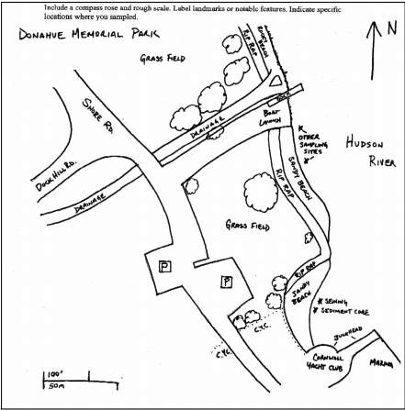
Location: Cornwall Landing Boat Ramp, Donahue Memorial Park
Area: Sandy beach next to the Cornwall Yacht club used for seining and sediment coring. Beach next to the boat launch is used for other sampling.
Surrounding Land Use: 100% open grassy park
Sampling Site: pier, sandy beach, altered banks, shoreline riprap, bulkhead
Shoreline: Rocky, sandy beach

ITEM | Time | Reading |  |  | Comments
Physical
Air Temperature | 11:00 AM  11:30 AM  12:00 PM | 13.3 ºC  13.3 ºC  15.6 ºC |  | 56 ºF  56 ºF  60 ºF
Wind Speed: Anemometer | 11:00 AM | 13-18 mph  Beaufort force: 3 |  | 11.45 knots | South
Weather today | No rain, partly cloudy
Weather recently | Heavy rains, cold temperatures
Water Temperature | 12:34 PM  12:35 PM | 15 º C  18 º C |  | 59 ºF  64.4 ºF
Turbidity - turbidity tube |  | 52cm, 48cm, 57cm |  |  | Avg: 52.3 cm
Chemical
Salinity- High Range Quantabs | *480 ppm Cl⁻ | *867.1 ppm total salinity |  | *Salinity readings are a comparatively high for this area in 2018 – we needed low range quantabs for this site in 2018.
pH – Color match kit | 12:28 PM | 7
Fish | Count | Species
Fish - seined throughout the sampling event | 3  9  3  1  1  1  6 | Alewives  Blueback Herring  Pumpkinseed sunfish  Bluegill sunfish  Largemouth Bass  Hogchokers  White Perch |  |  | DIVERSITY: 7  TOTAL COUNT: 24
Tides- | Time | Rising, Falling, Unchanged | Height (cm) |  | Rate of Tidal Change (cm/min)
 | 11:08 AM  11:23 AM  11:33 AM  11:38 AM  12:15 PM  12:30 PM | -  Falling  Falling  Falling  Rising  Rising | 50  46  45  44  53  59 |  | -  .267  .1  .2  .391  .4
Current- | cm/second | Knots | North/South |  | Ebb/Flood/Still
11:18 AM |  |  | South |  | Ebb

