Day in the Life of the Hudson River 10/16/18 Data
PIER I, 59TH STREET, MANHATTAN
RIVER MILE: 6.8
Salt Front: ~RM 24 (Between Piermont & Dobbs Ferry)
Mott Hall Charter School- Christie Kim
90 students 8th grade, 10 adults
GLOBE- City College of New York
Latitude 40.780325 N & Longitude - 73.988589 W
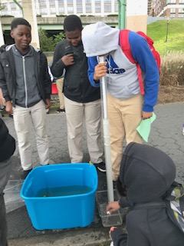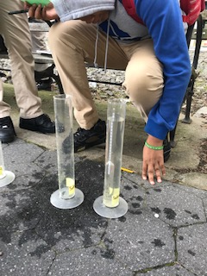
Location: Pier I, 59th Street, Manhattan, NY
Area: Restored former railroad pier.
Surrounding Land Use: 100% Urban/Residential
Sampling Site: Sampling took place on Pier I
Shoreline: Tiny beach area, shore with bulkhead, riprap, covered with vegetation, old railroad pilings
Water: ~ 6 meters
Plants in area: no plants in the water area, but lots of plants on shore
River Bottom: Sandy
Sample Time: 10:00 AM- 12:00 PM
ITEM | Time | Reading |  | Comments
Physical
Water Temperature | 10-12 PM | Avg: 14.47 ºC
Turbidity - long site tube | 10-12 PM | Avg: 19.32 cm
Chemical
Salinity- glass hydrometer | Time | Density | Total Salinity
Salinity- glass hydrometer | 10-12 PM | Avg: 1.04 | Avg: 5.8 ppt
DO – meter | Time | Temp | ppm DO |  | Comments
DO – meter | 10-12 PM |  |  |  | Meter was broken
pH – | 10-12 PM | Avg: 7.77

