Day in the Life of the Hudson River 10/16/18 Data
SEEGER RIVERFRONT PARK, BEACON, RIVER MILE: 61.2
Salt Front: ~RM 24
Valley Central Middle School- Will Gunther, Nancy Fabrizio, Nancy Rypkema
75 students 7th-8th grade, 12 adults
Latitude 41.507975 N & Longitude – 73.986708 W

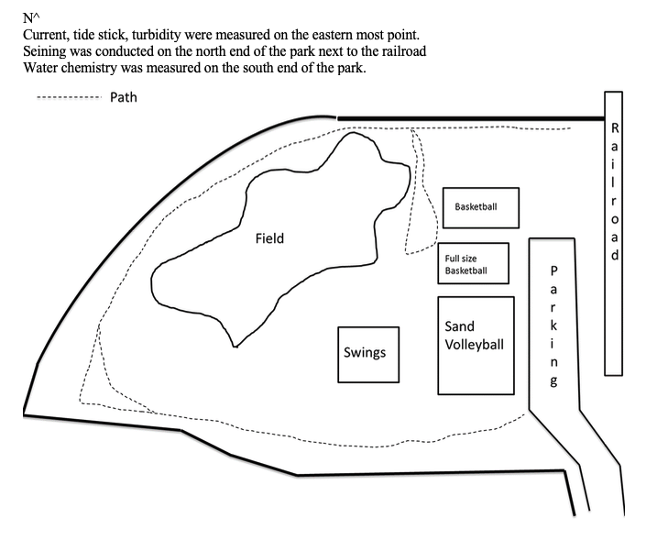
Location: Pete and Toshi Seeger Riverfront Park, Beacon, Dutchess County, NY
Area: The park at the end of Red Flynn Drive (past long dock park) near the Beacon train station; caught fish in the cove at the end of the park; grassy lawns, forested around edges, parking lot to the side. Children’ play area, large riprap
Surrounding Land Use: 100% Urban/Residential (Parkland)
Sampling Site: beach, covered in vegetation, banks altered, riprap
Shoreline: bridge, train station, covered in vegetation (trees), concrete debris, dock, riprap
Plants in area: no plants in water area
Water: <1 m, choppy
River Bottom: Rocky then muddy

ITEM | Time | Reading |  | Comments
Physical
Air Temperature: | 9:29 AM  10:20 AM  10:45 AM  11:09 AM  11:36 AM  12:02 PM  12:30 PM | 11.2 º C  12 º C  13 º C  13 º C  13.6 º C  15.8 º C  16.7 º C | 53 º F  54 º F  56 º F  56 º F  56.6 º F  59 º F  63.4 º F
Wind Speed: | 9:29 AM  10:20 AM  10:45 AM  11:09 AM  11:36 AM  12:02 PM  12:30 PM | 16 knots  21 knots  17 knots  18 knots  17 knots  29 knots  18 knots | West  Northwest  Northeast  Northeast  Northeast  Northeast  Northwest | Gusts up to 30 knots
Weather Today: | No rain, partly cloudy
Weather Previous: | Rain on Monday, consistently in the mid 50’s. The week prior temperature were in the 80’s on Tuesday and Wednesday
Water Temperature | 9:45 AM  10:15 AM  10:30 AM  11:15 AM  12:01 PM  12:30 PM | 9 º C  10 º C  10 º C  10 º C  10 º C  10 º C
Turbidity- long sight tube | 12:00 PM | 24 cm 28 cm 26 cm | Avg: 26 cm
Chemical
Salinity- low range quantabs | 9:35 AM | 53 ppm, 55 ppm, 56 ppm | Avg: 55 ppm
DO – drop count test kits | Time | Temp | ppm DO | % saturation
DO – drop count test kits | 10:15 AM | 10 ºC | 11 | 95
pH- meter | 11:45 AM | 7.5, .7, 7.6 | Avg: 7.6
Fish – seine | Number | Name | Length of longest
Fish – seine | 3  3  7  13  1  6  3  3  2 | Spottail Shiner  Bay Anchovy  American Shad  Banded Killifish  White Perch  Striped Bass  Yellow Perch  Tessellated Darter  Mummichog | 9 cm  8 cm  8 cm  9 cm  7 cm  7 cm  6 cm  6 cm  7 cm
Fish – seine | TOTAL: 41 | Diversity: 9
Macroinvertebrates- Seine | Number | Name | Length of longest
Macroinvertebrates- Seine | 3 | Lady Crab | 3 cm
Macroinvertebrates- Seine | TOTAL: 3 | Diversity: 1
Tides- | Time | Rising, Falling, Still | Height (cm) | Rate of Tidal Change (cm/min)
 | 9:47 AM  9:53 AM  10:15 AM  10:44 AM  11:12 AM  11:36 AM  11:59 AM  12:27 PM | Still  Still  Still  Still  Still  Still  Still  Falling | 2  2  2  2  2  2  2  0 | 0  0  0  0  0  0  0  0.07
Currents Flow | Cm/second | Comment
 | NA | There was significant westerly wind blowing perpendicular to the river at our site this year. The flow of the surface water was mainly influenced by the wind and the orange would just come back to shore. We still attempted this all day, but the results were the same.

