Day in the Life of the Hudson River 10/16/18 Data
KINGSTON POINT PARK
Ulster County, NY
RIVER MILE: 92
Salt Front: ~ RM 24
Robert Graves Elementary School -
75 students 3rd grade, 11 adults
KC Keegan, Kingston Parks and Recreation
Nancy Koopman, Robert Graves
Latitude 41º 55.48 N & Longitude 73º 57.55 W

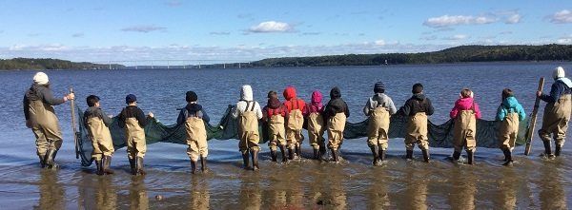
Location: Swimming Beach Kingston Point, City of Kingston, Ulster County
Area: Beach, forested, and parking lot; used for picnics, boating fishing, swimming, jogging, kayaking
Surrounding Land Use: 5% Forested; 10% Industrial/Commercial; 85% Beach
Sampling Site: Beach area
Shoreline: Sandy shoreline (75 feet from shoreline to parking lot & 200 feet wide) with boat launch; banks are altered; riprap to north along brickyard shoreline; large amount of brick debris from prior industry
Water Depth: 1 foot
Plants in area: Water chestnuts washed up on beach
River Bottom description: Sandy
Other: Many ring billed gulls; zebra mussels

ITEM | Time | Reading |  | Comments
Physical
Air Temperature | 12:50 PM | 10 ºC | 50 ºF
Wind Speed: Beaufort Force |  | #1 | South
Weather today | No rain, partly cloudy (26-50%)
Weather recently | Rain and mist
Water Temperature | 10:20 AM  11:10 AM  12:30 PM | 12.78 º C  11.67 º C  10 º C | 55 ºF  53 ºF  50 ºF
Turbidity - long sight tube | 10:40 AM | 20 cm, 19 cm, 24 cm  Avg: 21
Chemical
Salinity- Low Range Quantabs for first 3  ____________  Hydrometer------- | 10:20 AM  11:10 AM  12:35 PM  _________  11:20 AM | >684 ppm Cl⁻  <32 ppm Cl⁻  31 ppm Cl⁻  ______________  measured as TS | >**1235.7 ppm  Below quantab detection limit  56 ppm total  _____________  *6000 ppm (6ppt) | *This is way too high  ** Emailed this  ____________  *Not realistic
pH – Color match  pH pen  pH pen | 10:30 AM  11:15 AM  12:40 PM | 7, 7, 7  7.5, 7.9 Avg: 7.7  7.8
Alkalinity | 11:15 AM | 20 ppm* |  | *pretty low
Fish | Number | Name | Length of longest (in)
Seine- 30 foot net, 4 foot depth with bag | 1  45  13  14  33  1  1 | Channel Catfish  Herring  Striped Bass  Banded Killifish  Spottail Shiner  Mummichog  Tessellated Darter | 13  2  2.5  2  4  1  1
Fish Totals | TOTAL: 108 | Diversity: 7
Macroinvertebrates | Number | Name | Length of longest
 | 2 | Blue Crab
Macroinvertebrate Totals | TOTAL: 2 | Diversity: 1
Tides- tide stick | Time | Rising, Falling, Unchanged | Height (cm) | Rate of Tidal Change (cm/min)
 | 10:28 AM  11:07 AM |  | 0  Not recorded
Sediment Core | Description | Rare | Common | Abundant
 | 12.7 cm  H2S Smell  Oil on Top | Gravel  Pebbles  Brick  Coal | Sand | Mud
Boat Traffic Commercial | Name | Color | North or South | Loaded or Light
10:00 AM | Inter-marine | Blue and White | Northbound | Light
Boat Traffic Recreational | Name | Color | North or South | Loaded or Light
11:10 AM  11:35 AM  11:35 AM  11:47 AM | Autumn Born  Katrina  Kayak  Sailboat | Blue and White  White  Gray  White | Southbound  Southbound  Northbound  Northbound
Other Observations | Lots of brick  Some coal | Lots of washed up water chestnut | Some shell pieces from Asia clam

