Day in the Life of the Hudson River 10/22/19 Data
HUNT’S POINT RIVERSIDE PARK, BRONX
RIVER MILE: 4 (Bronx River)
Hudson Salt Front: ~RM 53
The School at Columbia University- Ben Raikes
60 students 6th grade, 10 adults
Rocking the Boat- Sara Miles
Latitude 40. 81769 N & Longitude – 73.88149
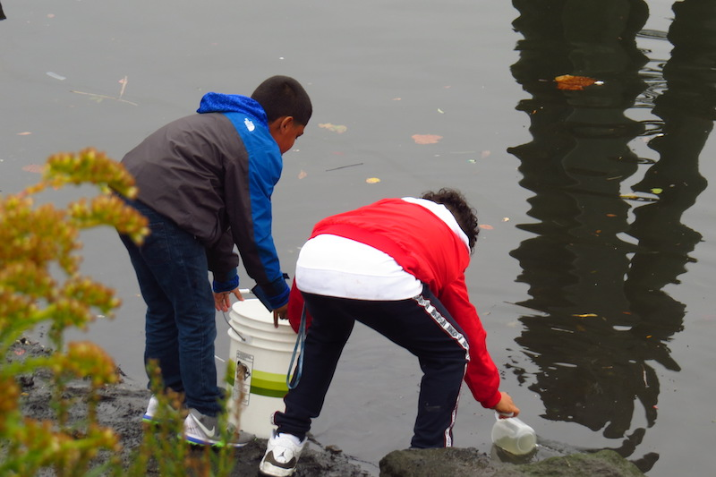
Location: Hunt’s Point, Riverside Park, Bronx River, NY
Area: Mostly used for boating and fishing. Pier with grassy area and parking lot.
Surrounding Land Use: 95% Industrial/Commercial; 5% Beach
Sample Site: Beach, pier, altered shoreline, riprap, covered with vegetation, debris in area
Shoreline: Rocky, riprap with pipe entering the water
River Bottom: Muddy, rocky
Water: 6 feet deep, calm
ITEM | Time | Reading |  | Comments
Physical
Air Temperature: | NR
Wind Speed: | NR
Weather Today: | Overcast
Weather Previous:
Water Temperature | NR | º C | º F
Turbidity- long sight tube | 10:30 AM  11:30 AM  12:30 PM | 48 cm, 52 cm  35 cm, 39 cm  17cm, 7 cm, 21 cm | Avg. 50 cm  Avg. 37 cm  Avg. 15 cm
Chemical
Salinity- hydrometer | 10:30 AM  11:30 AM  12:30 PM | 12, 10, 12 ppt  6, 8, 8 ppt  6,10, 6 ppt | Avg. 11.25 ppt  Avg. 7.25 ppt  Avg. 7.33 ppt
DO – NR | Time | Temp | ppm DO | % saturation
pH- NR

