Day in the Life of the Hudson River 10/22/19 Data
BROOKLYN BRIDGE PARK (EAST), BROOKLYN
RIVER MILE: 1.7 (East River)
Salt Front: ~RM 53
MS915 – Nicole Marcellin
3 groups (28, 27 25 students) 80 total 8th grade students, 10 adults
Brooklyn Bridge Park- Christina Tobitsch
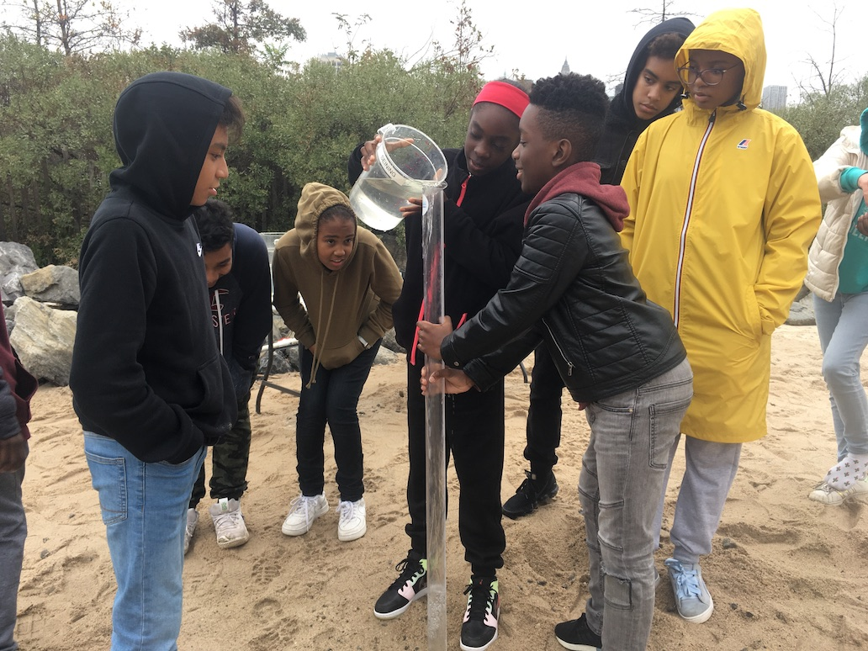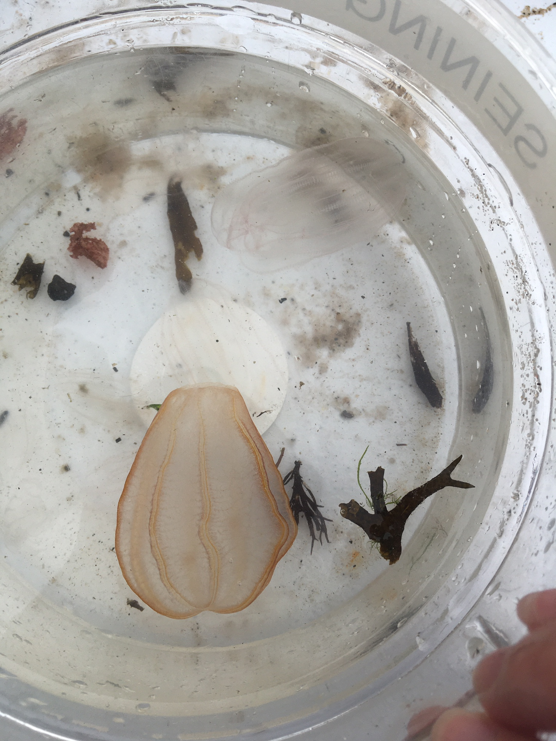
Latitude 40.69653 N & Longitude – 73.99971 W
Degrees, minutes, seconds 40 º 41’47.6 N and - 73 º 59’56.7”W
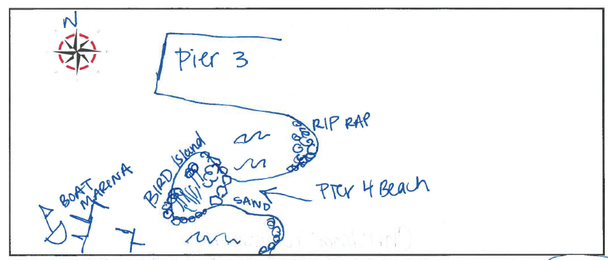

Location: Pier 5 of Brooklyn Bridge Park, Brooklyn, NY
Area: Mixed use park, marina south and park pier north of beach
Surrounding Land Use: 100% Urban/residential and park land
Sampling Site: South of boat marina and in front of the soccer field.
Shoreline: beach, vegetation, riprap, pipe entering the water
Water: Calm
River Bottom: Sandy, rocky
No plants – just algae ~ 10%
ITEM |  | Time | Reading |  | Comments
Physical
Air Temperature: |  | 10:47AM  11:34 AM  12:06 PM  12:35 PM | 15.5º C  15.5º C  16.7 C  17.8º C | 60 º F  60 º F  62 º F  64 º F
Wind |  | 10:00 AM | Beaufort #2
Weather Today: |  | 10:30-11:00 AM light rain, full sampling time overcast (75%)
Weather Previous: |  | N/R
Water Temperature- in a bucket |  | 10:30 AM  11:30 AM  12:30 PM | 16º C  16º C  17º C | 61º F  61º F  62º F
Turbidity -  HORIBA multiparameter probe |  | Time  10:50 AM  11:45 AM  12:50 PM | Long Tube  70.5 cm  83.5 cm  94 cm | Probe  21.7 ntu  15.6 ntu  8.4 ntu | Turbidity decreased during the day and students speculated that incoming tide or addition of freshwater (rain) may have influenced it.
Chemical
Salinity-  H= hydrometer  M=meter |  | 10:15 AM | 22 ppt (H)  20 ppt (H)  19.9 ppt (M) | 20.75 average
 |  | 11:15 AM | 22 ppt (H)  21 ppt (H)  20.45 ppt (M) | 21.15 average
 |  | 12:30 PM | 21 ppt (H)  19 ppt (H)  18.9 ppt (M) | 19.6 average
DO –  C = Chemetrics  M = Meter |  | Time | Temp | ppm DO | % saturation
 |  | 10:30 AM |  | 8 ppm (C)  6.5 ppm(C)  6.96 (M) | 80.3%
 |  | 11:30 AM |  | 7 ppm(C)  6 ppm(C)  7.51 ppm (M) | 87.4%
 |  | 12:30 PM |  | 7 ppm(C)  7 ppm(C)  7.02 (M) | 80.9%
pH -  TK = Test Kit  M = Meter |  | 10:20 AM | *6 (TK)  *7.8 (M) | *They noted both of these may be inaccurate
 |  | 11:30 AM | 8 (TK)  8 (TK)  8.56 (M)
 |  | 12:30 PM | 8 (TK)  8/9 (TK)  8.59 (M)
Fish – seine – 20 ft. length  16 hauls total |  | Number | Name | Length of longest
 |  | 584  11  1  1  7 | Atlantic Silverside  Striped Anchovy  Winter flounder  Pipefish  Menhaden | 11.5 cm  5 cm  7 cm  8 cm  8 cm
 |  | TOTAL: 604 | Diversity: 5
Macroinvertebrates |  | Number | Name | Length of longest
 |  | 1  1  5  6  21 | Hermit crab  Mussel  Moon Jelly  Comb jelly Beroe  Comb jelly Leidyi
 |  | TOTAL: 34 | Diversity: 5
Tides- | Time | Rising, Falling, Still | Height (cm) | Tidal Notes
 | 10:00 AM - 1:00 PM | Flood |  | Low Tide 9:48 AM 0.9 ft | High Tide 3:58 AM 4.1 ft
Currents- | cm/second | Rising, Falling, Unchanged | North/South | Ebb/Flood/Still
N/R
Core | Length | Description | Rare | Common | Abundant
 | 18 cm | Bottom – wet and more compact  Top – drier sand & looser | Wood  ?macroinvertebrates (need a microscope) | - Gravel  - Shells (small fragments)  - Brick  - Living vegetation (algae) | Sand
Boats | Time | Name | Color | North or South | Loaded or Light
N/R
Other Observations |  | Shell fragments (clam, oyster, mussel), small pebbles, algae (red, sea lettuce, rockweed), large pieces of driftwood  Birds and bees abundant in vegetated areas of the beachfront

