Day in the Life of the Hudson River 10/22/19 Data
BROOKLYN BRIDGE PARK (EAST), BROOKLYN
RIVER MILE: 1.7 (East River)
Salt Front: ~RM 53
Brooklyn Friends School- Janet Villas
70 students 8th grade, 10 adults
Latitude 40 º 41’44” N & Longitude – 73 º 59’60” W
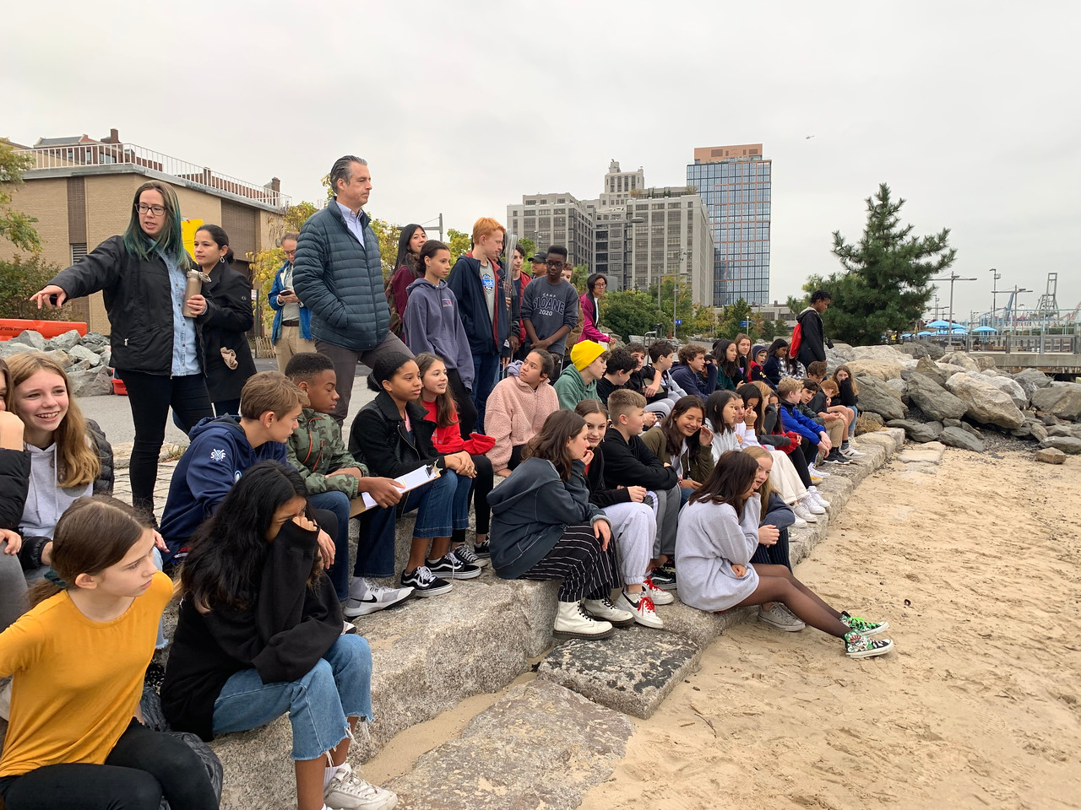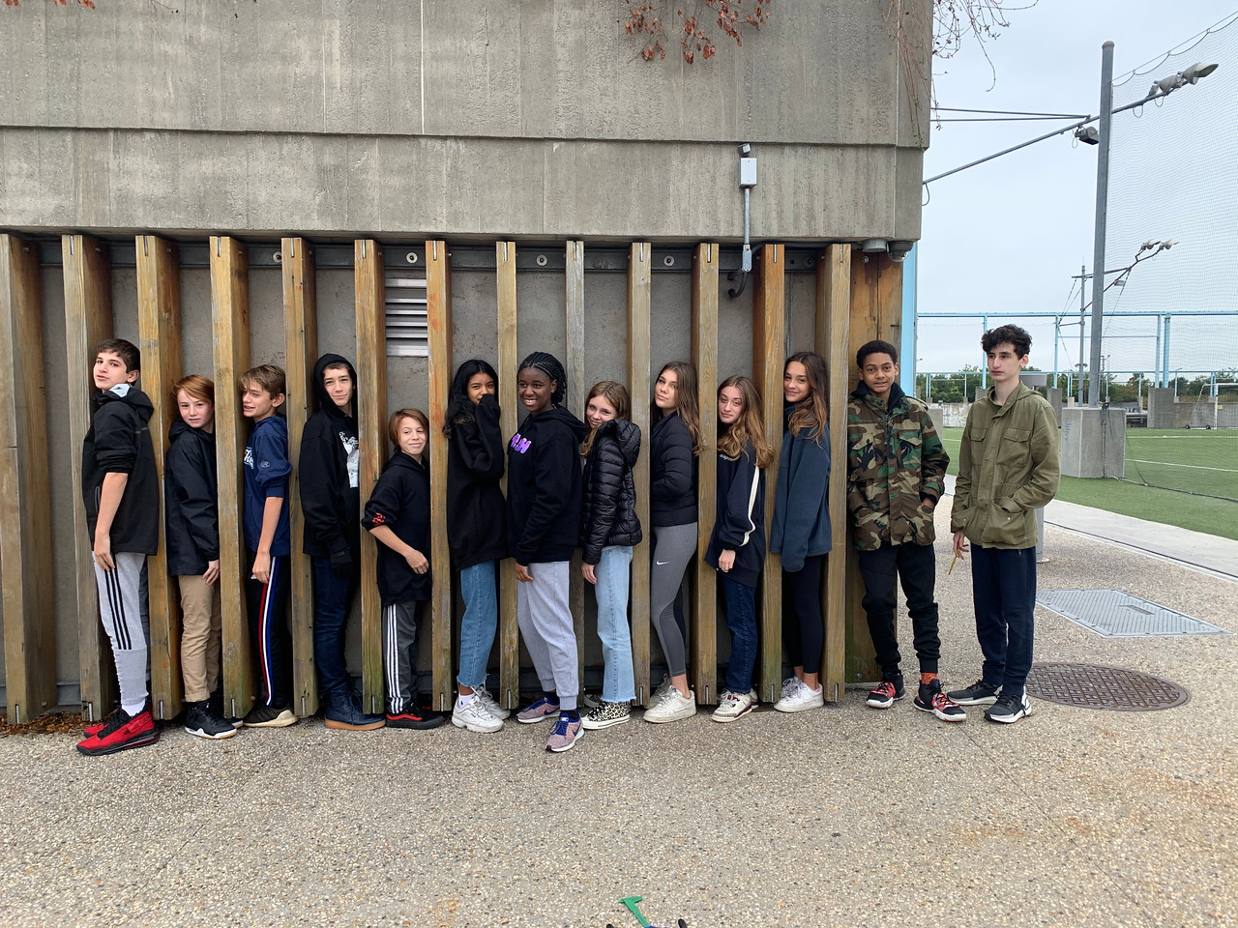

Location: Pier 5 of Brooklyn Bridge Park, Brooklyn, NY
Area: Developed set of piers
Surrounding Land Use: 100% Urban/residential and park land
Sampling Site: South of boat marina and in front of the soccer field.
Shoreline: Rocky shoreline, riprap, concrete bulkhead
Water: Choppy
River Bottom: Sandy
Sample times: 9-11 AM
ITEM |  | Time | Reading |  | Comments
Physical |  | 9AM | 10AM
Air Temperature: |  | 16.7 º C | 16.7 º C
Weather Today: |  | Partly cloudy (26-50%) cool breeze
Weather Previous: |  | N/R
Water Temperature |  | 15.8 º C | 16.7 º C
Turbidity - secchi |  | 300 cm | 300 cm
Turbidity – long site tube |  | 77 cm | 82 cm
Chemical |  | 9AM | 10 AM
Salinity- venier probe |  | 16.2 ppt | 15.7 ppt
DO – Meter |  | 13.7 ppm | 15.8 ppm
pH - meter |  | 7.5 | 7.5
Nitrates |  | 1 ppm | 1 ppm
Animal Life – Bucket of water through a sieve |  | Number | Name | Length of longest
 |  | N/R  N/R | Sea Robin  Blackfish | Diversity 2
Macroinvertebrates |  | N/R  N/R  3  N/R | Barnacles  Shore Shrimp  Green Crab  Amphipod | Diversity 4
Tides- dock to water | cm/second | Rising, Falling, Unchanged | North/South
N/R
Currents- N/R | Time | Name | Color | Flood
1:15 PM | Cormorants | Pair of wood ducks |  | North or South
Other Observations | Cormorants
Ships | Ferries | Barges | NYPD

