Day in the Life of the Hudson River 10/22/19
FRANCIS LEWIS PARK, RIVER MILE: 13.7
Salt Front: ~RM 53
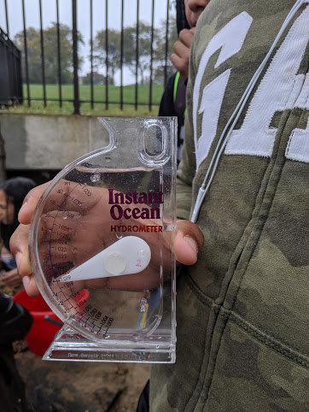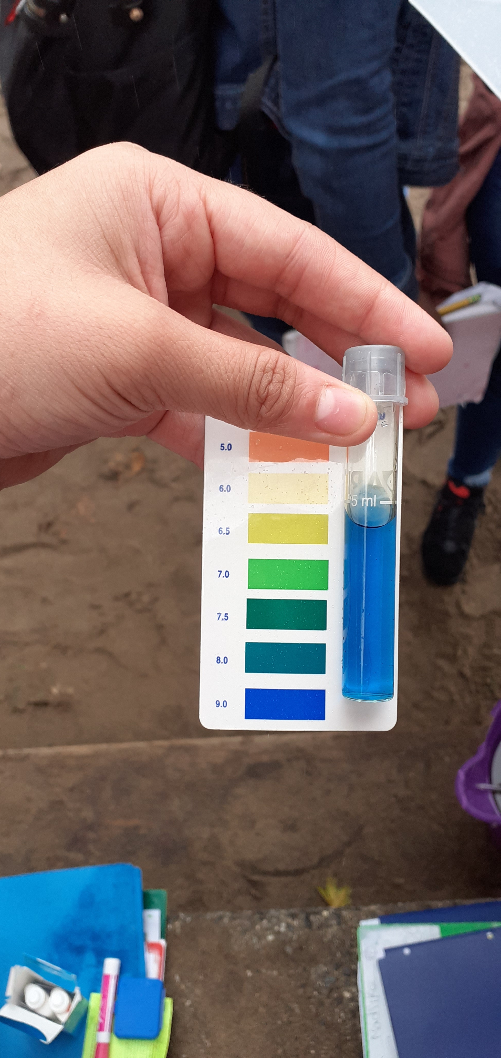
Mirela Shpuza Shurdha -International High School for Health Sciences
79 students 9th-10th grade
Latitude 40.797289 N & Longitude -73.826217 W
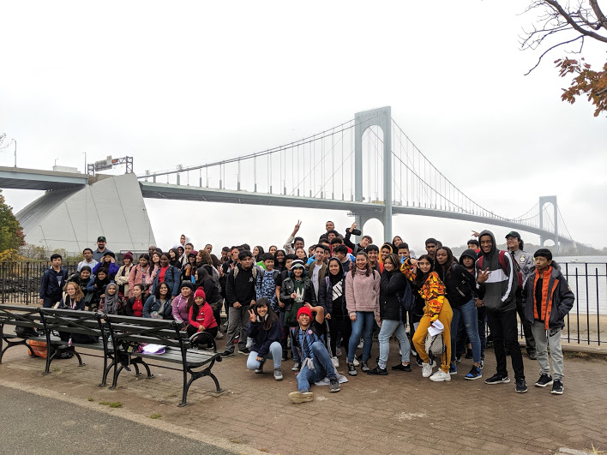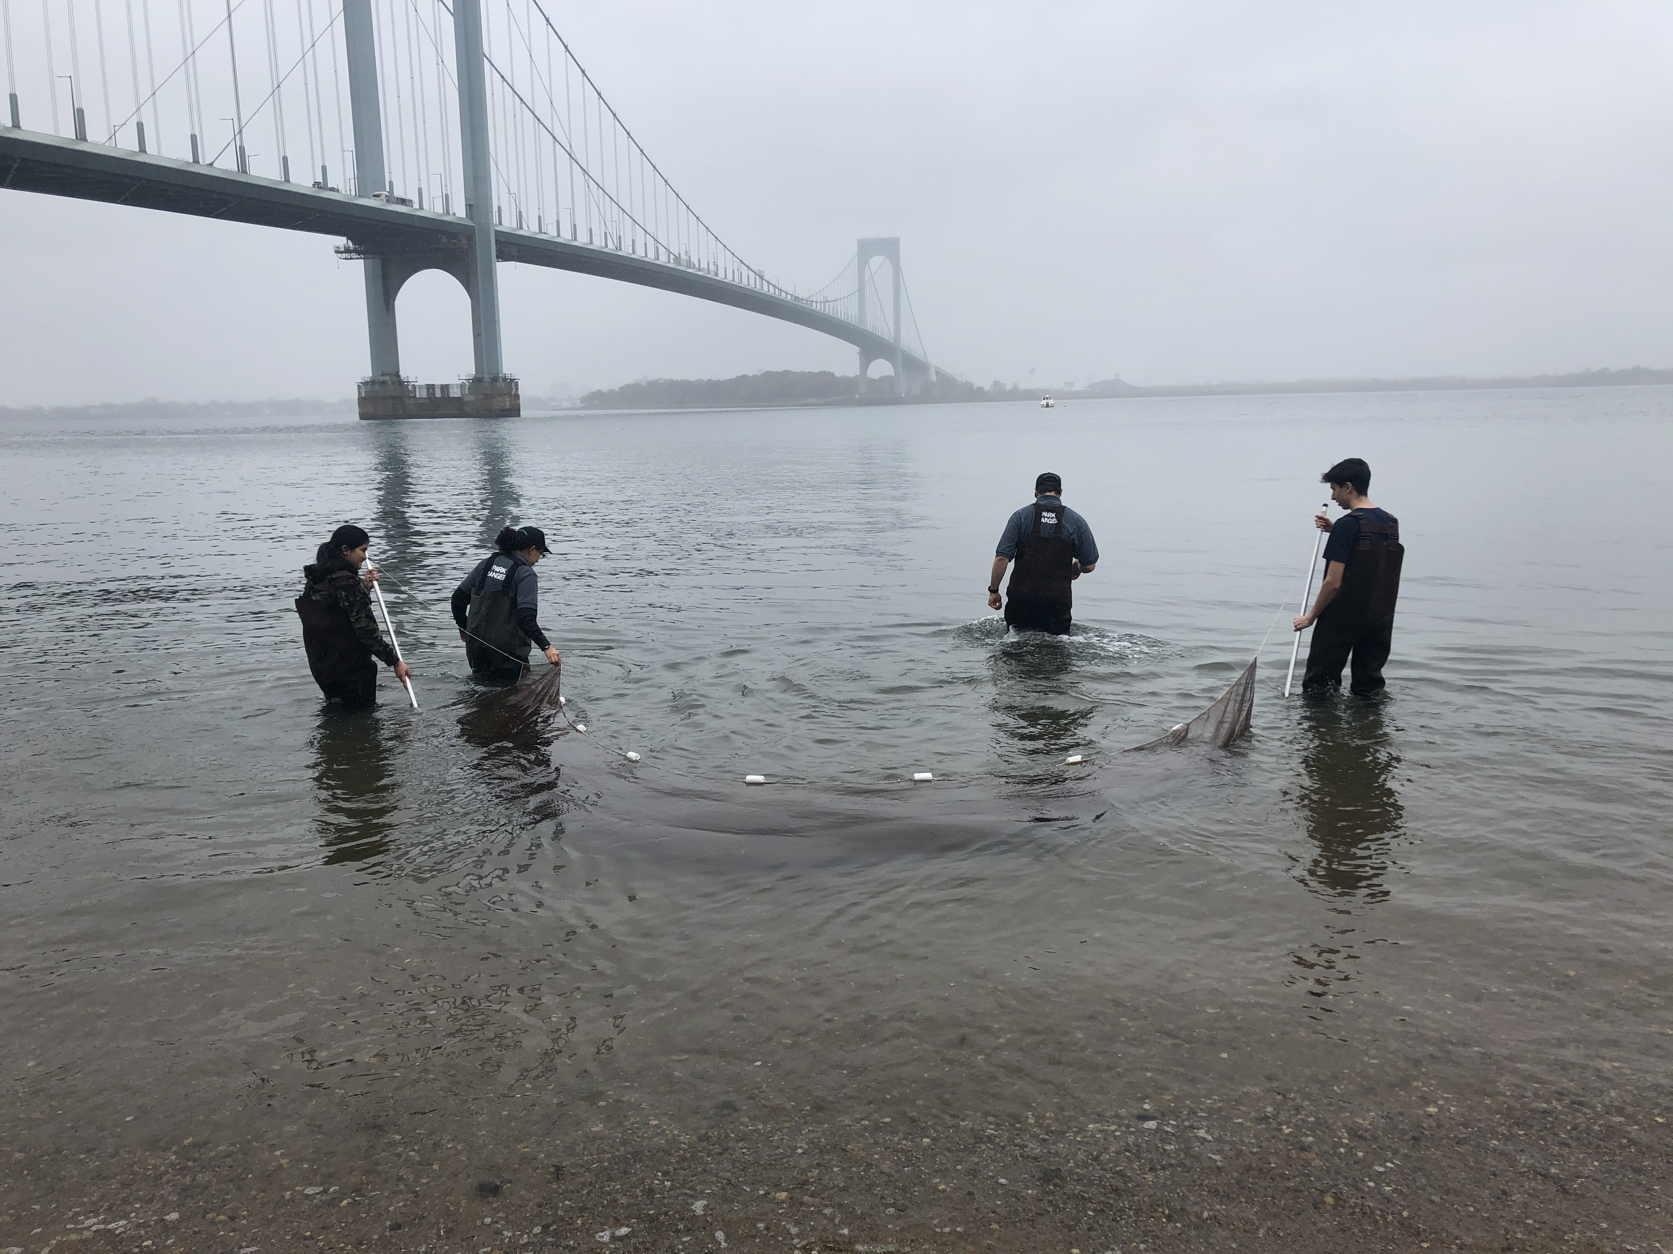
Location: Francis Lewis Park, Queens, NY
Area: Forested and grassy near site; pier
Surrounding Land Use: Forested; Beach
Sampling Site: Park area
Shoreline: Sandy, rocky, beach
Plants in area: none
River Bottom: Muddy
ITEM |  | Time |  | Reading |  |  | Comments
Physical
Air Temperature: | 10:40 AM  11:10 AM  11:43 AM  12:06 PM | 15 º C  15 º C  16 º C  16 º C
Wind Speed: | NA
Weather Today: | NA
Weather Previous: | NA
Water Temperature | 10:40 AM  11:10 AM  11:43 AM  12:06 PM | 14 º C  16 º C  15 º C  15 º C
Turbidity - Long sight tube | NA | 41 cm
Chemical
Salinity- hydrometer | 10:40 AM  11:10 AM  11:43 AM  12:06 PM | 26,000 ppm  26,000 ppm  26,000 ppm  26,000 ppm
DO – | Time | Temp |  | ppm DO | % saturation
DO – | 10:40 AM  11:10 AM  11:43 AM  12:06 PM | 14 º C  16 º C  15 º C  15 º C |  | 7  5  6.5  7
pH - | 10:40 AM  11:10 AM  11:43 AM  12:06 PM | 8  9  8  8.5
Fish – seine  10:30  11:15  11:30-11:40 | Number | Name |  | Length of longest
Fish – seine  10:30  11:15  11:30-11:40 | 14  38  1 | Atlantic Silverside  Atlantic Silverside  Atlantic Silverside
Fish – seine  10:30  11:15  11:30-11:40 | TOTAL: 53 | Diversity: 1
Macroinvertebrates- Seine  10:30  11:15  11:30-11:40 | Number | Name |  | Length of longest
Macroinvertebrates- Seine  10:30  11:15  11:30-11:40 | 2  3  2  3  2 | Blue Crab  Moon Jelly  Ghost Shrimp *  Ghost Shrimp  Ghost Shrimp |  | *Palaemonetes
Macroinvertebrates- Seine  10:30  11:15  11:30-11:40 | TOTAL: 12 | Diversity: 3
Tides- | Time | Rising, Falling, Still |  | Height (cm) | Rate of Tidal Change (cm/min)
NR
Currents Flow | Cm/second | Knots |  | North/South | Ebb/Flood/Still
NR

