Day in the Life of the Hudson River 10/22/19 Data
BROOLYN BRIDGE PARK (WEST), MANHATTAN
RIVER MILE: East River 2.3
Salt Front: ~RM 54
Leman Manhattan Preparatory School- Bill Livingston
36 students 10th -12th grade, 2 adults
Latitude 40.7076 N & Longitude – 73.99982 W

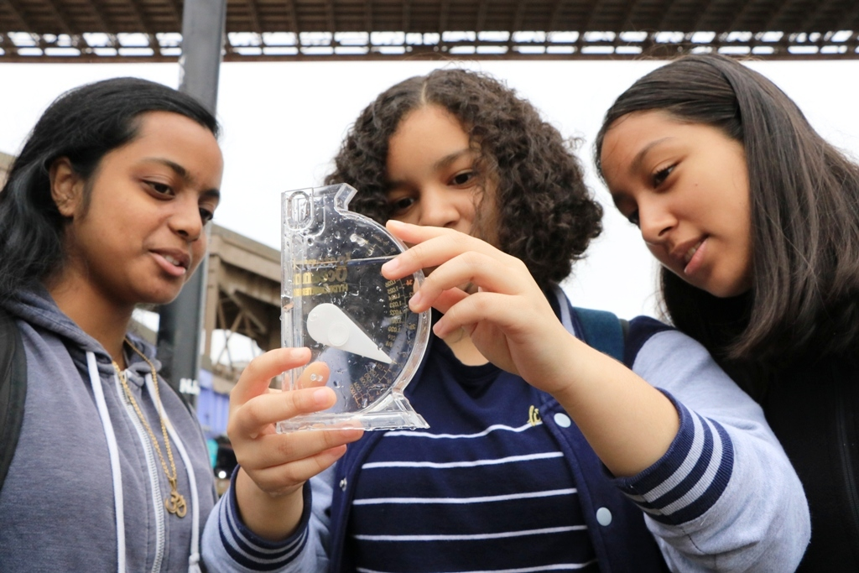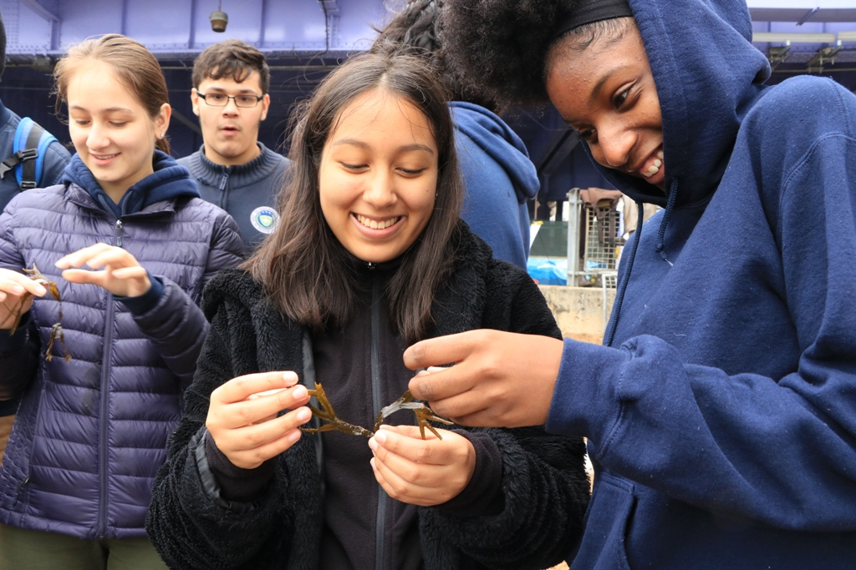

Location: Brooklyn Promenade- Brooklyn Bridge, Manhattan, NY
Area: Beach under the Brooklyn Bridge- 125 feet north of Dover street, west side of the East river. Pier and path for recreational walking, jogging, bike riding, and fishing. Surrounding land is a sandy beach with water. Water used for fishing and boating; beach is open to the public but no swimming; lots of rocks and sand; near parking lot.
Surrounding Land Use: 60% Urban Residential; 30% Industrial/Commercial; 10% Beach
Sampling Site: Sandy, beach, covered in vegetation, pier; banks altered; bulkhead with timbers; debris in area such as broken concrete, docking; riprap; pipe entering river (south CSO ~40 meters- not visible).
Water: Choppy, 4 feet deep
River Bottom: Sandy, rocky (pebbles and stones)
Plants: 3% plants covering the water area: Irish moss and Gracela
ITEM | Time | Reading |  | Comments
Physical
Air Temperature: | 10:00 AM  1:20 PM  1:40 PM  2:00 PM  2:20 PM | 13.9 ºC  17.3 ºC  17 ºC  16.4 ºC  16 ºC | º F  º F
Wind Speed: | 10:40 AM  2:20 PM | Beaufort: 4  Beaufort: 6
Weather Today: | NR
Weather Previous: | NR
Water Temperature | 9:20 AM  10:00 AM  10:20 AM  10:40 AM  1:20 PM  2:00 PM  2:20 PM | 17.1 ºC  17.8 ºC  16 ºC  16.1 ºC  16.6 ºC  16 ºC  16.6 ºC | º F  º F  º F
Turbidity -  Long site tube | 2:00 PM | 61.2 cm
Chemical
Salinity- hydrometer | 9:20 AM  10:00 AM  10:20 AM  1:00 PM  1:20 PM  2:00 PM  2:20 PM | 24 ppt  23 ppt  23 ppt  20 ppt  25 ppt  24 ppt  24 ppt
DO – | Time | Temp | ppm DO | % saturation
DO – | 9:20 AM  10:00 AM  11:40 AM  1:00 PM  2:00 PM | 17.1 ºC  17.8 ºC  16 ºC | 12  8  5.75  5.5  6 | 105  85  58  55  63
pH - pH strips | 10:00 AM  10:20 AM  1:20 PM  2:00 PM  2:20 PM | 6  7  6  7  7
Nitrates – Flinn/Lamotte Color Comparator Kits | 10:40 AM  1:00 PM  2:20 PM | 1.5 ppm  4.4 ppm  1.0 ppm
Phosphates – Flinn/LaMotte Color Comparator Kits | 10:40 AM  1:20 PM  2:20 PM | 0.4ppm  6.6 ppm  0.2 ppm
Fish – Seine  Length of seine: 20’  Width of seine: 4’ | Number | Name | Length of longest
Fish – Seine  Length of seine: 20’  Width of seine: 4’ | 4  1  1 | Atlantic Silverside Striped Bass  Herring (shad)
Fish – Seine  Length of seine: 20’  Width of seine: 4’ | TOTAL: 6 | Diversity: 3
Macroinvertebrates- | Number | Name | Length of longest
Macroinvertebrates- | 20 | Comb Jellies
Macroinvertebrates- | TOTAL: 30 | Diversity: 1
 | Indirect Evidence from shells as tides prevented exploring in tide pools | Blue Mussels  Surf calms  Quahog  Oyster  Blue Crab  European Green Crab  Ocellated Lady Crab | Mytilus edulis
Tides- | Time | Rising, Falling, Still | Height (cm) | Rate of Tidal Change (cm/min)
 | 9:00 AM  9:20 AM  10:00 AM  10:20 AM  10:40 AM  11:00 AM  1:20 PM  1:40 PM  2:00 PM  2:20 PM  2:40 PM |  | 0 cm  2 cm  6 cm  8 cm  10 cm  12 cm  76 cm  83.8 cm  91.4 cm  106 cm  120 cm
Current- *measured in a cove | cm/second | Rising, Falling, Unchanged | Height (cm) | Rate of Change (cm/min)
Currents Flow | Cm/second | Knots | North/South | Ebb/Flood/Still
10:00 AM  1:20 PM  1:40 PM  2:00 PM  2:20 PM  2:40 PM | 13.8  3  12  5  8  2

